
2nd Year Project
RENTAL CAR SYSTEM
Jessica Power, Kobi Bourne, Ryan Mulcahy, Sarah Crotty
Rysa-Rentals
Table of Contents
Intro 3
User Interface 4
Add Screens 4
Amend/View Screens 6
Delete Screens 8
Report Screen (Blacklist) 10
Report Screens (Car) 12
Report Screens (Company) 14
NAV 16
System Design Diagram 17
Database tables 18
RentalCat table - Kobi Bourne 18
Company table – Jessica Power 19
CarType table – Sarah Crotty 20
Car table – Ryan Mulcahy 21
Blacklist table – Ryan Mulvany 22
Group Work 23
Connection Class 23
Under construction page 24
Home Screen 25
Header Class 26
Nav class 27
Nav CSS 30
Global CSS 33
Logo Image 39
Individual work 40
Kobi Bourne 40
ADD SCREEN 40
AMEND/VIEW SCREEN 48
DELETE SCREEN 57
CAR REPORT SCREEN 63
RYAN MULCAHY 69
ADD SCREEN 69
Amend/View Car Details 80
Delete Screen 92
Blacklist Report 108
Jessica Power 124
ADD SCREEN 130
Amend/View Screen 137
Delete Screen 148
Rental Screen 158
Sarah Crotty 179
ADD SCREEN 179
DELETE SCREEN 190
AMEND SCREEN 202
COMPANY REPORT SCREEN 218

Intro
This project is an example of a rental car system used by employees. It has expected functionality such as various add, delete and amend/view features. Users can navigate to every screen from each individual screen using a nav bar.
This system contains a home page, all function screens, reports screens and a under construction page used for any pages unfinished/not needed as per the project specification. The nav bar was chose over having a separate menu page for better accessibility.

Most pages are structured the same including a nav-bar, a header and a form. The nav-bar holds the links to all pages, the header has the company name and logo, and the form contains the main feature/data (eg: displays report, input for add) of the page.

The style and overall layout was developed using group css files, one for the nav styling and one for the rest of the page styling. The theme is a combination of blues, light and dark for contrast.

User Interface

Add Screens
RYSA Rentals System/GroupWork
The add screens across the system follow a consistent user interface design, ensuring a uniform user experience regardless of the type of data being entered (e.g. Company, Car, Category). This consistency makes the system easier to learn and use.
Page Structure
Each screen includes a fixed header at the top and a vertical navigation menu on the left-hand side. The main form is displayed centrally within the remaining screen space, making it the primary focus for the user.
Positioning and Spacing
All forms are horizontally centred and maintain consistent spacing from the navigation panel. The form is positioned slightly lower on the page to ensure it is fully visible below the fixed header.
Visual Styling
A gradient background is applied across the page to create a modern and professional appearance. The form itself is placed inside a light blue container, providing strong contrast and improving readability.
Container Design
The form container includes rounded corners and a subtle box shadow. This helps separate it visually from the background and creates a clean, structured layout.
Branding Elements
The system logo is positioned in the top-right corner of the fixed header and remains visible across all screens, reinforcing consistent branding throughout the application.
Typography and Colour Scheme
The interface uses Arial, sans-serif for clarity and readability. Headings are larger and centred to stand out, while labels are bold for clear identification. Dark text is used within the form, while lighter text is used in the header to maintain contrast.

Form Layout and Components
Form elements are arranged using a structured layout, with labels and inputs aligned consistently using .form-group. Input validation is handled using HTML patterns to ensure correct data entry. Drop-down lists are used where appropriate to allow users to select from predefined values, improving accuracy and consistency.
Controls and Actions
Buttons are grouped together and centred at the bottom of the form. The primary action button (Submit) is styled in blue to highlight its importance, while secondary actions such as Reset or Clear are styled in red to distinguish their function.

Amend/View Screens
RYSA Rentals System/GroupWork
The amend/view screens across the system follow a consistent user interface design, ensuring a uniform user experience regardless of the type of data being viewed or updated. This consistency allows users to easily understand how to interact with the system.
Page Structure
Each screen is structured with a fixed header at the top and a vertical navigation menu on the left-hand side. The main form is displayed centrally within the available space, making it the primary focus for the user.
Positioning and Spacing
All forms are horizontally centred and maintain consistent spacing from the navigation panel. The form is positioned slightly lower on the page to ensure it is fully visible below the fixed header.
Visual Styling
A gradient background is applied across the page to create a modern and professional appearance. The form is contained within a light blue panel, providing strong contrast and improving readability.
Container Design
The form container features rounded corners and a subtle box shadow. This helps visually separate the form from the background and creates a clean, structured layout.
Branding Elements
The system logo is displayed in the top-right corner of the fixed header and remains visible across all screens, reinforcing consistent branding throughout the application.
Typography and Colour Scheme
The interface uses Arial, sans-serif for clarity and readability. Headings are larger and centred to stand out, while labels are bold for easy identification. Dark text is used within the form, while lighter text is used in the header to maintain contrast.

Form Layout and Components
Form elements are arranged using a structured layout, with labels and inputs aligned consistently using .form-group. A dropdown list is used to select a record, and once selected, the corresponding details are automatically populated into the form fields. Initially, all fields are displayed as read-only to prevent accidental changes, and they can be enabled when the user chooses to amend the record. Validation rules ensure that all updated data meets the required formats.
Controls and Actions
Buttons are grouped together and centred at the bottom of the form. The primary action button (Save Changes) is styled in blue to highlight its importance, while secondary actions are clearly distinguished. An additional control allows the user to toggle between viewing and editing modes, improving usability and control.

Delete Screens
RYSA Rentals System/GroupWork
The delete screens throughout the system are designed using a consistent layout and styling approach. This ensures that users experience the same look and behaviour across all delete-related functions, making the system easier to navigate and use.
Page Structure
Each screen is divided into three main sections: a fixed header at the top, a vertical navigation menu on the left, and the main content area. The form is displayed within the central content area, making it the primary focus of the page.
Positioning and Spacing
The form is centrally aligned within the available space and maintains equal spacing from the navigation panel. It is also positioned slightly lower on the page to avoid overlapping with the fixed header, ensuring all content is clearly visible.
Visual Styling
A gradient background is applied across the page to give a modern and professional look. The form itself is placed inside a light blue container, creating contrast and improving readability for the user.
Container Design
The form container features rounded corners and a subtle shadow effect. This helps distinguish it from the background and provides a clean, structured appearance.
Branding Elements
The system logo is displayed in the top-right corner of the fixed header. It remains visible across all screens, helping maintain consistent branding throughout the application.
Typography and Colour Scheme
A clean and readable font (Arial, sans-serif) is used across the interface. Headings are larger and centred to stand out, while labels are bold to improve clarity. Dark text is used within the form for readability, while lighter text is used in the header for contrast.
Form Layout and Components
Form elements are arranged using a structured layout, with labels and inputs aligned consistently using grouping styles. A dropdown list is used to select a record, and once selected, the corresponding data is automatically populated into the form fields. All fields are displayed as read-only to prevent accidental edits.

Controls and Actions
Action buttons are grouped together and positioned centrally at the bottom of the form. The primary action button (Submit/Delete) is styled in blue to indicate importance, while secondary actions such as Reset or Clear are styled in red to differentiate their function.

Report Screen (Blacklist)
RYSA Rentals System/Ryan
The Blacklist Report screen follows the same overall design principles used throughout the system, ensuring a consistent and familiar user experience. The layout, colours, and structure align with other screens, making navigation intuitive.
Page Layout
The screen is structured with a fixed header at the top and a vertical navigation panel on the left. The report content is displayed within the main section of the page, centred to draw user attention to the report data.
Content Positioning
The report area is centrally aligned and spaced evenly from the navigation menu. Adequate padding is used to ensure the content does not feel crowded and remains clearly visible beneath the fixed header.
Visual Appearance
A dark-themed background with subtle gradients is used to create a professional and modern interface. The report header is displayed within a styled container that contrasts with the background, helping it stand out.
Header Styling
The report title (“Blacklist Report”) is prominently displayed in a large, centred font within a highlighted container. Decorative elements such as accent lines and subtle background effects enhance the visual appeal and draw focus to the title.
Branding
The system logo remains visible in the header across the screen, reinforcing consistent branding and identity throughout the application.
Typography and Colour
A combination of serif and sans-serif fonts is used to balance professionalism and readability. Light-coloured text is used against the dark background for contrast, while accent colours (such as red) are used to highlight important elements related to blacklist data.
Report Controls
The screen includes clearly labelled buttons that allow the user to sort the report by different criteria, including date, company name, and amount owed. The currently selected option is visually highlighted, helping users understand how the data is being displayed.

Data Presentation
The report is displayed in a structured table format with clearly defined columns. These include details such as date blacklisted, company name, amount owed at the time of blacklisting, current amount owed, and the number of previous blacklist occurrences.
Table Design
The table uses alternating row colours (zebra striping) to improve readability. Column headings are styled distinctly to separate them from the data, and hover effects provide visual feedback when users interact with the rows.
Functionality
Data is dynamically retrieved from the database and displayed in real time. Users can change the sorting order using the provided controls, which reloads the report with updated results. Only active company records are shown, ensuring the accuracy and relevance of the information.

Report Screens (Car)
RYSA Rentals System/Kobi
The Car Report screen follows the same overall design used throughout the system. The layout, colours, and structure align with other screens.
Page Layout & Content Positioning
The page uses a fixed header at the top of the screen and a navigation bar on the left. The report is displayed within a centred form, with the data presented in a table. Padding is used to ensure all content is evenly spaced and clearly readable.
Visual Appearance
The same dark/light blue theme has been reused to keep in line with the overall website look. A dark background with a light form is used for contrast. The report header and nav are displayed to match this theme.
Branding
The system logo remains visible in the header across the screen, reinforcing consistent branding and identity throughout the application.
Font
A combination of serif and sans-serif fonts is used. A dark blue/navy text is used against the light form background for readability and contrast.
Report Controls
The screen includes three buttons that allow the user to sort the report by model, times rented, or date added. The currently selected option is disabled and visually darkened to indicate it cannot be selected again, while the remaining options stay enabled
Data Presentation
The report data is displayed in a table within the form. It includes details such as Car registration, Model, Brand, Status, Date Added and Times Rented.
Table Design
The table has a simple structure with clearly defined columns and consistent borders. Column headings are styled in bold to distinguish them from the data.
Functionality Data is dynamically retrieved from the database and displayed in real time. Users can change the sorting order using the provided controls, which reloads the report with updated results. Only cars with delete flags set to 0 are shown, ensuring the accuracy and relevance of the information.

Report Screens (Company)
The Company Report screen follows the same overall design principles used throughout the system while having its own distinct styling applied through a dedicated companyReport.css file, which overrides the global form styling to suit the full-width report layout.
Page Layout
The screen is structured with a fixed header at the top and a vertical navigation panel on the left. The report content sits within a report-container div that is pushed clear of both the fixed header and the sidebar using margin top and margin left, with the data centred within the remaining space.
Content Positioning
The report-container uses padding of 30px and a margin-top of 180px to ensure all content clears the fixed header and remains clearly visible. The table and sort buttons are centred within this container.
Visual Appearance
Unlike the other report screens, the Company Report uses a light table on the dark page background rather than a dark-themed container. The report table has a white background with a dark navy heading row, creating a strong contrast that makes the data easy to read. The global form box styling is completely removed by the companyReport.css override setting background, box-shadow, padding, margin and border-radius all to none so no blue form container appears behind the table.
Branding
The system logo remains visible in the fixed header across the screen, reinforcing consistent branding and identity throughout the application.
Typography and Colour
Arial sans-serif is used throughout for clarity. Column headings are white text on a dark navy (#1e3a8a) background. Data rows use dark text (#1f2937) for readability. Blacklisted companies display a bold red Y in the Blacklisted column to draw immediate attention to high-risk records. Credit Limit and Amount Owed values are prefixed with a euro symbol and formatted to two decimal places using numberformat().
Report Controls
The screen includes three clearly labelled buttons. Company Name, Best Customers, and Amount Owed. The active sort button is styled in grey (#607084) with a not-allowed cursor to show it cannot be selected again. The remaining buttons are styled in blue (#2563eb) with a darker hover state, matching the overall system button style.
Data Presentation
The report displays six columns. Company Name, Address, Total Rentals, Blacklisted, Credit Limit, and Amount Owed. Only companies where deleteFlag = 0 are included, ensuring deleted records are excluded from the output.
Table Design
The table uses alternating row colours for readability. even rows have a light blue tint (#f0f4ff) and odd rows are white. A hover effect changes the row background to a slightly deeper blue (#dbeafe) to provide visual feedback when the user moves over a row. Column headings are bold and visually separated from the data by the dark header row.
Functionality
Data is dynamically retrieved from the database and displayed in real time. Clicking a sort button sets a hidden form field to the chosen value and submits the form, reloading the page with the new sort applied. The currently active button is disabled server-side using PHP so the correct button is always disabled on page load regardless of which sort was last selected.

NAV
RYSA Rentals System/GroupWork
The menu interface across the system follows a consistent user interface design, ensuring easy navigation and a uniform user experience throughout the system.
Layout & Alignment
The layout consists of a fixed header at the top of the page and a vertical navigation menu positioned on the left-hand side. The main content is displayed centrally within the remaining screen space. Elements are horizontally centred with consistent spacing, and content is positioned slightly lower to avoid overlap with the header.
Background & Border
The content area uses a light blue background to provide contrast. Rounded corners and subtle box shadows are used to separate elements and maintain a clean structure.
Logo
The system logo is positioned in the fixed header at the top right of the page and remains visible across all screens, reinforcing consistent branding.
Font, Text Colour & Headings
The interface uses Arial, sans-serif for clarity and readability. Headings are larger and centred, while labels and menu items are clearly distinguishable. Dark text is used for readability, with light text in the header for contrast.
Buttons
Menu items are displayed as vertically stacked buttons or links within the navigation panel. They are positioned for easy access and consistent interaction.
Other Elements
Drop-down menus are used to group related options. Submenus expand and collapse when selected, and active selections are visually highlighted. JavaScript is used to control dropdown behaviour.

System Design Diagram
This diagram illustrates the overall structure of the website and how its pages interact with one another.

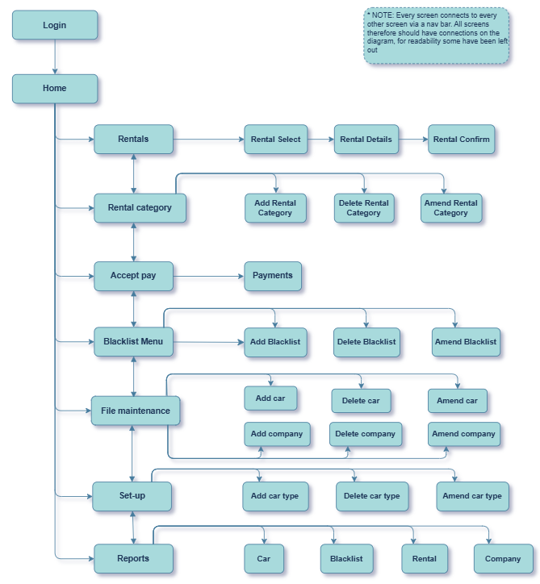

Database tables

RentalCat table - Kobi Bourne
This table contains 5 fields used when interacting with a rental category. This allows the user to assign category (ID), cost, discounts and set a delete-flag.
Table Structure
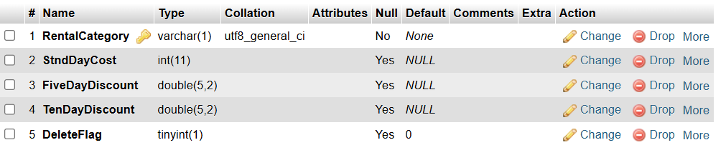

Table Content
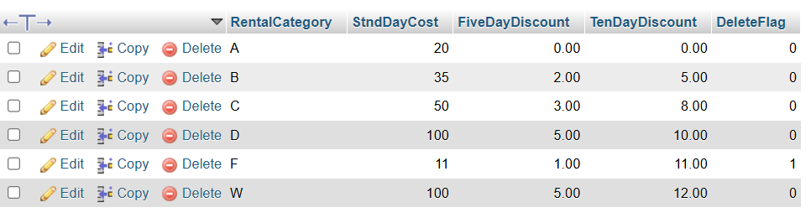

Company table – Jessica Power
This table contains 14 fields used when adding a new company. This allows the user to add and interact with a company record.
Table Structure
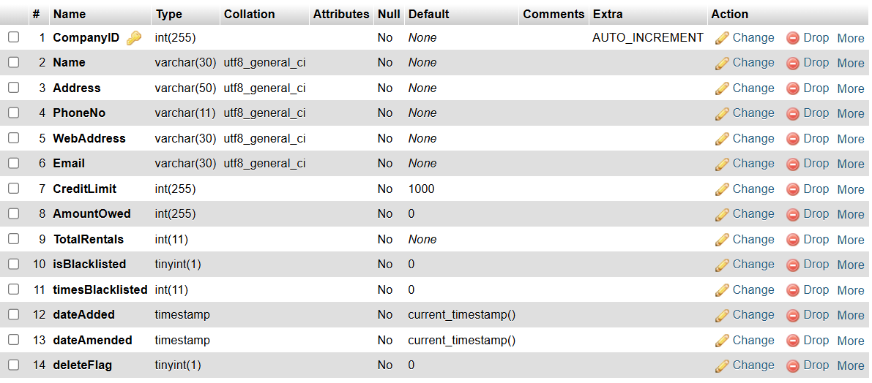

Table Content
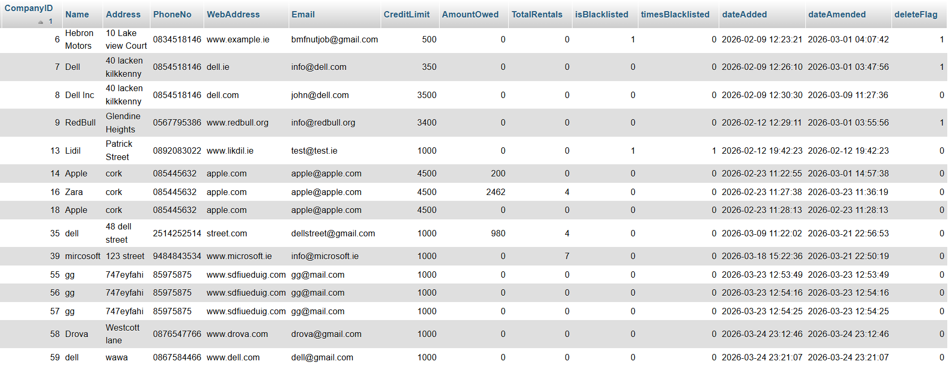

CarType table – Sarah Crotty
This table contains 8 fields used when adding a new car type. This allows the user to add a new car type.
Table Structure
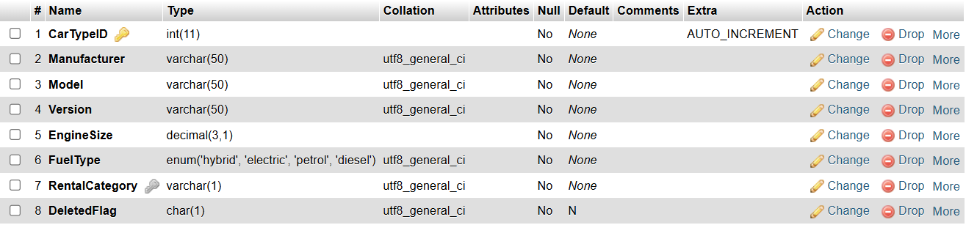

Table Content
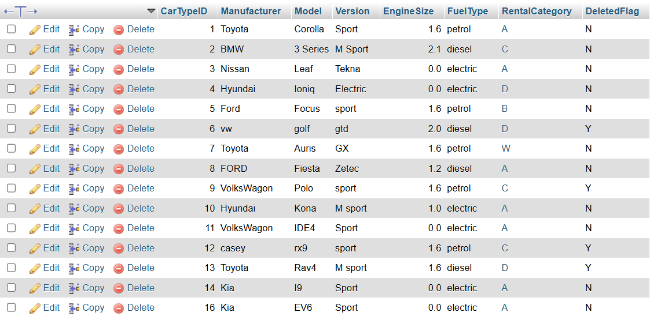

Car table – Ryan Mulcahy
The table stores car fleet information, with carID as an auto-increment primary key and fields capturing registration, type, colour, chassis number, body style, number of doors, purchase price, date added, current status, cumulative rentals, and a deletion flag.
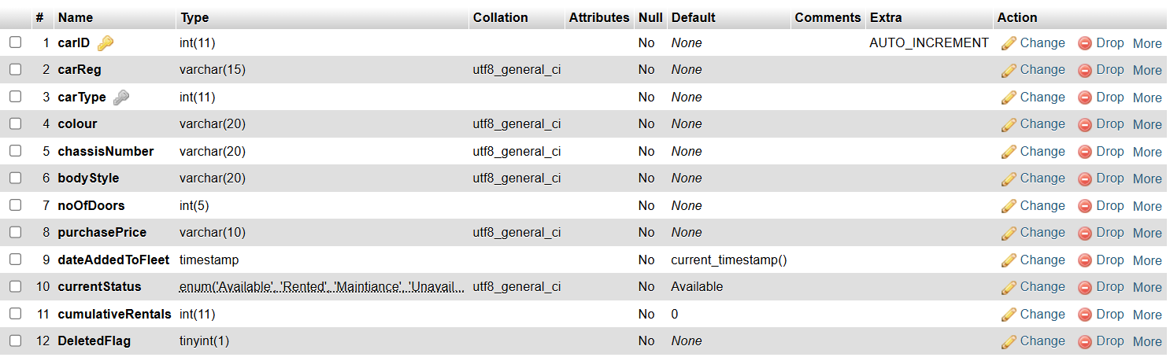

The table contains car fleet records, listing each car’s ID, registration, type, colour, chassis number, body style, number of doors, purchase price, date added to the fleet, current status, total rentals, and deletion flag.
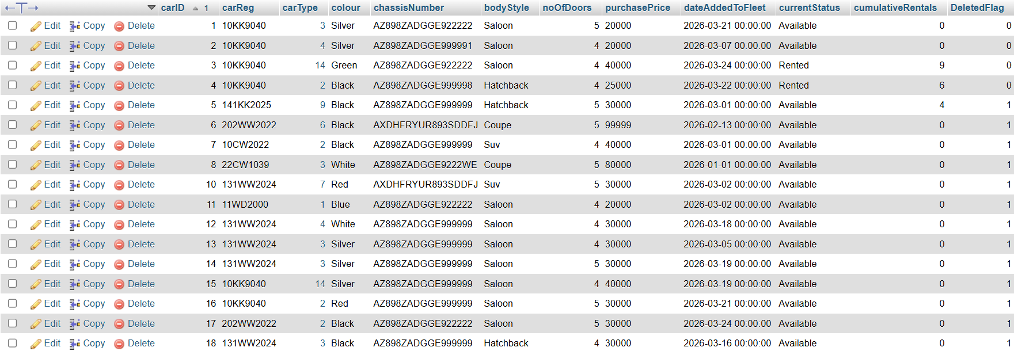

Blacklist table – Ryan Mulvany
The table stores blacklist records, with BlacklistID as an auto-increment primary key and fields capturing the date blacklisted, amount owed, and the associated company ID.
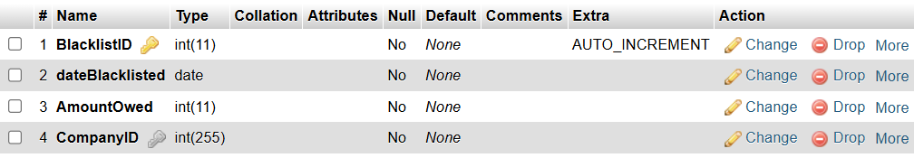

The table contains records of blacklisted companies, showing each entry’s ID, blacklist date, amount owed, and the associated company ID.
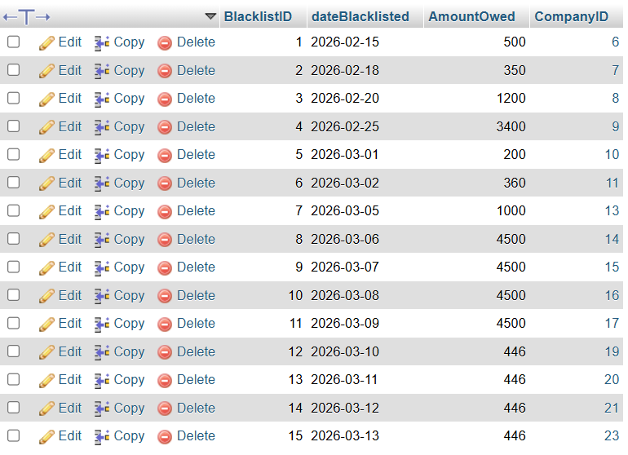

Group Work

Connection Class
Used for connecting to the database.
db.inc.php
<!--
This is just a php file for connecting the database to reduce
repetition in screens
coding started - Feb 2026
-->

<?php
$hostname="localhost"; //Where database is located
$username="rentacar_db"; //Username for database
$password="L1mit3dmile;"; //Databeses password

$dbname="continental"; //The name of the database

//Connecting to the database passing the above details for connection
$con = mysqli_connect($hostname,$username,$password, $dbname);

if(!$con)
{
die("Failed to connect to MySQL: " . mysqli_connect_error());
}
?>

Under construction page
Used as a placeholder page for unfinished pages
underConstruction.html.php
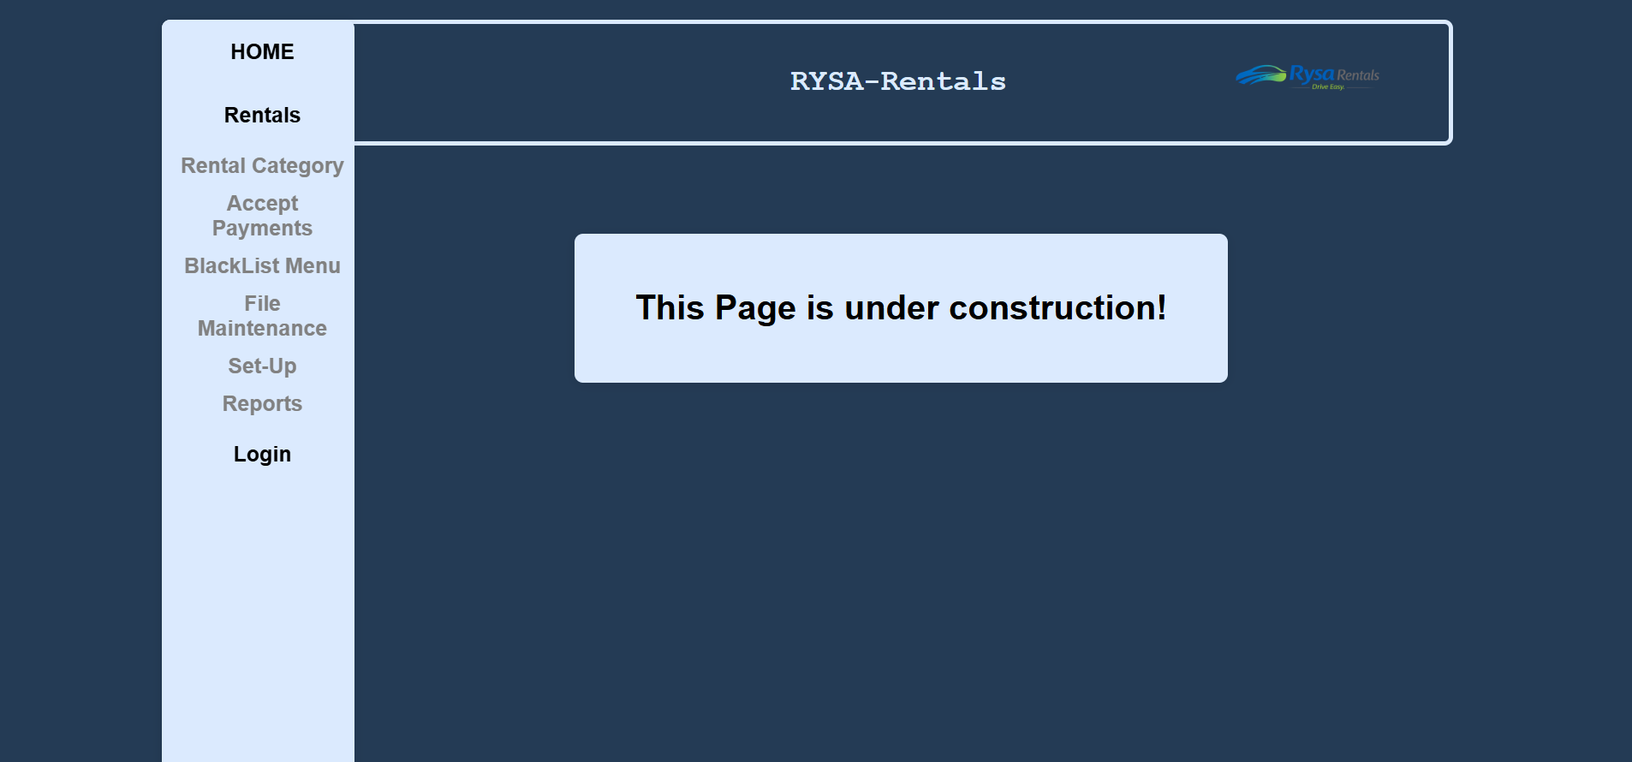

<!-- Name: Group work -->
<!-- Month: March 2026 -->
<!-- Purpose: under construction html page for work in progress or unimplemented pages -->
<!DOCTYPE html>
<html lang="en">
<head>
<meta charset="UTF-8">
<meta name="viewport" content="width=device-width, initial-scale=1.0">
<title>Under Construction</title>
</head>
<body>
<?php include('header.php') ?>
<?php include('nav.php'); ?>
<div class="center">
<form>
<h1>This Page is under construction!</h1>
</form>
</div>
</body>
</html>

Home Screen
Used as the home page.
Home.html.php
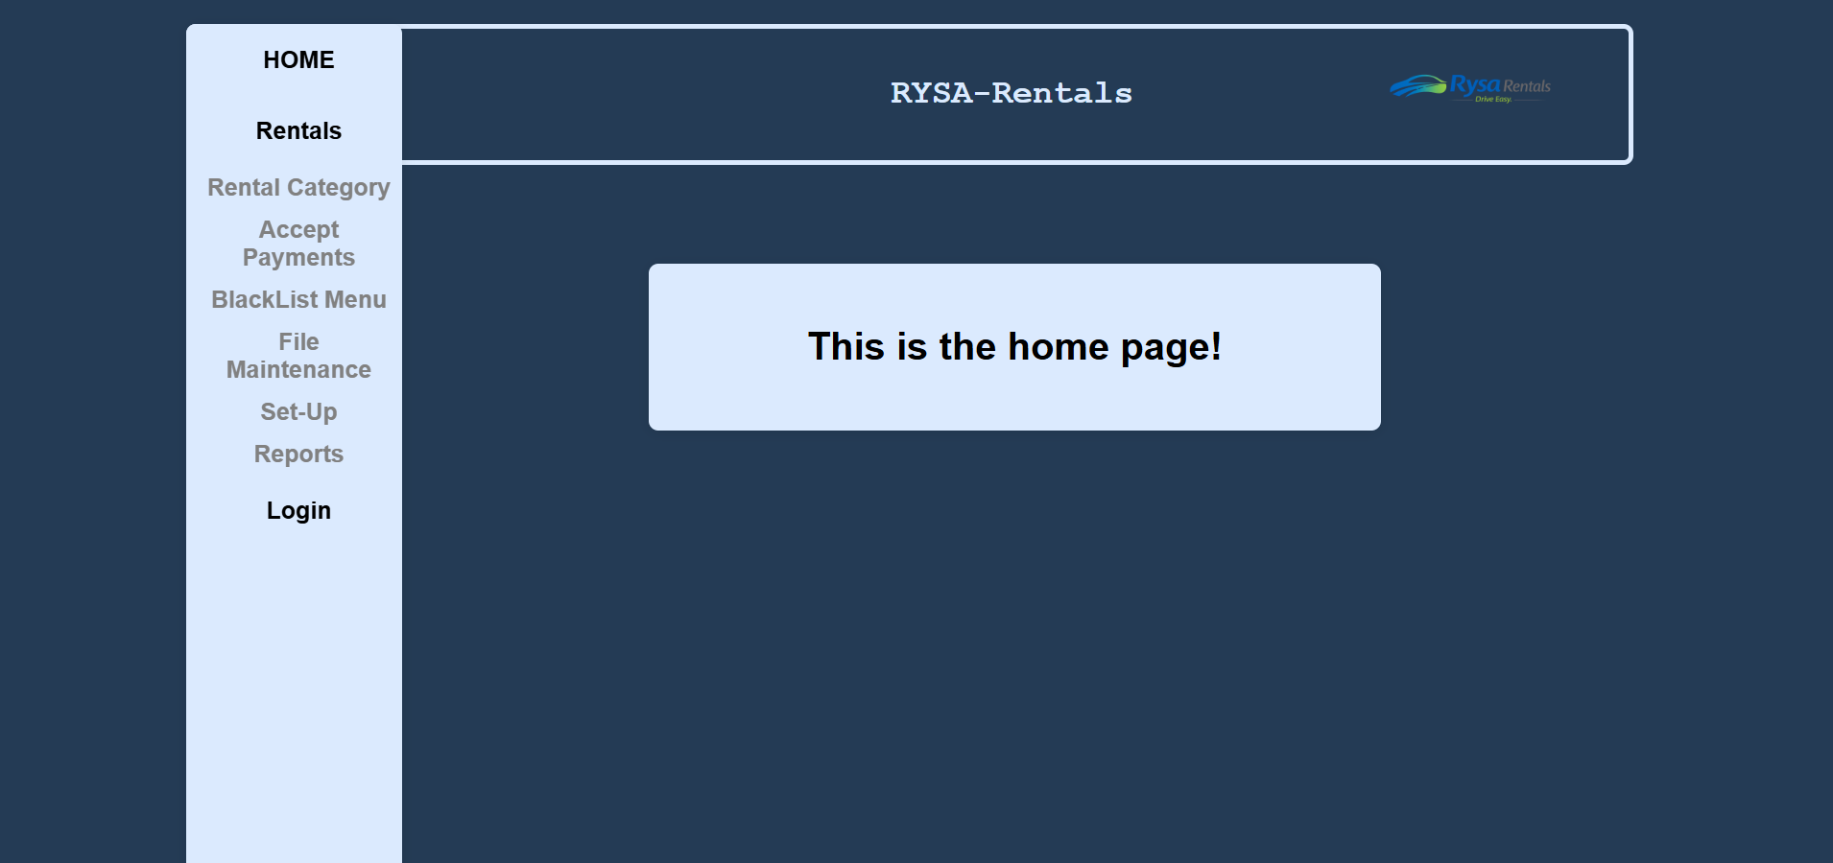

<!DOCTYPE html>
<html lang="en">
<head>
<meta charset="UTF-8">
<meta name="viewport" content="width=device-width, initial-scale=1.0">
<title>Under Construction</title>
</head>
<body>
<?php include('header.php') ?>
<?php include('nav.php'); ?>
<div class="center">
<form>
<h1>This is the home page!</h1>
</form>
</div>
</body>
</html>

Header Class
Used for the header.
Header.php


<link rel="stylesheet" href="../../GroupWork/global.css">

<?php
echo "<div class='header'>
<div class='title'><h3>RYSA-Rentals</h3></div>
<div class='logo'><img src='../../GroupWork/RYSARentals.png'/></div></div>"

?>

Nav class
Used for the nav side-bar.
nav.php
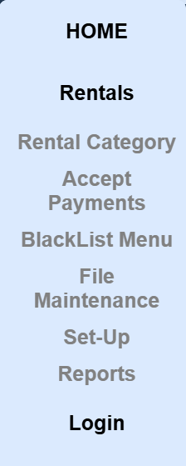

<link rel="stylesheet" href="../../GroupWork/nav.css">
<?php
echo "
<ul>
<button class='links'>
<a href='/GroupWork/home.html.php'>HOME</a>
</button>

<button class='links'>
<a href='/Jessica/RentalScreen/RentalSelCompany.html.php'>Rentals</a>
</button>

<button class='dropdown'>
Rental Category<i></i>
</button>
<div class='dropdown-content'>
<a href='/Kobi/Add/AddRentalCat1.html.php'>Add a New Rental Category</a>
<a href='/Kobi/Delete/delete.html.php'>Delete a Rental Category</a>
<a href='/Kobi/Amend/AmendView.html.php'>Rental Category View/Amend </a>
</div>

<button class='dropdown'>
Accept Payments<i></i>
</button>
<div class='dropdown-content'>
<a href='/GroupWork/underConstruction.html.php'>Payments</a>
</div>

<button class='dropdown'>
BlackList Menu<i></i>
</button>
<div class='dropdown-content'>
<a href='/GroupWork/underConstruction.html.php'>Add a New Blacklist Record</a>
<a href='/GroupWork/underConstruction.html.php'>Delete a Blacklist Record</a>
<a href='/GroupWork/underConstruction.html.php'>Blacklist View/Amend Records</a>
</div>

<button class='dropdown'>
File Maintenance<i></i>
</button>
<div class='dropdown-content'>
<a href='/Jessica/AddCompany/CompanyAdd.html.php'>Add a New Company</a>
<a href='/Jessica/DeleteCompany/CompanyDelete.html.php'>Delete a Company</a>
<a href='/Jessica/AmendCompany/CompanyAmend.html.php'>Company View/Amend Records</a>
<a href='/Ryan/Add/addCar.html.php'>Add a New Car</a>
<a href='/Ryan/Delete/deleteCar.html.php'>Delete a Car</a>
<a href='/Ryan/Amend/carAmendView.html.php'>Car View/Amend Records</a>
</div>

<button class='dropdown'>
Set-Up<i></i>
</button>
<div class='dropdown-content'>
<a href='/Sarah/AddCarType/addcarType.html.php'>Add a New Car Type</a>
<a href='/GroupWork/underConstruction.html.php'>Delete a Car Type</a>
<a href='/GroupWork/underConstruction.html.php'>Car Type View/Amend Records</a>

</div>

<button class='dropdown'>
Reports<i></i>
</button>
<div class='dropdown-content'>
<a href='/GroupWork/underConstruction.html.php'>Company Reports</a>
<a href='/Kobi/CarReport/CarReport.html.php'>Car Reports</a>
<a href='/GroupWork/underConstruction.html.php'>Rental Reports</a>
<a href='/Ryan/BlacklistReport/blacklistReport.php'>Blacklist Reports</a>
</div>

<button class='links'>
<a href='/GroupWork/underConstruction.html.php'>Login</a>
</button>

</ul>
<script>
/* Loop through all dropdown buttons to toggle between hiding and showing its dropdown content - This allows the user to have multiple dropdowns without any conflict */
var dropdown = document.getElementsByClassName('dropdown');
var i;

for (i = 0; i < dropdown.length; i++) {
dropdown[i].addEventListener('click', function() {
this.classList.toggle('active');
var dropdownContent = this.nextElementSibling;
if (dropdownContent.style.display === 'block') {
dropdownContent.style.display = 'none';
} else {
dropdownContent.style.display = 'block';
}
});
}
</script>";
?>

Nav CSS
Used for the header.
nav.css

.main{
display: flex;
gap:30px;
justify-content: space-between;
}

.nav{
flex-shrink: 0;
width: 200px;
}

form { /* Form container with white background */
flex-grow:1;
width:100%;
}

ul {
list-style-type: none;
border-radius: 8px;
box-shadow: 0 2px 10px rgba(0,0,0,0.1);
margin: 0;
padding: 0;
width:180px;
background-color: #dbeafe; /*was white */
height: 100%; /* Full height */
position: fixed; /* Make it stick, even on scroll */
overflow: auto; /* Enable scrolling if the sidenav has too much content */
}

/* the links button */
.links {
padding: 6px 8px 6px 16px;
text-decoration: none;
font-size: 20px;
color: #818181;
display: block;
border: none;
background: none;
width: 100%;
text-align: center;
cursor: pointer;
outline: none;
}

.links a{
color: black;
padding: 12px 16px;
text-decoration: none;
display: block;
text-align: center;
cursor: pointer;
}

/* the dropdown button */
.dropdown {
padding: 6px 8px 6px 16px;
text-decoration: none;
font-size: 20px;
color: #818181;
display: block;
border: none;
background: none;
width: 100%;
text-align: center;
cursor: pointer;
outline: none;
}

.dropdown-content {
display: none;
background-color: #dbeafe; /*#f9f9f9;*/
box-shadow: 0px 8px 16px 0px rgba(0,0,0,0.2);
z-index: 1;
}

.dropdown-content a {
color: black;
padding: 12px 16px;
text-decoration: none;
display: block;
text-align: center;
cursor: pointer;
}

.dropdown-content a:hover {
display: block;
background-color: #243b55 ; /*#555555*/
color: white;
}

/* Add an active class to the active dropdown button */
.active {
background-color: #1d50be;/*was green*/
color: white;
}

Global CSS
CSS used for every page of the project
global.css
body { /* Page layout and centering */
font-family: Arial, sans-serif;
padding: 20px;
padding-left:10%;
padding-right:14%; /*added to fix tim spacing problem*/
height:100%;
/*background: linear-gradient(135deg, #141e30, #243b55);*/
background-color:#243b55;
}

.header{
margin-top:0; /**/
width:78%; /*was 85*/ /*sets width */
height: 15%;/*15%;*/ /*sets height */
position: fixed;
background-color: #243b55; /*#333*/ /*#243b55 #1f2937 */
display: flex;
align-items: center; /*centers content in header*/
border:4px solid #dbeafe; /*border styling, width-type-color*/
border-radius: 8px; /*these 4 new*/
}

.logo
{
position: relative; /* Make it stick, even on scroll */
float: right;
margin-left: auto;
}

.logo img{
height: 160px; /*was 150*/
}

form { /* Form container with white background */
background-color: #dbeafe; /*WAS WHITE*/
margin:130px auto 50px auto;
max-width: 550px; /*was 600*/
padding: 30px;
border-radius: 8px;
box-shadow: 0 2px 10px rgba(0,0,0,0.1);
margin-top: 200px;
}

.center {

margin-left:230px;
}

.php-form { /* Form container php-page with white background */
background-color: #dbeafe;

margin:300px auto 50px auto;
max-width: 400px; /*was 600*/
text-align: center;
padding: 30px;
border-radius: 8px;
box-shadow: 0 2px 10px rgba(0,0,0,0.1);
}

/* Heading */
h2 {
text-align: center;
color: #333;
margin-bottom: 30px;
}

h3 {
text-align: center;
}

h1
{
text-align: center;
}
.title
{
color: #dbeafe;
font-size: 1.5rem;
margin-left: 38vw;
font-family: 'Courier New', monospace;

}

.form-group { /* Space between form fields */
margin-bottom: 20px;
display:flex;
gap:30px;
align-items:center;
width:100%;
justify-content: space-between;
}

/* Label styling */
label {
display: inline-block;
color: #555;
font-weight: bold;
}

input { /* Input field styling */
width: 50%; /*WAS 60*/
min-width:100px; /*added*/
padding: 10px;
border: 1px solid #ddd;
border-radius: 4px;
box-sizing: border-box;
font-size: 14px;
display:inline-block;
}

input:focus, textarea:focus, select:focus { /* Brighter reen border when input is focused */
border-color: darkgrey;
}

input:invalid { /* Red border for invalid input */
border-color: #ff6b6b;
}

input:valid { /* Green border for valid input */
border-color: #51cf66;
}

input:hover /*changes color of background when hovering -k */
{
background-color: #E0E0DD;
}

.button-group { /* Button layout */
display: flex;
gap: 10px;
margin-top: 30px;
justify-content: center; /*added*/
}

button { /* Button styling */
flex: 1;
padding: 12px;
border: none;
border-radius: 4px;
font-size: 16px;
cursor: pointer;
font-weight: bold;
}

button input { /* Button styling */
flex: 1;
width:20%;
padding: 6px;
border: none;
border-radius: 4px;
font-size: 16px;
cursor: pointer;
font-weight: bold;
}

button[type="submit"] { /* Green submit button */
background-color: #2563eb;/*#4CAF50;*/
color: white;
}

button[type="submit"]:hover { /* Darker green on hover */
background-color: #1e3a8a; /*#45a049;*/
}

button[type="reset"] { /* Red clear button */
background-color: #da190b; /*#f44336;*/
color: white;
}

button[type="reset"]:hover { /* Darker red on hover */
background-color: #ab3129; /*#da190b*/
}

button.amendbutton
{
background-color: #607084;
color:white;
}

button.amendbutton:hover
{
background-color: #4e5c6c;
}

button.deletebutton
{
background-color: #da190b;
color: white;
margin-left:150px;
margin-right:150px;
}

button.deletebutton:hover
{
background-color: #ab3129;
}

.return{ /* return button that is an input tag on php files */
padding: 12px;
border: none;
border-radius: 4px;
font-size: 16px;
cursor: pointer;
font-weight: bold;
background-color: #607084;
color: white;
text-decoration: none;
}

.return:hover{
background-color: #1e3a8a;
cursor: pointer;
color: white;
}

.listbox{
width:40%;
min-width:100px;
}

.listboxJ
{
margin-bottom: 20px;
width:100%;
}

.notSubmitted{
text-align: center;
color: Black;
font-size: 0.9em;
}

select {
width: 50%;
padding: 10px;
border: 1px solid #ddd;
border-radius: 4px;
font-size: 14px;
}

.button-menu { /* Input field styling */
width: 30%; /*WAS 60*/
min-width:120px; /*added*/
min-height:80px; /*added*/
padding: 10px;
margin-left:10px;
border: 1px solid #ddd;
border-radius: 8px;
box-sizing: border-box;
font-size: 14px;
display:inline-block;
background-color: #edf2ef;
color:black;
}

.button-menu a {
padding: 12px;
border: none;
font-size: 16px;
color:black;
cursor: pointer;
font-weight: bold;
text-align: center;
text-decoration: none;
display: inline-block;
}
table{
margin-left: auto;
margin-right: auto;
text-align:center;
border: 1px solid black; /* simple border for table */
}

/* Cells */
th, td {
padding: 5px; /* spacing inside cells */
border: 1px solid black; /* border around cells */
}

Logo Image
Image used for the company logo
RysaRental.png


Individual work

Kobi Bourne

ADD SCREEN
This screen provides the user with the ability to Add a Rental Category. Each Rental Category has a title, day rate, and two discount fields. The screen has the appropriate validation. There is also a php page that confirms the Rental Categories details created.
AddRentalCat1.html.php
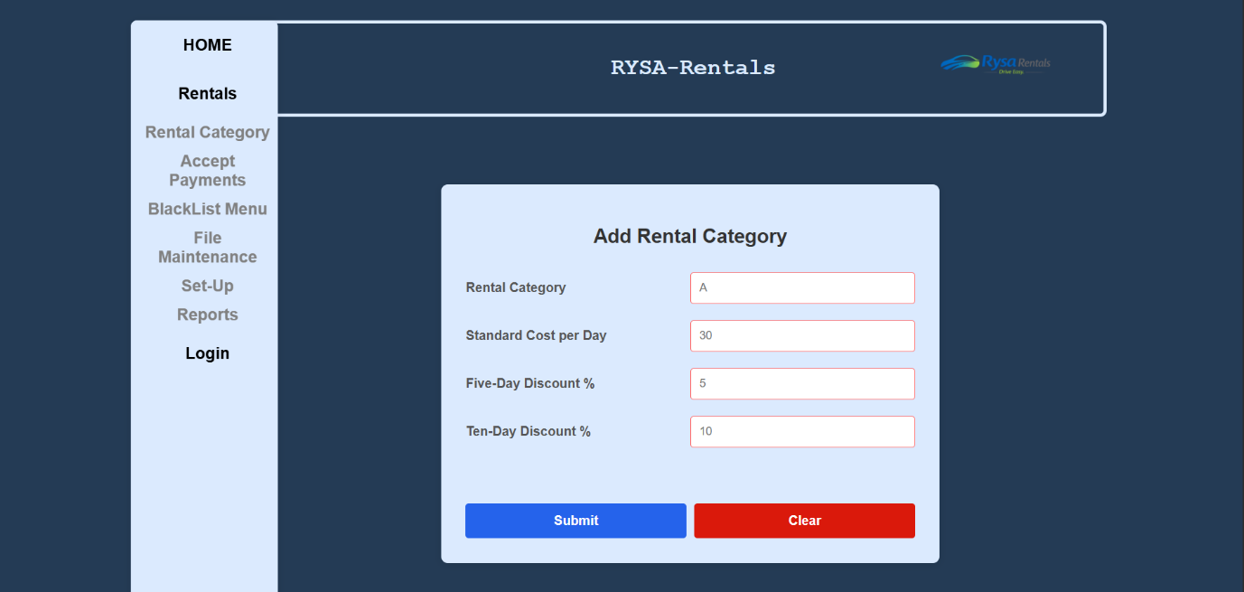

ADD Screen Code
<!--
Student name: Kobi Bourne
Student Number: C00249676
Date: 12/02/2026
Task: Rental Category Add Screen
-->
<!DOCTYPE html> <!--tells browser its a html doctype -->
<html> <!--start -->
<head> <!--start of head -->
<title>Rental Managment </title> <!--what is in tab -->
<link rel="stylesheet" href="../../GroupWork/global.css">
<!--link to css file in GroupWork folder-->
<meta name="viewport" content="width=device-width, initial-scale=1.0">
<!--makes webpage adapt to device width -->
</head> <!--end of head -->
<body> <!--start of body -->
<!--links header and nav files -->
<div class="main"> <!--main container for page content -->
<?php include('../../GroupWork/header.php') ?>
<div class="nav"> <!--div for nav styling-->
<?php include('../../GroupWork/nav.php')?> <!--link to nav -->
</div>
<form action="Rentals.php" method="POST" onsubmit="return ValidateForm() && ConfirmForm();"> <!-- form sends data Rentals.php, uses post -->
<!-- when submit clicked, validateForm() checks inputs and confrimform() asks for confirm click before submitting -->
<h2> Add Rental Category </h2> <!-- heading -->
<!--inputs all in divs , inside form -->
<div class="form-group">
<label for="RentalCategory">Rental Category</label><br>
<input type="text" name="RentalCategory" id="RentalCategory" placeholder="A" autocomplete="off" pattern="[A-Z]" title="Enter a single captial letter" required/>
<!--sets input to text, pattern letters, inputbox for RentalCategory, only one capital letter allowed, has to be filled -->
</div>
<div class="form-group"> <!-- div using class form-group -->
<!-- input data for db -->
<label for="StndDayCost">Standard Cost per Day</label><br>
<input type="number" name="StndDayCost" id="StndDayCost" placeholder="30" autocomplete="off" title="Enter an integar between 1 - 1000" min="1" max="1000" required/>
<!--sets type of input to text, inputbox for StndDayCost, more than one less than 1001, has to be filled -->
</div>
<div class="form-group">
<label for="FiveDayDiscount"> Five-Day Discount %</label><br>
<input type="number" name="FiveDayDiscount" id="FiveDayDiscount" placeholder="5" title="Enter an integar between 0 - 50" min="0" max="50" required/>
<!--sets type of input to number, inputbox for FiveDayDiscount, min =0 , max =50, has to be filled -->
</div>
<div class="form-group">
<label for="TenDayDiscount"> Ten-Day Discount %</label><br>
<input type="number" name="TenDayDiscount" id="TenDayDiscount" placeholder="10" title="Enter an integar between 0 - 70" min="0" max="70" required/>
<!--sets type of input to number, inputbox for TenDayDiscount, min =0, max =70, has to be filled -->
</div>
<br>
<!--submit and clear buttons-->
<div class="button-group">
<button type="submit">Submit</button>
<button type="reset">Clear</button>
</div>
</form> <!-- end of form -->
<script src="Valid.js"></script> <!--link to js file-->
</div> <!-- end -->
</body> <!-- end of body -->
</html> <!-- end of html -->

Rentals.php
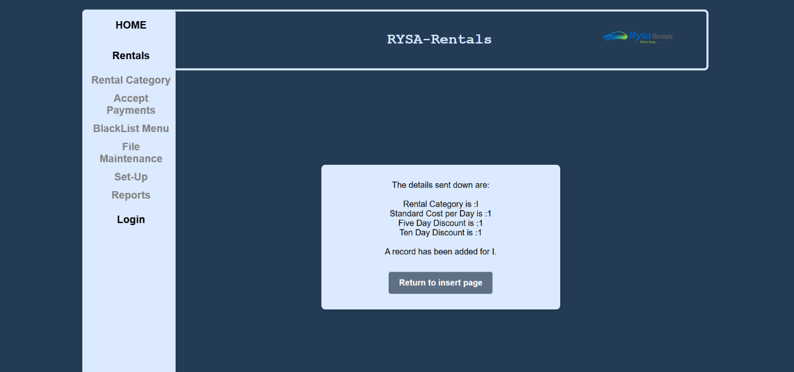
<!--
Student name: Kobi Bourne
Student Number: C00249676
Date: 12/02/2026
Task: PHP for add screen
-->
<!DOCTYPE html> <!--tells browser its a html doctype -->
<html> <!--start of html -->
<head> <!--start of head -->
<meta charset="UTF-8">
<title>Rental Management</title>
<!-- Link to CSS file -->
<link rel="stylesheet" href="../../GroupWork/global.css">
</head> <!--end of head -->
<body> <!--start of body-->
<!--links header and nav files -->
<?php include('../../GroupWork/header.php') ?>
<div class="main"> <!--main container -->
<div class="nav">
<?php include('../../GroupWork/nav.php') ?>
</div>
<form class="php-form"> <!-- form start, php-form for layout-->
<?php
include '../../GroupWork/db.inc.php'; /*link to db con class in Group folder*/
$con = mysqli_connect($hostname, $username, $password, $dbname);
/*connect to database*/
if (!$con) /*if connection failed*/
{
die("Failed to connect to MySQL: " . mysqli_connect_error());
/*print error*/
}

/*print details submitted*/
echo '<form class="php-form">';
echo "The details sent down are: <br><br>";
echo "Rental Category is :" . $_POST['RentalCategory'] . "<br>";
echo "Standard Cost per Day is :" . $_POST['StndDayCost'] . "<br>";
echo "Five Day Discount is :" . $_POST['FiveDayDiscount'] . "<br>";
echo "Ten Day Discount is :" . $_POST['TenDayDiscount'] . "<br>";
/*insert new rentalCat into DB*/
$sql = "Insert into RentalCat (RentalCategory, StndDayCost, FiveDayDiscount, TenDayDiscount)
VALUES ('$_POST[RentalCategory]','$_POST[StndDayCost]','$_POST[FiveDayDiscount]','$_POST[TenDayDiscount]')";

if (!mysqli_query($con,$sql)) /*if error with query*/
{
die ("An Error in the SQL Query: " . mysqli_error($con) ); /*print error*/
}
/*if works print*/
echo "<br>A record has been added for " . $_POST['RentalCategory'] . "." . "<br>";
mysqli_close($con); /*close con*/
?>
<!-- return button -->
<div class="button-group">
<input type="button" class="return" value="Return to insert page"
onclick="window.location.href='AddRentalCat1.html.php'"> <!--redirect back to AddRental1.html.php -->
</div>
</form> <!--end of form -->
</div> <!--end of main -->
</body> <!--end of body -->
</html> <!--end of html -->

Valid.js
/*
Student name: Kobi Bourne
Student Number: C00249676
Date: 12/02/2026
Task: JS for add screen
*/
function ConfirmForm ()
{
//confirm box before form submits
confirms = confirm("Confirm record insertion?"); // print, confirm record made
if(confirms === false) //if cancel clicked
{
return false; //dont submit form
}

return true; //submits form
}

function ValidateForm()
{
//function vars , value from inputs
let RentalCategory = document.getElementById("RentalCategory");
let StndDayCost = document.getElementById("StndDayCost");
let FiveDayDiscount = document.getElementById("FiveDayDiscount");
let TenDayDiscount = document.getElementById("TenDayDiscount");

//pattern check for RentalCategory
if (!RentalCategory.value.match(/^[A-Z]$/)) //single uppercase letter
{
alert("Rental Category must be a single uppercase letter (A-Z)."); //alert box, prints string
RentalCategory.focus(); //puts cursor here
return false; //stop submission
}

// StndDayCost must be positive num
if (StndDayCost.value <= 0 || StndDayCost.value > 1000)
{
alert("Standard Cost per Day must be a number greater than 0 and less than 1001.");
StndDayCost.focus(); //puts cursor here
return false;
}

// FiveDayDiscount between 0-50
if (FiveDayDiscount.value < 0 || FiveDayDiscount.value > 50)
{
alert("Five-Day Discount must be between 0 and 50.");
FiveDayDiscount.focus(); //puts cursor here
return false;
}

//if TenDayDiscount is greater then 0 or less then 70
if (TenDayDiscount.value < 0 || TenDayDiscount.value > 70)
{
alert("Ten-Day Discount must be between 0 and 70.");
TenDayDiscount.focus(); //puts cursor here
return false;
}

//If all checks pass, return true to submit form
return true;
}

Project
AI Disclosure Document
Student Name: Kobi Bourne
Student ID: C00249676
Course Name Software Development
Project Title Car Rental 1
Code Unit Add Screen
Date Submitted: 25/03/2026

AI Assistance Disclosure
AI Technologies Used
Indicate whether you used AI technologies in completing this task:
☑No, I did not use any AI tools.
☐ Yes, I used AI tools. (List all AI technologies used, e.g., ChatGPT, GitHub Copilot, Codeium, Google Bard, etc.)

Prompts Used
If AI was used, describe the prompts or queries you provided to the AI tools:

Nature of Assistance
Indicate how AI technologies contributed to your work by selecting and elaborating on the relevant categories below:

AMEND/VIEW SCREEN
This screen provides the user with the ability to amend or view a Rental Category. This screen has the appropriate validation. All fields except Rental Cat ID can be changed via unlocking them using the Amend/View button. There is also a php page that confirms the Rental Categories record change.
AmendView.html.php
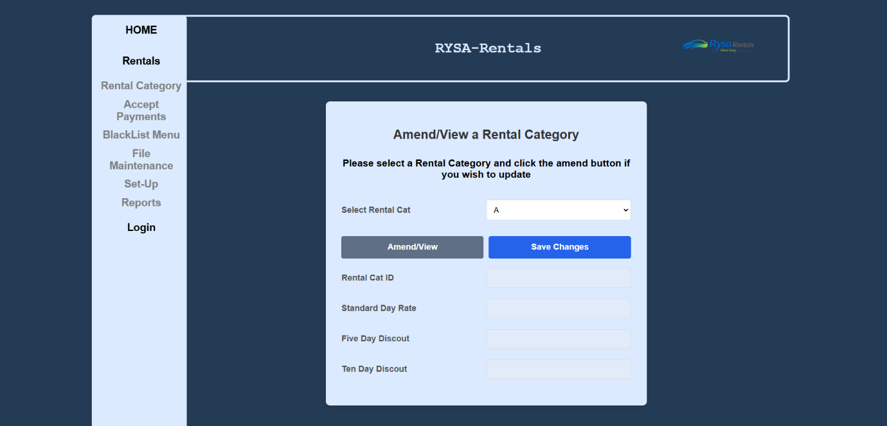

Amend View Code
<!--
Student name: Kobi Bourne
Student Number: C00249676
Date: 12/02/2026
Task: Rental Category Amend/View Screen
-->
<!DOCTYPE html> <!--tells browser its a html doctype -->
<html> <!--start of html -->
<head> <!--start of head -->
<title>Rental Managment </title> <!--what is in tab -->
<link rel="stylesheet" href="../../GroupWork/global.css"> <!--link to css file-->
<meta name="viewport" content="width=device-width, initial-scale=1.0"> <!--makes page responsive -->
</head> <!--end of head -->
<body> <!--start of body -->
<!--links header and nav files -->
<?php include('../../GroupWork/header.php') ?>
<div class="main"> <!--main container for page content -->
<div class="nav"> <!--div for nav styling-->
<?php include('../../GroupWork/nav.php') ?>
</div>
<!-- Form to submit amended details -->
<!-- form sends data AmendView.php, uses post -->
<form name="myForm" action="AmendView.php" onsubmit="return ValidateForm() && confirmCheck()" method="post">
<!--validateForm() checks inputs and confrimcheck() asks for confirm click before submitting -->

<div class = "form" >
<!--headings-->
<h2> Amend/View a Rental Category </h2>
<h3> Please select a Rental Category and click the amend button if you wish to update </h3>
<br>
<!--inclde listbox-->
<div class = "form-group">
<label for="listbox">Select Rental Cat</label>
<?php include 'listbox.php'; ?>
</div>
<div class ="button-group"> <!-- Button to toggle amend/view mode and submit button -->
<button class="amendbutton" type = "button" id = "amendViewbutton" onclick = "toggleLock()"> Amend/View</button>
<button type = "submit" value = "Save Changes" >Save Changes</button>
</div>
<br>

<!-- rental fields -->
<div class="form-group">
<label for="amendRentalID"> Rental Cat ID </label>
<input type = "text" name = "amendRentalID" id = "amendRentalID" disabled>
</div>
<div class="form-group">
<label for="amendStndDayCost">Standard Day Rate</label>
<input type = "number" name = "amendStndDayCost" id = "amendStndDayCost" title="Enter an integar between 1 - 1000" min="1" max="1000" required disabled>
</div>

<div class="form-group">
<label for="amendFiveDayDiscount"> Five Day Discout </label>
<input type = "number" name = "amendFiveDayDiscount" id = "amendFiveDayDiscount" title = "this need to be between 0 and 50" min="0" max="50" required disabled>
<!--sets type to number, inputbox for FiveDayDiscount, min =0 , max =50 , has to be filled, disabled -->
</div>

<div class="form-group">
<label for="amendTenDayDiscount">Ten Day Discout </label>
<input type = "number" name = "amendTenDayDiscount" id = "amendTenDayDiscount" title="Enter an integar between 0 - 70" min="0" max="70" required disabled>
<!--sets type to number, inputbox for TenDayDiscount, min =0 , max =70 , has to be filled, disabled -->
</div>
</div>
</form> <!-- end of form -->
<script src="Amend.js"></script> <!--link to js file-->
</div>
</body> <!-- end of body -->
</html> <!-- end of html -->

AmendView.php
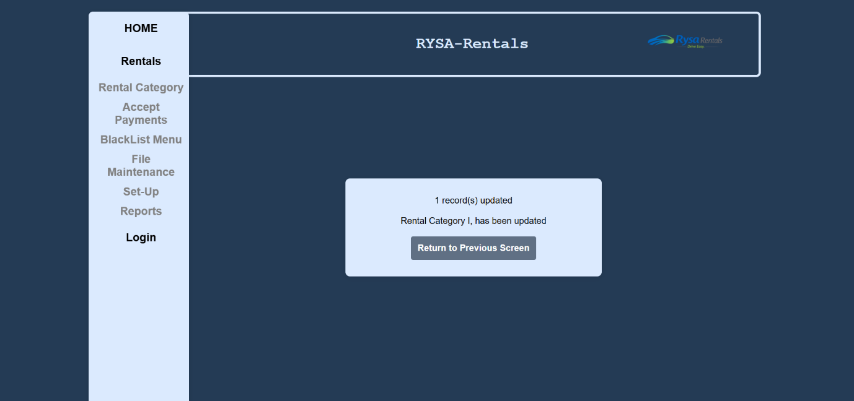
<!--
Student name: Kobi Bourne
Student Number: C00249676
Date: 12/02/2026
Task: php for Amend/View Screen
-->

<!DOCTYPE html> <!--tells browser its a html doctype -->
<html> <!--start of html -->
<head> <!--start of head -->
<link rel="stylesheet" type="text/css" href="../../GroupWork/global.css"> <!--link to css-->
<title>Rental Management</title> <!--text that shows in tab -->
</head> <!--end of head -->
<body> <!--start of body -->
<!--links header and nav files -->
<?php include('../../GroupWork/header.php') ?>
<div class="main"> <!--main container -->
<div class="nav">
<?php include('../../GroupWork/nav.php') ?>
</div>
<!-- form to submit amended vals -->
<form class="php-form" action = "AmendView.html.php" method ="post">
<?php include '../../GroupWork/db.inc.php'; //con class
date_default_timezone_set('UTC'); //set timezone
// SQL query to update rentalCat details
$sql = "UPDATE RentalCat SET StndDayCost = '$_POST[amendStndDayCost]',
FiveDayDiscount = '$_POST[amendFiveDayDiscount]',
TenDayDiscount = '$_POST[amendTenDayDiscount]' WHERE RentalCategory = '$_POST[amendRentalID]' ";

// Run the SQL query
if(! mysqli_query($con, $sql))
{
echo "Error ".mysqli_error($con);//if fail print
}
else
{
if(mysqli_affected_rows($con) !=0) //check if updated
{
// print

echo mysqli_affected_rows($con)." record(s) updated <br><br>";
echo "Rental Category ". $_POST['amendRentalID'].", " ." has been updated";

}
else
{
echo "No records were changed";//print if no changes
}

}
mysqli_close($con);//close con
?>

<!-- Button to return to previous page -->
<br><br>
<button class="amendbutton" type = "submit" >Return to Previous Screen</button>
</form>

Amend.js
/*
Student name: Kobi Bourne
Student Number: C00249676
Date: 12/02/2026
Task: JS for amend screen
*/
function populate() /*function to populate listbox*/
{
var sel = document.getElementById("listbox");/*Get the listbox element*/
var result; //var to store result
result = sel.options[sel.selectedIndex].value; // get value of selected option
var rentalDetails = result.split(','); /* Split the selected value into an array */
document.getElementById("amendRentalID").value = rentalDetails[0];
document.getElementById("amendStndDayCost").value = rentalDetails[1]; /* get elements by id and get from index pos in array */
document.getElementById("amendFiveDayDiscount").value = rentalDetails[2];
document.getElementById("amendTenDayDiscount").value = rentalDetails[3];
}
function toggleLock() /* function for locking/unlocking amend */
{
/* if amend details option is selected */
if(document.getElementById("amendViewbutton").value == "Amend Details")
{
document.getElementById("amendStndDayCost").disabled = false; //diasbled = false, we can amend
document.getElementById("amendFiveDayDiscount").disabled = false;
document.getElementById("amendTenDayDiscount").disabled = false;
document.getElementById("amendViewbutton").value = "View Details"; //changing button text
}
else
{
document.getElementById("amendStndDayCost").disabled = true;
document.getElementById("amendFiveDayDiscount").disabled = true; //diasbled = true , we can't amend
document.getElementById("amendTenDayDiscount").disabled = true;
document.getElementById("amendViewbutton").value = "Amend Details"; //changing button text back
}
}

function ValidateForm()
{
//function vars , value from inputs
let StndDayCost = document.getElementById("amendStndDayCost");
let FiveDayDiscount = document.getElementById("amendFiveDayDiscount");
let TenDayDiscount = document.getElementById("amendTenDayDiscount");
// StndDayCost must be positive num
if (StndDayCost.value <= 0 || StndDayCost.value > 1000)
{
alert("Standard Cost per Day must be a number greater than 0 and less than 1001."); //alert box, prints string
StndDayCost.focus(); //puts cursor here
return false; //stop submission
}
// FiveDayDiscount between 0-50%
if (FiveDayDiscount.value < 0 || FiveDayDiscount.value > 50)
{
alert("Five-Day Discount must be between 0 and 50.");
FiveDayDiscount.focus();
return false;
}

//if TenDayDiscount is greater then 0 or less then 70
if (TenDayDiscount.value < 0 || TenDayDiscount.value > 70)
{
alert("Ten-Day Discount must be between 0 and 70.");
TenDayDiscount.focus();
return false;
}
return true; //If all checks pass, allow submission
}

function confirmCheck() // function to confirm entered details
{
var response;
response = confirm('Are you sure you want to save these changes?'); // text that pops up on submit
if(response){
document.getElementById("amendRentalID").disabled = false;
document.getElementById("amendStndDayCost").disabled = false; //enables fields
document.getElementById("amendFiveDayDiscount").disabled = false;
document.getElementById("amendTenDayDiscount").disabled = false;
}
else
{
//if cancel, reset vals and lock
populate(); //reset vals
toggleLock(); //lock fields
return false; // stop submission
}
}

Listbox.php
<!--
Student name: Kobi Bourne
Student Number: C00249676
Date: 12/02/2026
Task: listbox php
-->
<?php
include '../../GroupWork/db.inc.php'; //include con class
date_default_timezone_set('UTC');//set timezone

$sql = "SELECT RentalCategory, StndDayCost, FiveDayDiscount, TenDayDiscount FROM RentalCat WHERE DeleteFlag = 0"; //select fields that are not "deleted"

if (!$result = mysqli_query($con, $sql)) //if query fails
{
die('Error in querying the database' . mysqli_error($con)); // print error
}

echo "<br><select name = 'listbox' id = 'listbox' onclick = 'populate()'>"; //make lsitbox , call populate when clicked

while ($row = mysqli_fetch_array($result)) //loop through rows
{
$RentalCategory = $row['RentalCategory']; //store vals from db
$StndDayCost = $row['StndDayCost'];
$FiveDayDiscount = $row['FiveDayDiscount'];
$TenDayDiscount = $row['TenDayDiscount'];
$allText = "$RentalCategory,$StndDayCost,$FiveDayDiscount,$TenDayDiscount";
//combine into one string
echo "<option value = '$allText'>$RentalCategory</option>";
// create option in the listbox
}

echo "</select>"; //close list
mysqli_close($con); //close con

?>

Project
AI Disclosure Document
Student Name: Kobi Bourne
Student ID: C00249676
Course Name Software Development
Project Title Car Rental 1
Code Unit Amend Screen
Date Submitted: 25/03/2026
AI Assistance Disclosure
AI Technologies Used
Indicate whether you used AI technologies in completing this task:
☑No, I did not use any AI tools.
☐ Yes, I used AI tools. (List all AI technologies used, e.g., ChatGPT, GitHub Copilot, Codeium, Google Bard, etc.)

Prompts Used
If AI was used, describe the prompts or queries you provided to the AI tools:

Nature of Assistance
Indicate how AI technologies contributed to your work by selecting and elaborating on the relevant categories below:

DELETE SCREEN
This screen provides the user with the ability to delete a Rental Category. This screen has the appropriate validation. Once a category is deleted, it’s delete flag is set to 1, so it is still stored in the database. We get some text on the screen after we confirm deleting the category telling the user what category was deleted
delete.html.php
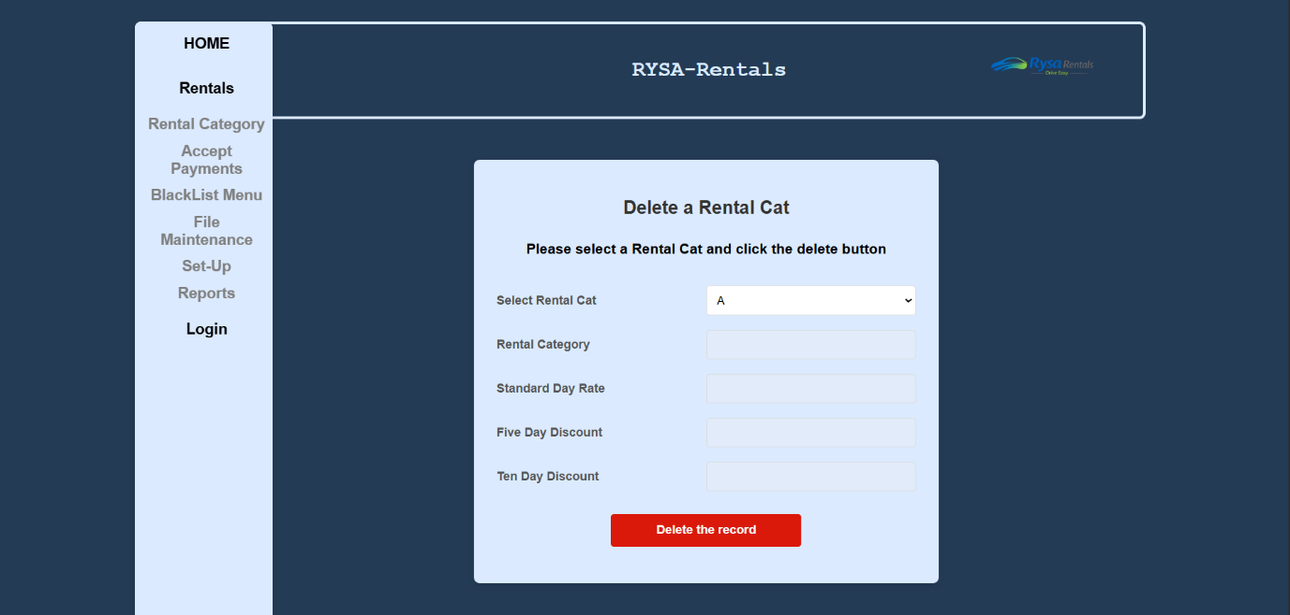

Delete code
<!--
Student name: Kobi Bourne
Student Number: C00249676
Date: 12/02/2026
Task: Rental Category Delete Screen
-->
<!DOCTYPE html> <!--tells browser its a html doctype -->
<?php session_start(); //start session
?>
<html> <!--start of html -->
<head> <!--start of head -->
<title>Rental Managment </title> <!--what is in tab -->
<link rel="stylesheet" href="../../GroupWork/global.css"> <!--link to css file-->
<meta name="viewport" content="width=device-width, initial-scale=1.0"> <!--makes page responsive -->
</head> <!--end of head -->
<body> <!--start of body -->
<!--links header and nav and con files -->
<?php include '../../GroupWork/db.inc.php'; ?> <!--check this file pos-->
<?php include('../../GroupWork/header.php') ?>
<div class="main">
<div class="nav">
<?php include('../../GroupWork/nav.php') ?> </div>
<script>
function populate() //function to fill table
{
var sel = document.getElementById("listbox"); //get listbox
var result; // var to save result
result = sel.options[sel.selectedIndex].value;
// get value of selected option
var rentalDetails = result.split(','); // split string into array
//document.getElementById("display").innerHTML = "The details of the selected person are: " + result
document.getElementById("deleteRentalCategory").value = rentalDetails[0];
document.getElementById("deleteStndDayCost").value = rentalDetails[1];
document.getElementById("deleteFiveDayDiscount").value = rentalDetails[2];
document.getElementById("deleteTenDayDiscount").value = rentalDetails[3];
}

function confirmCheck() //function to confirm delete
{
var response; // var to save response
response = confirm('Are you sure you want to delete this rental cat?');
if (response) //if clicked ok , send to php
{
// enable fields so php can read vals
document.getElementById("deleteRentalCategory").disabled = false;
document.getElementById("deleteStndDayCost").disabled = false;
document.getElementById("deleteFiveDayDiscount").disabled = false;
document.getElementById("deleteTenDayDiscount").disabled = false;
return true; //allow submission
}
else //if cancel
{
populate(); // reset fields to current selection
return false; // stop form submission
}
}
</script>

<!--<p id="display"></p>-->
<!-- Form to delete rental category -->
<form name="deleteForm" action="delete.php" onsubmit="return confirmCheck()" method="post">

<div class="form"> <!--class for form -->

<h2>Delete a Rental Cat</h2> <!--headings-->

<h3>Please select a Rental Cat and click the delete button</h3>
<br>
<div class="form-group">
<label for="listbox">Select Rental Cat</label>
<?php include 'listbox.php'; ?> <!--link listbox-->
</div>

<!-- Input fields for details -->
<div class="form-group">
<label for="deleteRentalCategory">Rental Category </label>
<input type = "text" name = "deleteRentalCategory" id = "deleteRentalCategory" disabled>
</div>

<div class="form-group">
<label for="deleteStndDayCost">Standard Day Rate </label>
<input type = "text" name = "deleteStndDayCost" id = "deleteStndDayCost" disabled >
</div>

<div class="form-group">
<label for="deleteFiveDayDiscount">Five Day Discount</label>
<input type="text" name = "deleteFiveDayDiscount" id = "deleteFiveDayDiscount" disabled>
</div>

<div class="form-group">
<label for="deleteTenDayDiscount">Ten Day Discount</label>
<input type = "text" name = "deleteTenDayDiscount" id = "deleteTenDayDiscount" disabled>
</div>

<div class="button-group"> <!--delete button-->
<button type = "submit" class="deletebutton">Delete the record</button>
</div>
<br>
</div>
<?php
if (ISSET($_SESSION["RentalCategory"])) //if deleted , print
{
echo "<h3> Record deleted for ". $_SESSION["RentalCategory"] . "</h3>";
}
session_destroy(); //delete session data
?>
</form> <!--end form-->
</div> <!--end main-->
</body> <!--end body-->
</html> <!--end html-->

delete.php
<!--
Student name: Kobi Bourne
Student Number: C00249676
Date: 12/02/2026
Task: php for delete Screen
-->

<?php
session_start(); //start session
?>
<br><br>
<?php include '../../GroupWork/db.inc.php'; //include con class

$sql = "UPDATE RentalCat SET DeleteFlag = 1 WHERE RentalCategory = '$_POST[deleteRentalCategory]'"; //sql query - delete from person

if (! mysqli_query($con,$sql)) // if quesry fails
{
echo "Error ".mysqli_error($con); //print
}

//set session vars
$_SESSION["RentalCategory"] = $_POST['deleteRentalCategory'];
$_SESSION["StndDayCost"] = $_POST['deleteStndDayCost'];
$_SESSION["FiveDayDiscount"] = $_POST['deleteFiveDayDiscount'];
$_SESSION["TenDayDiscount"] = $_POST['deleteTenDayDiscount'];

mysqli_close($con); // close con
//header('Location: delete.html.php') ;
//exit();
?>
<script>
window.location = "delete.html.php"; //back to delete page
</script>

Listbox.php
<!--
Student name: Kobi Bourne
Student Number: C00249676
Date: 12/02/2026
Task: listbox php
-->
<?php
include '../../GroupWork/db.inc.php'; //include con class
date_default_timezone_set('UTC');//set timezone

$sql = "SELECT RentalCategory, StndDayCost, FiveDayDiscount, TenDayDiscount FROM RentalCat WHERE DeleteFlag = 0"; //select fields that are not "deleted"

if (!$result = mysqli_query($con, $sql)) //if query fails
{
die('Error in querying the database' . mysqli_error($con)); // print error
}

echo "<br><select name = 'listbox' id = 'listbox' onclick = 'populate()'>"; //make lsitbox , call populate when clicked

while ($row = mysqli_fetch_array($result)) //loop through rows
{
$RentalCategory = $row['RentalCategory']; //store vals from db
$StndDayCost = $row['StndDayCost'];
$FiveDayDiscount = $row['FiveDayDiscount'];
$TenDayDiscount = $row['TenDayDiscount'];
$allText = "$RentalCategory,$StndDayCost,$FiveDayDiscount,$TenDayDiscount"; //combine into one string
echo "<option value = '$allText'>$RentalCategory</option>"; // create option in the listbox
}

echo "</select>"; //close list
mysqli_close($con); //close con

?>

Project
AI Disclosure Document
Student Name: Kobi Bourne
Student ID: C00249676
Course Name Software Development
Project Title Car Rental 1
Code Unit Delete Screen
Date Submitted: 25/03/2026
AI Assistance Disclosure
AI Technologies Used
Indicate whether you used AI technologies in completing this task:
☑No, I did not use any AI tools.
☐ Yes, I used AI tools. (List all AI technologies used, e.g., ChatGPT, GitHub Copilot, Codeium, Google Bard, etc.)

Prompts Used
If AI was used, describe the prompts or queries you provided to the AI tools:

Nature of Assistance
Indicate how AI technologies contributed to your work by selecting and elaborating on the relevant categories below:

CAR REPORT SCREEN
This screen provides the user with the ability to view the Car Report. It displays all the cars currently active(delete flag set to 0) in the fleet, and their details. There are three order options, - Alphabetical Order of Model Name (Default) - Most Popular Cars(times rented in descending order) - Oldest car (date added in ascending order )
CarReport.html.php
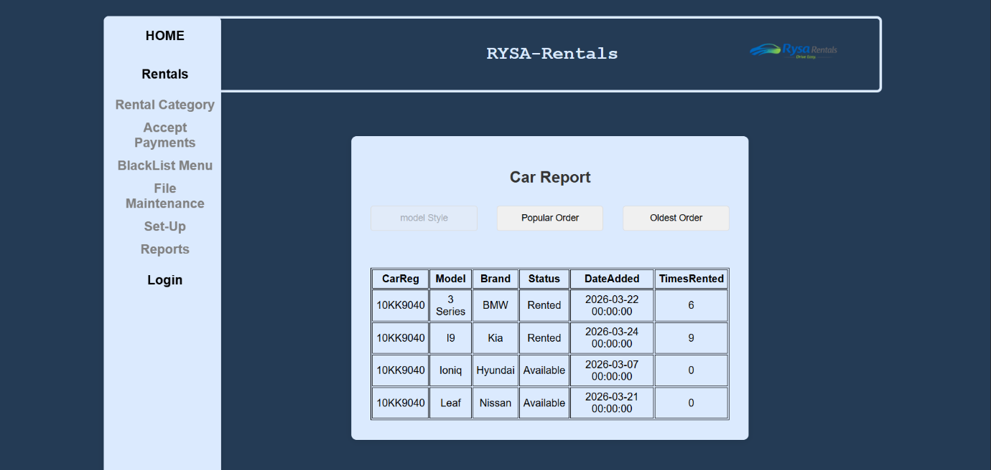

Car Report code
<!--
Student name: Kobi Bourne
Student Number: C00249676
Date: 12/02/2026
Task: Car Report Screen
-->
<!DOCTYPE html> <!--tells browser its a html doctype -->
<html> <!--start of html -->
<head> <!--start of head -->
<title>Car Reports</title> <!--what appears in tab -->
<?php include '../../GroupWork/db.inc.php';?> <!--con class link -->
<link rel="stylesheet" type="text/css" href="../../GroupWork/global.css"> <!-- Link to CSS -->
</head> <!--end of head -->
<body> <!--start of body -->
<!--links header and nav files -->
<?php include('../../GroupWork/header.php') ?>
<div class="main"> <!--main container for page content -->
<div class="nav"> <!--div for nav styling-->
<?php include('../../GroupWork/nav.php') ?>
</div>
<!-- Form to show amended details -->
<form action = "CarReport.html.php" method = "post" name = "CarReport">
<input type = "hidden" name = "choice">
<!--form submits to same page to refresh report -->
<h2>Car Report</h2> <!--heading-->

<div class="form-group"> <!--buttons to change order of report -->
<input type = 'button' id = "modelButton" value = 'model Style'
onclick = 'modelOrder()' title = 'Car Reports ordered by model' disabled>
<input type = 'button' id = "popButton" value = 'Popular Order'
onclick = 'popOrder()' title = 'Car Reports ordered by popularity'>
<input type = 'button' id = "oldButton" value = 'Oldest Order'
onclick = 'oldOrder()' title = 'Car Reports ordered from oldest'>
</div>
<br><br>
<script>
//order by model
function modelOrder()
{
document.CarReport.choice.value = "model";
document.CarReport.submit();
}
//order by times rented
function popOrder()
{
document.CarReport.choice.value = "pop"; //set hidden value
document.CarReport.submit(); //submit form
}
//order by order date
function oldOrder()
{
document.CarReport.choice.value = "old";
document.CarReport.submit();
}
</script>

<?php

$choice = "model"; // default model
if (ISSET($_POST['choice']))
{
$choice = $_POST['choice'];
}
if ($choice == "model") //if model selected
{
?>
<script>
//disable selected button, enable others
document.getElementById("modelButton").disabled = true;
document.getElementById("popButton").disabled = false;
document.getElementById("oldButton").disabled = false;

</script>

<?php
//model sql query, joins tables and order is Ascending
$sql = "SELECT
Car.carReg,
CarType.Model,
CarType.Manufacturer,
Car.currentStatus,
Car.dateAddedToFleet,
Car.cumulativeRentals
FROM Car
JOIN CarType ON Car.carType = CarType.CarTypeID
WHERE Car.DeletedFlag = 0
ORDER BY CarType.Model ASC";

Report($con,$sql); //call report function
}
if ($choice == "pop") //if popularity selected
{
?>
<script>
document.getElementById("modelButton").disabled = false;
document.getElementById("popButton").disabled = true;
document.getElementById("oldButton").disabled = false;
</script>
<?php
$sql = "SELECT
Car.carReg,
CarType.Model,
CarType.Manufacturer,
Car.currentStatus,
Car.dateAddedToFleet,
Car.cumulativeRentals
FROM Car
JOIN CarType ON Car.carType = CarType.CarTypeID
WHERE Car.DeletedFlag = 0
ORDER BY Car.cumulativeRentals DESC";

Report($con,$sql);

}
if($choice == "old") //if oldest order selected
{
?>
<script>
document.getElementById("modelButton").disabled = false;
document.getElementById("popButton").disabled = false;
document.getElementById("oldButton").disabled = true;
</script>
<!---->
<?php
$sql = "SELECT
Car.carReg,
CarType.Model,
CarType.Manufacturer,
Car.currentStatus,
Car.dateAddedToFleet,
Car.cumulativeRentals
FROM Car
JOIN CarType ON Car.carType = CarType.CarTypeID
WHERE Car.DeletedFlag = 0
ORDER BY Car.dateAddedToFleet ASC";

Report($con,$sql);
};

function Report($con,$sql) //display table
{
$result = mysqli_query($con,$sql); //run query, result = query

//start table
echo "<div style='text-align:center;'><table>
<tr><th>CarReg</th><th>Model</th><th>Brand</th><th>Status</th><th>DateAdded</th><th>TimesRented</th></tr>";

while ($row=mysqli_fetch_array($result)) //loop through results

{
//print rows
echo "<tr>
<td>". $row['carReg']." </td>
<td>".$row['Model']."</td>
<td>".$row['Manufacturer']."</td>
<td>".$row['currentStatus']."</td>
<td>". $row['dateAddedToFleet']."</td>
<td>". $row['cumulativeRentals']."</td>

</tr>";
}
echo "</table></div>"; //end of table
}

mysqli_close($con); //con close
?>

<script src="amend.js"></script> <!--link to js file-->
</form> <!-- end of form -->
</div> <!--end main -->
</body> <!-- end of body -->
</html> <!-- end of html -->

Project
AI Disclosure Document
Student Name: Kobi Bourne
Student ID: C00249676
Course Name Software Development
Project Title Car Rental 1
Code Unit Car Report Screen
Date Submitted: 25/03/2026
AI Assistance Disclosure
AI Technologies Used
Indicate whether you used AI technologies in completing this task:
☑No, I did not use any AI tools.
☐ Yes, I used AI tools. (List all AI technologies used, e.g., ChatGPT, GitHub Copilot, Codeium, Google Bard, etc.)

Prompts Used
If AI was used, describe the prompts or queries you provided to the AI tools:

Nature of Assistance
Indicate how AI technologies contributed to your work by selecting and elaborating on the relevant categories below:

RYAN MULCAHY

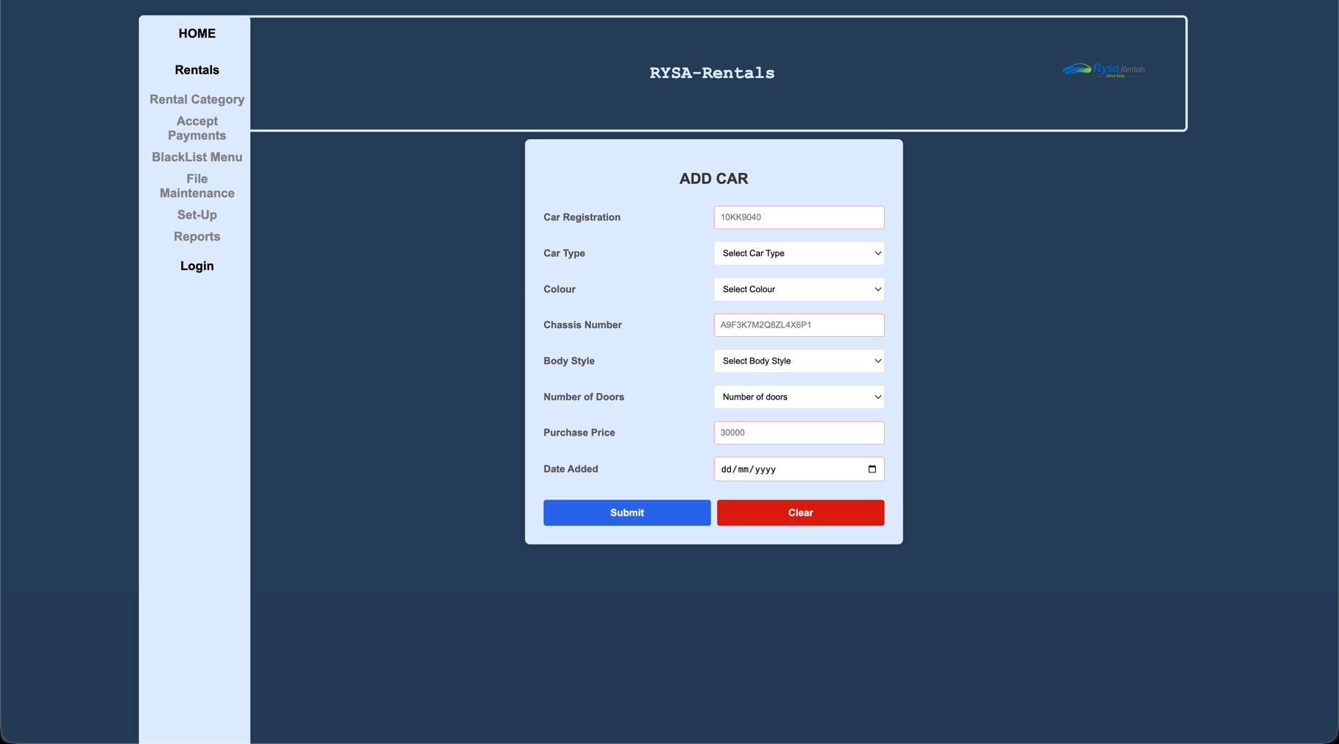
ADD SCREEN

Purpose of Add Screen
The purpose of the add screen is to allow the user to input and store new car records into the system database through a structured and validated form.
The screen provides input fields for all required car details, including registration number, car type, colour, chassis number, body style, number of doors, purchase price, and the date the vehicle was added to the fleet. Validation rules are applied to ensure that all data entered is accurate and follows the correct format, such as enforcing Irish registration formats and a 17-character chassis number.
Additional validation is implemented using JavaScript to control the date entered, ensuring that vehicles cannot be added too far in the past or future. This helps maintain realistic and reliable data within the system.
Before submission, the user is prompted with a confirmation message to prevent accidental additions. Once confirmed, the data is inserted into the database and a success message is displayed.
Overall, the add screen ensures that new vehicle records are added efficiently, consistently, and with proper validation to maintain data integrity within the system.
addcar.html.php
<!--
Student Name : Ryan Mulcahy
Student Id Number: C00315272
Date : FEB - 2026
Purpose : ADD SCREEN
-->
<!doctype html>
<html lang="en">
<head>
<meta charset="UTF-8" />
<meta name="viewport" content="width=device-width, initial-scale=1.0" />
<title>Car Add Screen</title>
<!-- Link to external CSS file -->
<link rel="stylesheet" type="text/css" href="../../GroupWork/global.css">
<link rel="stylesheet" type="text/css" href="../../GroupWork/nav.css">

</head>
<body>

<?php include('../../GroupWork/header.php') ?>

<div class="main">
<div class="nav">
<?php include('../../GroupWork/nav.php') ?>
</div>

<form id="addCar" action="addCar.php" method="post">
<h2>ADD CAR</h2>
<div class="form-group">
<label for="carReg">Car Registration</label>
<input
type="text"
name="carReg"
id="carReg"
placeholder="10KK9040"
pattern="^[0-9]{2,3}[A-Z]{2}[0-9]{4}$"
minlength="8"
maxlength="9"
oninput="this.value = this.value.toUpperCase()"
title="We only accept Irish Reg for example 202KK1930"
required
/>
</div>

<div class="form-group">
<label for="listbox">Car Type</label>
<select name="carType" id="carType" required title="Please select a Car Type from the dropdown">
<option value="" selected disabled> Select Car Type </option>
<?php include 'listbox.php'; ?>
</select>
</div>

<div class="form-group">
<label for="colour">Colour</label>
<select name="colour" id="colour" required title="Please select colour from drop down">
<option value="" selected disabled>Select Colour </option>
<option value="Red">Red</option>
<option value="Black">Black</option>
<option value="Silver">Silver</option>
<option value="White">White</option>
<option value="Green">Green</option>
<option value="Blue">Blue</option>
</select>

</div>

<div class="form-group">
<label for="chassisNumber">Chassis Number</label>
<input
type="text"
id="chassisNumber"
name="chassisNumber"
placeholder="A9F3K7M2Q8ZL4X6P1"
pattern="^[0-9A-Z]{17}$"
minlength="17"
maxlength="17"
oninput="this.value = this.value.toUpperCase()"
title="Chassis Number must be exactly 17 characters long with a similar sequence to the placeholder"
required
/>
</div>

<div class="form-group">
<label for="bodyStyle">Body Style</label>
<select name="bodyStyle" id="bodyStyle" required title="Please select body style from drop down">
<option value="" selected disabled>Select Body Style</option>
<option value="Hatchback">Hatchback</option>
<option value="Saloon">Saloon</option>
<option value="Suv">SUV</option>
<option value="Coupe">Coupe</option>
</select>
</div>

<div class="form-group">
<label for="noOfDoors">Number of Doors</label>
<select name="noOfDoors" id="noOfDoors" required title="Please indicate if your car is 4 or 5 door">
<option value=""selected disabled>Number of doors</option>
<option value="4">4</option>
<option value="5">5</option>
</select>
</div>

<div class="form-group">
<label for="purchasePrice">Purchase Price</label>
<input
type="text"
name="purchasePrice"
id="purchasePrice"
placeholder="30000"
pattern="^[0-9]{5}$"
minlength="5"
maxlength="5"
required
title="How much did the vehicle cost ? ie. 30000 or 50000"
/>
</div>

<div class="form-group">
<label for="dateAddedToFleet">Date Added</label>
<input
type="date"
name="dateAddedToFleet"
id="dateAddedToFleet"
required
title="Please add date of car when it was added to fleet"
/>
</div>

<div ></div>

<div class="button-group">
<button type="submit">Submit</button>
<button type="reset">Clear</button>
</div>
</form>
<script src="addCar.js"></script>
</body>
</html>

addCar.php
<!--
Student Name : Ryan Mulcahy
Student Id Number: C00315272
Date : FEB - 2026
Purpose : ADD SCREEN
-->

<meta charset="UTF-8">
<title>Car Management</title>
<link rel="stylesheet" type="text/css" href="../../GroupWork/global.css">

<?php include('../../GroupWork/header.php') ?>

<div class="main">
<div class="nav">
<?php include('../../GroupWork/nav.php') ?>
</div>
<form name="amendForm" action="addCar.html.php" method="post">

<?php
// Include is import and we are importing the code from the php file DB.inc.php
include '../../GroupWork/db.inc.php'; // Connect to database
// Set Time to UTC Standard
date_default_timezone_set("UTC");

echo "<form>Car details being submitted : <br><br>" .
"Car Reg is : " . htmlspecialchars($_POST['carReg']) . "<br>" .
"Colour is : " . htmlspecialchars($_POST['colour']) . "<br>" .
"Chassis Number is : " . htmlspecialchars($_POST['chassisNumber']) . "<br>" .
"Body Style is : " . htmlspecialchars($_POST['bodyStyle']) . "<br>" .
"No Of Doors is : " . htmlspecialchars($_POST['noOfDoors']) . "<br>" .
"Purchase Price is : " . htmlspecialchars($_POST['purchasePrice']) . "<br>" .
"Date Added To Fleet is : " . htmlspecialchars($_POST['dateAddedToFleet']) . "<br>";

// SQL Code stored in sql where we are inserting values into car DB
$sql = "Insert into Car (carReg,carType,colour,chassisNumber,bodyStyle,noOfDoors,purchasePrice,dateAddedToFleet) VALUES ('$_POST[carReg]','$_POST[carType]','$_POST[colour]','$_POST[chassisNumber]','$_POST[bodyStyle]','$_POST[noOfDoors]','$_POST[purchasePrice]','$_POST[dateAddedToFleet]')";

// Checks if connection is right and we are able to connect to our DB otherwise error msg is pushed
if (!mysqli_query($con,$sql))
{
die("An Error in the SQL Query:" . mysqli_errno($con));
}
// No errors prompted this messaged gets printed and connection is closed
echo "<br>Car Registration " . $_POST['carReg'] ." has been added to our database.". "<br><br>";

mysqli_close($con);

?>
<!-- Return to insert Page -->
<!-- Link to external CSS file -->

<input class="return" value="Return to previous page"
onclick="window.location.href='addCar.html.php'">
</body>
</html>

Listbox.php
<!--
Student Name : Ryan Mulcahy
Student Id Number: C00315272
Date : FEB - 2026
Purpose : ADD SCREEN
-->

<?php
include '../../GroupWork/db.inc.php'; // Connect to database
date_default_timezone_set('UTC');

// Pulling cartype info from sarah Table
$sql = "SELECT CarTypeID, Manufacturer, Model, Version, EngineSize, FuelType FROM CarType";

// Error Handling
if (!$result = mysqli_query($con, $sql))
{
die('Error in querying the database' . mysqli_error($con));
}

// Echo out all car type details in a select option with a blank selection as a start.
while ($row = mysqli_fetch_array($result))
{
$id = $row['CarTypeID'];
$fmake = $row['Manufacturer'];
$fmodel = $row['Model'];
$fversion =$row['Version'];
$engineSize = $row['EngineSize'];
$fuelType = $row['FuelType'];

echo "<option value='$id'>
$fmake $fmodel $fversion $engineSize $fuelType
</option>";
}
// close the connection
mysqli_close($con);
?>

addCar.js
/*
Student Name : Ryan Mulcahy
Student Id Number: C00315272
Date : FEB - 2026
Purpose : ADD SCREEN
*/

"use strict";

// Make sure the DOM is ready before we try to access the form/inputs
document.addEventListener("DOMContentLoaded", function () {
const form = document.querySelector("#addCar"); // <-- # for id
const dateInput = document.getElementById("dateAddedToFleet");

// --- Date Validation for when we can add a vehicle into our DB
function dateValidate() {
dateInput.setCustomValidity("");

if (!dateInput.value) return true;

// Checking user date inputted via the form
const inputDate = new Date(dateInput.value);

// Today establish today date and then we use this to establish our new variable in the past and future.
// Initialise a new date object in today
const today = new Date();
// Set time to 0
today.setHours(0, 0, 0, 0);
// we are copying from our today object
const pastThreeMonths = new Date(today);
// now we can setMonth function and use get date and subtract 3 months from it.
pastThreeMonths.setMonth(today.getMonth() - 3);
// we are copying from our today object
const futureTwoMonths = new Date(today);
// now we can setMonth function and use get date and add two months.
futureTwoMonths.setMonth(today.getMonth() + 2);

// Logic and error prompts
if (inputDate > futureTwoMonths) {
dateInput.setCustomValidity(
"Can't future date a vehicle no further than two months in advance ",
);
return false;
}

if (inputDate < pastThreeMonths) {
dateInput.setCustomValidity(
"Can't backdate a vehicle into our database no further than three months in the past",
);
return false;
}
return true;
}

// validate as they type/change
dateInput.addEventListener("input", dateValidate);

// validate on submit + confirm insert
form.addEventListener("submit", function (event) {
const dateOk = dateValidate();
const htmlOk = form.checkValidity(); // required/pattern checks

if (!dateOk || !htmlOk) {
event.preventDefault();
form.reportValidity();
return;
}

// Window Pop up to confirm if we would like to add this record to our DB
const ok = window.confirm(
"We are adding a new vehicle into our database.\n\nTo continue with this addition please select ok to add",
);
if (!ok) {
event.preventDefault();
}
});
});
Project
AI Disclosure Document
Student Name: Ryan Mulcahy
Student ID: C00315272
Course Name Software Development
Project Title RYSA Rentals
Code Unit ADD SCREEN
Date Submitted: 25/03/2026
AI Assistance Disclosure
AI Technologies Used
Indicate whether you used AI technologies in completing this task:
X No, I did not use any AI tools.
☐ Yes, I used AI tools. (List all AI technologies used, e.g., ChatGPT, GitHub Copilot, Codeium, Google Bard, etc.)

Prompts Used
If AI was used, describe the prompts or queries you provided to the AI tools:

Nature of Assistance
Indicate how AI technologies contributed to your work by selecting and elaborating on the relevant categories below:
- Code Suggestions & Auto-Completion: (e.g., AI suggested code snippets, function implementations, syntax corrections, etc.)

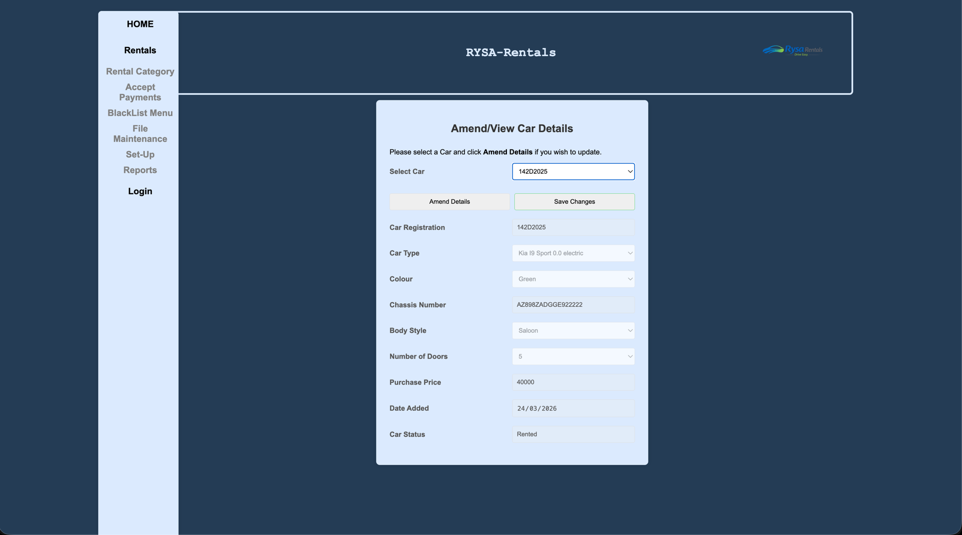
Amend/View Car Details

Purpose of Amend\View Screen
The purpose of the amend/view screen is to allow the user to view existing car records and update their details in a controlled and secure manner.
The screen enables the user to select a car from a list of active records and display its full details, including registration, car type, colour, chassis number, body style, number of doors, purchase price, date added, and current status. Initially, all fields are displayed in a read-only (disabled) state to prevent accidental changes.
When the user selects “Amend Details”, the relevant fields become editable, allowing the user to update the car information. Validation rules are applied to ensure all inputs meet the required formats, including constraints on fields such as chassis number and purchase price. Additional validation ensures that the date entered remains within an acceptable range.
Before saving any changes, the system prompts the user for confirmation to prevent unintended updates. Once confirmed, the updated details are saved to the database and a confirmation message is displayed.
Overall, the amend/view screen ensures that car records can be reviewed and updated accurately while maintaining data integrity through validation and controlled editing.
Amend | View Codebase
carAmendView.html.php
<!--
Student Name : Ryan Mulcahy
Student Id Number: C00315272
Date : FEB- 2026
Purpose : Amend/View Car
-->
<!DOCTYPE html>
<html lang="en">
<head>
<meta charset="utf-8">
<meta name="viewport" content="width=device-width, initial-scale=1">
<title>Car Management(Amend/View)</title>
<!-- Link to external CSS file -->
<link rel="stylesheet" type="text/css" href="../../GroupWork/global.css">
<link rel="stylesheet" type="text/css" href="../../GroupWork/nav.css">
</head>

<body>

<?php include('../../GroupWork/header.php') ?>

<div class="main">
<div class="nav">
<?php include('../../GroupWork/nav.php') ?>
</div>

<form id="amendForm" name="amendForm" action="carAmendView.php" method="post">

<h2>Amend/View Car Details</h2>
<p class="help-text">Please select a Car and click <b>Amend Details</b> if you wish to update.</p>

<!-- car Listbox called from carListbox -->
<div class="form-group">
<label for="listbox">Select Car</label>
<?php include 'carListBox.php'; ?>
</div>

<div class="button-group">
<input
type="button"
value="Amend Details"
id="amendViewbutton"
class="secondary"
onclick="toggleLock()"
>
<input type="submit" value="Save Changes" class="primary">
</div>
<div class="form-group">

<label for="carAmendId"></label>
<input
type="hidden"
name="carAmendId"
id="carAmendId"
value="<?php echo $carID; ?>"
>
</div>
<div class="form-group">
<label for="carReg">Car Registration</label>
<input
type="text"
name="carReg"
id="carReg"
placeholder="10KK9040"
disabled
/>
</div>

<div class="form-group">
<label for="listbox">Car Type</label>
<select name="amendCarType" id="amendCarType" required disabled title="Please select a Car Type from the dropdown">
<option value="" selected disabled>Select Car Type </option>
<?php include '../Add/listbox.php'; ?>
</select>
</div>

<div class="form-group">
<label for="AmendColour">Colour</label>
<select name="AmendColour" id="AmendColour" required disabled title="Please select AmendColour from drop down">
<option value="" selected disabled>Select Colour </option>
<option value="Red">Red</option>
<option value="Black">Black</option>
<option value="Silver">Silver</option>
<option value="White">White</option>
<option value="Green">Green</option>
<option value="Blue">Blue</option>
</select>

</div>

<div class="form-group">
<label for="amendChassisNumber">Chassis Number</label>
<input
type="text"
id="amendChassisNumber"
name="amendChassisNumber"
placeholder="A9F3K7M2Q8ZL4X6P1"
pattern="^[0-9A-Z]{17}$"
minlength="17"
maxlength="17"
oninput="this.value = this.value.toUpperCase()"
title="Chassis Number must be exactly 17 characters long with a similar sequence to the placeholder"
required
disabled
/>
</div>

<div class="form-group">
<label for="amendBodyStyle">Body Style</label>
<select name="amendBodyStyle" id="amendBodyStyle" required disabled title="Please select body style from drop down">
<option value=""selected disabled>Choose Body Style</option>
<option value="Hatchback">Hatchback</option>
<option value="Saloon">Saloon</option>
<option value="Suv">SUV</option>
<option value="Coupe">Coupe</option>
</select>
</div>

<div class="form-group">
<label for="amendNoOfDoors">Number of Doors</label>
<select name="amendNoOfDoors" id="amendNoOfDoors" required disabled title="Please indicate if your car is 4 or 5 door">
<option value=""selected disabled> Doors </option>
<option value="4">4</option>
<option value="5">5</option>
</select>
</div>

<div class="form-group">
<label for="amendPurchasePrice">Purchase Price</label>
<input
type="text"
name="amendPurchasePrice"
id="amendPurchasePrice"
placeholder="30000"
pattern="^[0-9]{5}$"
minlength="5"
maxlength="5"
required
disabled
title="How much did the vehicle cost ? ie. 30000 or 50000"
/>
</div>

<div class="form-group">
<label for="amendDateAddedtoFleet">Date Added</label>
<input
type="date"
name="amendDateAddedtoFleet"
id="amendDateAddedtoFleet"
required
disabled
title="Please add date of car when it was added to fleet"
/>
</div>

<div class="form-group">
<label for="currentStatus">Car Status</label>
<input
type="text"
name="currentStatus"
id="currentStatus"
value="<?php echo $currentStatus; ?>"
disabled
/>
</div>

<div ></div>

</form>
<script src="amendCar.js"></script>
</body>
</html>
carAmendView.php
<!--
Student Name : Ryan Mulcahy
Student Id Number: C00315272
Date : FEB - 2026
Purpose : Amend View Screen
-->

<meta charset="UTF-8">
<title>Car Management(Amend/View)</title>
<!-- Link to external CSS file -->
<link rel="stylesheet" type="text/css" href="../../GroupWork/global.css">

<?php include('../../GroupWork/header.php') ?>

<div class="main">
<div class="nav">
<?php include('../../GroupWork/nav.php') ?>
</div>
<!-- Form to redirect and display our Amend/View Info -->
<form name="amendForm" action="carAmendView.html.php" method="post">

<?php
include '../../GroupWork/db.inc.php'; // Connect to database

date_default_timezone_set('UTC');

// Updated SQL where we are updating our car DB with the amended details sent over via the form
$sql = "UPDATE Car
SET
carType = '$_POST[amendCarType]',
colour = '$_POST[AmendColour]',
chassisNumber = '$_POST[amendChassisNumber]',
bodyStyle = '$_POST[amendBodyStyle]',
noOfDoors = '$_POST[amendNoOfDoors]',
purchasePrice = '$_POST[amendPurchasePrice]',
dateAddedToFleet = '$_POST[amendDateAddedtoFleet]'
WHERE
carID = '$_POST[carAmendId]' ";

// Error Handling
if (!mysqli_query($con, $sql))
{
echo "Error " . mysqli_error($con);
}
else
{
if (mysqli_affected_rows($con) != 0)
{
echo "The follwing car record has been amended<br>";
// Post info out of the Car DB which we updated
echo
"Car Reg: " . $_POST['carReg'] . "<br>"
. "Car Type: " . $_POST['amendCarType'] . "<br>"
. "Colour: " . $_POST['AmendColour'] . "<br>"
. "Chassis Number: " . $_POST['amendChassisNumber'] . "<br>"
. "Body Style: " . $_POST['amendBodyStyle'] . "<br>"
. "No. of Doors: " . $_POST['amendNoOfDoors'] . "<br>"
. "Purchase Price: " . $_POST['amendPurchasePrice'] . "<br>"
. "Date Added To Fleet: " . $_POST['amendDateAddedtoFleet'] . "<br>"
. "has been updated.";
}
else
{
echo "No records were changed";
}
}

// Close the database connection
mysqli_close($con);

?>

<div class="form-group">
<input type = "submit" class="return" value = "Return to Amend screen"
onclick="window.location.href='carAmendView.html.php'">
</div>
</form>

carListBox.php
<!--
Student Name : Ryan Mulcahy
Student Id Number: C00315272
Date : FEB - 2026
Purpose : Amend View Screen
-->

<?php
include '../../GroupWork/db.inc.php'; // Connect to database
date_default_timezone_set('UTC');
// SQL Code being used to pull from our Car DB,
$sql = "SELECT carID, carReg, carType, colour, chassisNumber ,bodyStyle, noOfDoors ,purchasePrice, dateAddedToFleet, currentStatus FROM Car WHERE DeletedFlag = 0";

//Error Handling
if (!$result = mysqli_query($con, $sql))
{
die('Error in querying the database' . mysqli_error($con));
}

echo "<option value='CarTypeID'></option>";
echo "<select name='listbox' id='listbox' onclick='populate()'>";
while ($row = mysqli_fetch_array($result))
{
$id = $row['carID'];
$reg = $row['carReg'];
$carType = $row['carType'];
$colour = $row['colour'];
$chassisNumber = $row['chassisNumber'];
$bodyStyle = $row['bodyStyle'];
$noOfDoors = $row['noOfDoors'];
$purchasePrice = $row['purchasePrice'];
$dateAdded = date_create($row['dateAddedToFleet']);
$dateAdded = date_format($dateAdded, "Y-m-d");
$currentStatus = $row['currentStatus'];
// Storing all results into one variable and using that to display
$allText = "$id,$reg,$carType,$colour,$chassisNumber,$bodyStyle,$noOfDoors,$purchasePrice,$dateAdded,$currentStatus";
echo "<option value='$allText'>$reg</option>";
}

echo "</select>";
mysqli_close($con); ?>
amendCar.js
/*
Student Name : Ryan Mulcahy
Student Id Number: C00315272
Date : FEB- 2026
Purpose : Amend/View Car
*/

// Populate function - pulls the info from DB and populates it into our Form
function populate() {
var sel = document.getElementById("listbox");
var result = sel.options[sel.selectedIndex].value;
var carAmendDetails = result.split(",");

document.getElementById("carAmendId").value = carAmendDetails[0] || " ";
document.getElementById("carReg").value = carAmendDetails[1] || " ";
document.getElementById("amendCarType").value = carAmendDetails[2] || " ";
document.getElementById("AmendColour").value = carAmendDetails[3] || " ";
document.getElementById("amendChassisNumber").value =
carAmendDetails[4] || " ";
document.getElementById("amendBodyStyle").value = carAmendDetails[5] || " ";
document.getElementById("amendNoOfDoors").value = carAmendDetails[6] || " ";
document.getElementById("amendPurchasePrice").value =
carAmendDetails[7] || " ";
document.getElementById("amendDateAddedtoFleet").value =
carAmendDetails[8] || " ";
document.getElementById("currentStatus").value = carAmendDetails[9] || " ";
}

// ToggleLock Function - Lock and unlocks the form fields once amend details has been hit
function toggleLock() {
var btn = document.getElementById("amendViewbutton");
var editing = btn.value === "Amend Details";

document.getElementById("amendCarType").disabled = editing ? false : true;
document.getElementById("AmendColour").disabled = editing ? false : true;
document.getElementById("amendChassisNumber").disabled = editing
? false
: true;
document.getElementById("amendBodyStyle").disabled = editing ? false : true;
document.getElementById("amendNoOfDoors").disabled = editing ? false : true;
document.getElementById("amendPurchasePrice").disabled = editing
? false
: true;
document.getElementById("amendDateAddedtoFleet").disabled = editing
? false
: true;

btn.value = editing ? "View Details" : "Amend Details";
}

document.addEventListener("DOMContentLoaded", function () {
populate();
const form = document.querySelector("#amendForm"); // <-- # for id
const dateInput = document.getElementById("amendDateAddedtoFleet");

// --- Date Validation for when we can add a vehicle into our DB
function dateValidate() {
dateInput.setCustomValidity("");

if (!dateInput.value) return true;

// Checking user date inputted via the form
const inputDate = new Date(dateInput.value);

// Today establish today date and then we use this to establish our new variable in the past and future.
// Initialise a new date object in today
const today = new Date();
// Set time to 0
today.setHours(0, 0, 0, 0);
// we are copying from our today object
const pastThreeMonths = new Date(today);
// now we can setMonth function and use get date and subtract 3 months from it.
pastThreeMonths.setMonth(today.getMonth() - 3);
// we are copying from our today object
const futureTwoMonths = new Date(today);
// now we can setMonth function and use get date and add two months.
futureTwoMonths.setMonth(today.getMonth() + 2);

// Logic and error prompts
if (inputDate > futureTwoMonths) {
dateInput.setCustomValidity(
"Can't future date a vehicle no further than two months in advance ",
);
return false;
}

if (inputDate < pastThreeMonths) {
dateInput.setCustomValidity(
"Can't backdate a vehicle into our database no further than three months in the past",
);
return false;
}
return true;
}

// validate as they type/change
dateInput.addEventListener("input", dateValidate);

// validate on submit + confirm insert
form.addEventListener("submit", function (event) {
const dateOk = dateValidate();
const htmlOk = form.checkValidity(); // required/pattern checks

if (!dateOk || !htmlOk) {
event.preventDefault();
form.reportValidity();
return;
}

// Window Pop up to confirm if we would like to add this record to our DB
const ok = window.confirm(
"Please confirm that the details are correct",
);
if (!ok) {
event.preventDefault();
} else {
document.getElementById("carReg").disabled = false;
}
});
});

Project
AI Disclosure Document
Student Name: Ryan Mulcahy
Student ID: C00315272
Course Name Software Development
Project Title RYSA Rentals
Code Unit AMEND SCREEN
Date Submitted: 25/03/2026
AI Assistance Disclosure
AI Technologies Used
Indicate whether you used AI technologies in completing this task:
X No, I did not use any AI tools.
☐ Yes, I used AI tools. (List all AI technologies used, e.g., ChatGPT, GitHub Copilot, Codeium, Google Bard, etc.)

Prompts Used
If AI was used, describe the prompts or queries you provided to the AI tools:

Nature of Assistance
Indicate how AI technologies contributed to your work by selecting and elaborating on the relevant categories below:
- Code Suggestions & Auto-Completion: (e.g., AI suggested code snippets, function implementations, syntax corrections, etc.)

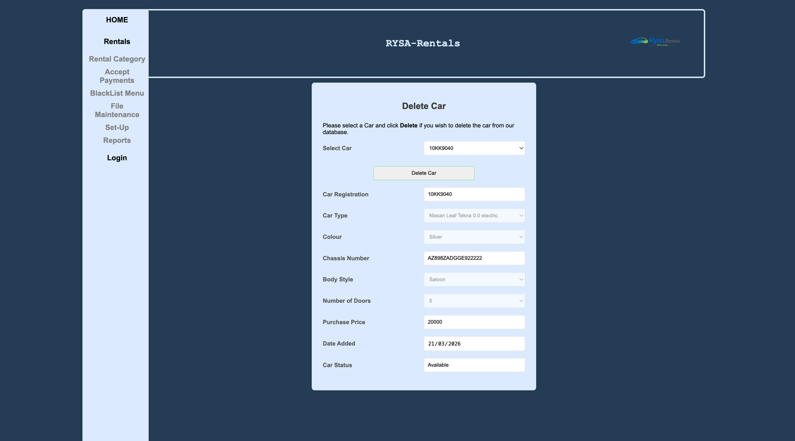
Delete Screen

Purpose of the Delete Screen
The purpose of the delete screen is to allow the user to safely remove a car record from the system database using a controlled and user-friendly interface.
The screen enables the user to select a car from a list of existing records and view its full details, such as registration, type, colour, chassis number, and status. These details are displayed in read-only fields to ensure accuracy and prevent unintended edits before deletion.
The system uses validation to ensure that only cars with a status of “Available” can be deleted, preventing the removal of vehicles that are currently in use or unavailable. A confirmation prompt is also provided to avoid accidental deletions.
When a car is deleted, the system performs a soft delete by updating the DeletedFlag in the database rather than permanently removing the record. This helps maintain data integrity and allows for potential recovery if needed.
Overall, the delete screen ensures that car records are removed securely, accurately, and with appropriate user confirmation and validation.
Delete Codebase
deleteCar.html.php
<!--
Student Name : Ryan Mulcahy
Student Id Number: C00315272
Date : Mar- 2026
Purpose : Delete Car
-->
<!DOCTYPE html>
<html lang="en">
<head>
<meta charset="utf-8">
<meta name="viewport" content="width=device-width, initial-scale=1">
<title>Car Management(Delete)</title>
<!-- Link to external CSS file -->
<link rel="stylesheet" type="text/css" href="../../GroupWork/global.css">
<link rel="stylesheet" type="text/css" href="../../GroupWork/nav.css">
</head>

<body>

<?php include('../../GroupWork/header.php') ?>

<div class="main">
<div class="nav">
<?php include('../../GroupWork/nav.php') ?>
</div>

<form id="deleteForm" name="deleteForm" action="deleteCar.php" method="post">

<h2>Delete Car</h2>
<p class="help-text">Please select a Car and click <b>Delete</b> if you wish to delete the car from our database.</p>

<!-- car Listbox called from carListbox -->
<div class="form-group">
<label for="carlistBox" id="carlistBox">Select Car</label>
<?php include 'deleteListBox.php'; ?>
</div>

<div class="button-group">

<input type="submit" value="Delete Car" class="primary">
</div>
<div class="form-group">

<label for="deleteCarID"></label>
<input
type="hidden"
name="deleteCarID"
id="deleteCarID"
value="<?php echo $carID; ?>"
>
</div>
<div class="form-group">
<label for="deleteCarReg">Car Registration</label>
<input
type="text"
name="deleteCarReg"
id="deleteCarReg"
placeholder="10KK9040"
readonly
/>
</div>

<div class="form-group">
<label for="listbox">Car Type</label>
<select name="deleteCarType" id="deleteCarType" required disabled title="Please select a Car Type from the dropdown">
<?php include '../Add/listbox.php'; ?>
</select>
</div>

<div class="form-group">
<label for="deleteColour">Colour</label>
<select name="deleteColour" id="deleteColour" required disabled>
<option value=""></option>
<option value="Red">Red</option>
<option value="Black">Black</option>
<option value="Silver">Silver</option>
<option value="White">White</option>
<option value="Green">Green</option>
<option value="Blue">Blue</option>
</select>

</div>

<div class="form-group">
<label for="deleteChassisNumber">Chassis Number</label>
<input
type="text"
id="deleteChassisNumber"
name="deleteChassisNumber"
placeholder="A9F3K7M2Q8ZL4X6P1"
pattern="^[0-9A-Z]{17}$"
minlength="17"
maxlength="17"
oninput="this.value = this.value.toUpperCase()"
readonly
/>
</div>

<div class="form-group">
<label for="deleteBodyStyle">Body Style</label>
<select name="deleteBodyStyle" id="deleteBodyStyle" required disabled>
<option value=""></option>
<option value="Hatchback">Hatchback</option>
<option value="Saloon">Saloon</option>
<option value="Suv">SUV</option>
<option value="Coupe">Coupe</option>
</select>
</div>

<div class="form-group">
<label for="deleteNumOfDoors">Number of Doors</label>
<select name="deleteNumOfDoors" id="deleteNumOfDoors" required disabled>
<option value=""></option>
<option value="4">4</option>
<option value="5">5</option>
</select>
</div>

<div class="form-group">
<label for="deletePurchasePrice">Purchase Price</label>
<input
type="text"
name="deletePurchasePrice"
id="deletePurchasePrice"
placeholder="30000"
pattern="^[0-9]{5}$"
minlength="5"
maxlength="5"
required
readonly
/>
</div>

<div class="form-group">
<label for="deleteDateAdded">Date Added</label>
<input
type="date"
name="deleteDateAdded"
id="deleteDateAdded"
required
readonly
/>
</div>

<div class="form-group">
<label for="currentStatus">Car Status</label>
<input
type="text"
name="currentStatus"
id="currentStatus"
value="<?php echo $currentStatus; ?>"
readonly
/>
</div>

<div ></div>

</form>
<script src="deleteCar.js"></script>
</body>
</html>

deleteCar.php
<!--
Student Name : Ryan Mulcahy
Student Id Number: C00315272
Date : Mar - 2026
Purpose : Delete Screen
-->

<meta charset="UTF-8">
<title>Car Management(Delete)</title>
<!-- Link to external CSS file -->
<link rel="stylesheet" type="text/css" href="../../GroupWork/global.css">

<?php include('../../GroupWork/header.php') ?>

<div class="main">
<div class="nav">
<?php include('../../GroupWork/nav.php') ?>
</div>
<!-- Form to redirect and display our delete -->
<form name="deleteForm" action="deleteCar.html.php" method="post">

<?php
include '../../GroupWork/db.inc.php'; // Connect to database

date_default_timezone_set('UTC');

// SQL below is setting a soft delete where it updates the flag from False to True
$sql = "UPDATE Car
SET
DeletedFlag = True
WHERE
carID = '$_POST[deleteCarID]' ";

// Error Handling
if (!mysqli_query($con, $sql))
{
echo "Error " . mysqli_error($con);
}
else
{
if (mysqli_affected_rows($con) != 0)
{
echo " The Following car: <br><br>";
// Printing Info out of the car that was Deleted from our Database.
echo
"Car Reg: " . $_POST['deleteCarReg'] . "<br>"
. "Car Type: " . $_POST['deleteCarType'] . "<br>"
. "Colour: " . $_POST['deleteColour'] . "<br>"
. "Chassis Number: " . $_POST['deleteChassisNumber'] . "<br>"
. "Body Style: " . $_POST['deleteBodyStyle'] . "<br>"
. "No. of Doors: " . $_POST['deleteNumOfDoors'] . "<br>"
. "Purchase Price: " . $_POST['deletePurchasePrice'] . "<br>"
. "Date Added To Fleet: " . $_POST['deleteDateAdded'] . "<br><br>"
. "has been Deleted from our Database.<br><br>";
}
else
{
echo "No records were Deleted";
}
}

// Close the database connection
mysqli_close($con);

?>

<div class="form-group">
<input type = "submit" class="return" value = "Return to Delete screen"
onclick="window.location.href='deleteCar.html.php'">
</div>
</form>
deleteCar.js
/*
Student Name : Ryan Mulcahy
Student Id Number: C00315272
Date : Mar - 2026
Purpose : Delete Screen - JS
*/

// Populate function - pulls the info from DB and populates it into our Form
function populate() {
var sel = document.getElementById("deleteListBox");
var result = sel.options[sel.selectedIndex].value;
var carAmendDetails = result.split(",");

document.getElementById("deleteCarID").value = carAmendDetails[0] || " ";
document.getElementById("deleteCarReg").value = carAmendDetails[1] || " ";
document.getElementById("deleteCarType").value = carAmendDetails[2] || " ";
document.getElementById("deleteColour").value = carAmendDetails[3] || " ";
document.getElementById("deleteChassisNumber").value =
carAmendDetails[4] || " ";
document.getElementById("deleteBodyStyle").value =
carAmendDetails[5] || " ";
document.getElementById("deleteNumOfDoors").value =
carAmendDetails[6] || " ";
document.getElementById("deletePurchasePrice").value =
carAmendDetails[7] || " ";
document.getElementById("deleteDateAdded").value =
carAmendDetails[8] || " ";
document.getElementById("currentStatus").value = carAmendDetails[9] || " ";
}

//
document.addEventListener("DOMContentLoaded", function () {
populate();
const form = document.querySelector("#deleteForm"); // <-- # for id
const carStatus = document.querySelector("#currentStatus");

// DeleteCheck Function checks to see the value of car status and if it's not available then we cant delete the car from our DB
function deleteCheck(params) {
if (carStatus.value.trim() !== "Available") {
alert(
"Can't delete a vehicle from our database that's not available for rental!!",
);
return false;
}
return true;
}

// validate on submit + confirm insert
form.addEventListener("submit", function (event) {
const carStatusOk = deleteCheck();

if (!carStatusOk) {
event.preventDefault();
return;
}

// Window Pop up to confirm if we would like to add this record to our DB
const ok = window.confirm(
"Please confirm that you want to delete the car from the database?",
);
if (!ok) {
event.preventDefault();
} else {
// Changes the following items to false so we can send the info to our database
document.getElementById("deleteCarType").disabled = false;
document.getElementById("deleteColour").disabled = false;
document.getElementById("deleteBodyStyle").disabled = false;
document.getElementById("deleteNumOfDoors").disabled = false;
}
});
});

deleteListbox.php
<!--
Student Name : Ryan Mulcahy
Student Id Number: C00315272
Date : Mar - 2026
Purpose : Delete Screen
-->
<?php
include '../../GroupWork/db.inc.php'; // Connect to database
date_default_timezone_set('UTC');
// SQL Code being used to pull from our Car DB,
$sql = "SELECT carID, carReg, carType, colour, chassisNumber ,bodyStyle, noOfDoors ,purchasePrice, dateAddedToFleet, currentStatus FROM Car WHERE DeletedFlag = 0";

// Error Handling
if (!$result = mysqli_query($con, $sql))
{
die('Error in querying the database' . mysqli_error($con));
}

// Displaying Car DB info in Listbox via our Reg
echo "<option value='CarTypeID'></option>";
echo "<select name='deleteListBox' id='deleteListBox' onclick='populate()'>";
while ($row = mysqli_fetch_array($result))
{
$id = $row['carID'];
$reg = $row['carReg'];
$carType = $row['carType'];
$colour = $row['colour'];
$chassisNumber = $row['chassisNumber'];
$bodyStyle = $row['bodyStyle'];
$noOfDoors = $row['noOfDoors'];
$purchasePrice = $row['purchasePrice'];
$dateAdded = date_create($row['dateAddedToFleet']);
$dateAdded = date_format($dateAdded, "Y-m-d");
$currentStatus = $row['currentStatus'];
// Storing all results into one variable and using that to display
$allText = "$id,$reg,$carType,$colour,$chassisNumber,$bodyStyle,$noOfDoors,$purchasePrice,$dateAdded,$currentStatus";
echo "<option value='$allText'>$reg</option>";
}

echo "</select>";
mysqli_close($con);
?>

Project
AI Disclosure Document
Student Name: Ryan Mulcahy
Student ID: C00315272
Course Name Software Development
Project Title RYSA Rentals
Code Unit DELETE SCREEN
Date Submitted: 25/03/2026
AI Assistance Disclosure
AI Technologies Used
Indicate whether you used AI technologies in completing this task:
X No, I did not use any AI tools.
☐ Yes, I used AI tools. (List all AI technologies used, e.g., ChatGPT, GitHub Copilot, Codeium, Google Bard, etc.)

Prompts Used
If AI was used, describe the prompts or queries you provided to the AI tools:

Nature of Assistance
Indicate how AI technologies contributed to your work by selecting and elaborating on the relevant categories below:
- Code Suggestions & Auto-Completion: (e.g., AI suggested code snippets, function implementations, syntax corrections, etc.)

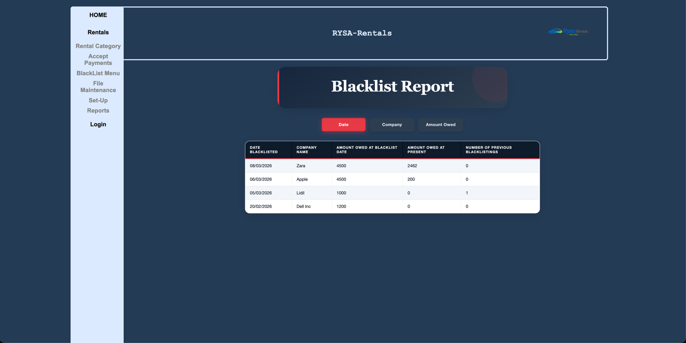
Blacklist Report

Purpose of the Blacklist Screen
The purpose of the blacklist screen is to display a structured report of companies that have been blacklisted within the system, allowing users to view and analyse outstanding debts and blacklist history.
The screen retrieves and presents key information such as the date a company was blacklisted, the company name, the amount owed at the time of blacklisting, the current amount owed, and the number of times the company has previously been blacklisted. This provides users with a clear overview of high-risk customers.
The report includes sorting functionality, enabling users to organise the data by date, company name, or amount owed. This allows for flexible analysis, such as identifying the most recent blacklist entries, companies with the highest debt, or viewing records alphabetically.
All data is dynamically retrieved from the database and displayed in a clear tabular format, ensuring accuracy and readability. The screen also ensures that only active (non-deleted) company records are included in the report.
Overall, the blacklist screen supports decision-making by providing a clear, organised, and interactive view of blacklisted companies and their financial status.

blacklistReport.php
<!--
Student Name : Ryan Mulcahy
Student Id Number: C00315272
Date : Mar- 2026
Purpose : Blacklist Report
-->

<!DOCTYPE html>

<html lang="en">
<head>
<meta charset="UTF-8">
<title>Blacklist Report</title>

<?php
// Include database connection file
include '../../GroupWork/db.inc.php';
?>

<!-- Link to shared/global CSS used across the system -->
<link rel="stylesheet" type="text/css" href="../../GroupWork/global.css">

<!-- Link to page-specific styling -->
<link rel="stylesheet" type="text/css" href="blacklistReport.css">
</head>

<body>

<?php
// Include header (likely contains logo, title, etc.)
include('../../GroupWork/header.php');
?>

<div class="main">

<div class="nav">
<?php
// Include navigation menu
include('../../GroupWork/nav.php');
?>
</div>

<div class="blacklist-report-page">

<!--
Form used to send sorting choice to the server.
Uses POST method so the page can reload with new sorting.
-->
<form action="blacklistReport.php" method="post" name="reportForm" class="sort-form">
<!-- Hidden input to store which sort option user selects -->
<input type="hidden" name="choice">
</form>

<!-- Page heading -->
<div class="report-header-box">
<h1 class="report-title">Blacklist Report</h1>
</div>

<!-- Subtitle (currently unused but available for dynamic text if needed) -->
<h3 class="report-subtitle"></h3>

<!-- Buttons to control sorting -->
<div class="report-buttons">

<!-- Sort by Date (default, initially disabled) -->
<input type="button" id="dateButton" value="Date"
onclick="dateOrder()"
title="Click here to see blacklist in date order" disabled>

<!-- Sort by Company Name -->
<input type="button" id="companyButton" value="Company"
onclick="companyOrder()"
title="Click here to see blacklist in alphabetical order">

<!-- Sort by Amount Owed -->
<input type="button" id="amountOwedButton" value="Amount Owed"
onclick="amountOwedOrder()"
title="Click here to see blacklist in decreasing order">
</div>

<script>
// When Date button is clicked
function dateOrder()
{
// Set hidden form value
document.reportForm.choice.value = "dateBlacklisted";
// Submit form to reload page with new sorting
document.reportForm.submit();
}

// When Company button is clicked
function companyOrder()
{
document.reportForm.choice.value = "Name";
document.reportForm.submit();
}

// When Amount Owed button is clicked
function amountOwedOrder()
{
document.reportForm.choice.value = "AmountOwed";
document.reportForm.submit();
}
</script>

<?php

// Default sorting choice (when page first loads)
$choice = "dateBlacklisted";

// If user submitted a sorting choice, override default
if (isset($_POST['choice'])) {
$choice = $_POST['choice'];
}

// SORT BY DATE (Default)

if ($choice == "dateBlacklisted") {

// Enable/disable buttons visually
echo "
<script>
document.getElementById('dateButton').disabled = true;
document.getElementById('companyButton').disabled = false;
document.getElementById('amountOwedButton').disabled = false;
</script>";

// SQL query sorted by most recent blacklist date
$sql = "SELECT
b.dateBlacklisted,
c.Name,
b.AmountOwed AS AmountOwedAtBlacklistDate,
c.AmountOwed AS AmountOwedAtPresent,
c.timesBlacklisted
FROM Blacklist b
INNER JOIN Company c
ON b.CompanyID = c.CompanyID
WHERE c.deleteFlag = 0
ORDER BY b.dateBlacklisted DESC";
}

// SORT BY AMOUNT OWED

elseif ($choice == "AmountOwed") {

echo "
<script>
document.getElementById('dateButton').disabled = false;
document.getElementById('companyButton').disabled = false;
document.getElementById('amountOwedButton').disabled = true;
</script>";

// SQL query sorted by highest current amount owed
$sql = "SELECT
b.dateBlacklisted,
c.Name,
b.AmountOwed AS AmountOwedAtBlacklistDate,
c.AmountOwed AS AmountOwedAtPresent,
c.timesBlacklisted
FROM Blacklist b
INNER JOIN Company c
ON b.CompanyID = c.CompanyID
WHERE c.deleteFlag = 0
ORDER BY c.AmountOwed DESC";
}

// SORT BY COMPANY NAME

else {

echo "
<script>
document.getElementById('dateButton').disabled = false;
document.getElementById('companyButton').disabled = true;
document.getElementById('amountOwedButton').disabled = false;
</script>";

// SQL query sorted alphabetically by company name
$sql = "SELECT
b.dateBlacklisted,
c.Name,
b.AmountOwed AS AmountOwedAtBlacklistDate,
c.AmountOwed AS AmountOwedAtPresent,
c.timesBlacklisted
FROM Blacklist b
INNER JOIN Company c
ON b.CompanyID = c.CompanyID
WHERE c.deleteFlag = 0
ORDER BY c.Name ASC";
}

// Call function to generate and display report table
produceReport($con, $sql);

function produceReport($con, $sql)
{
// Execute query
$result = mysqli_query($con, $sql);

// If query fails, stop execution and show error
if (!$result) {
die("Query failed: " . mysqli_error($con));
}

// Start HTML table
echo "<table>
<tr>
<th>Date Blacklisted</th>
<th>Company Name</th>
<th>Amount Owed at Blacklist Date</th>
<th>Amount Owed at Present</th>
<th>Number of Previous Blacklistings</th>
</tr>";

// Loop through each row returned from database
while ($row = mysqli_fetch_assoc($result)) {

// Convert date into readable format (DD/MM/YYYY)
$date = date_create($row['dateBlacklisted']);
$formattedDate = $date ? date_format($date, 'd/m/Y') : $row['dateBlacklisted'];

// Output table row
echo "<tr>
<td>{$formattedDate}</td>
<td>{$row['Name']}</td>
<td>{$row['AmountOwedAtBlacklistDate']}</td>
<td>{$row['AmountOwedAtPresent']}</td>
<td>{$row['timesBlacklisted']}</td>
</tr>";
}

// Close table
echo "</table>";
}

// Close database connection
mysqli_close($con);
?>

</div>
</div>

</body>
</html>

blacklistReport.css
/*
Student Name : Ryan Mulcahy
Student Id Number: C00315272
Date : Mar- 2026
Purpose : Blacklist Report - CSS
*/

/* ─── DESIGN TOKENS ───────────────────────────────────────────────────── */
:root {
--navy: #0d1b2a;
--navy-mid: #16263d;
--navy-light: #2d3e50;
--ice: #dbe4f0;
--ice-dim: #bfcddd;
--slate: #7f8fa3;
--accent: #e63946; /* sharp red — signals "blacklist" */
--accent-dim: #b52d38;
--white: #ffffff;
--off-white: #f2f6fa;
--text-dark: #0d1b2a;
--radius-sm: 8px;
--radius-md: 16px;
--radius-lg: 28px;
--shadow-card: 0 8px 32px rgba(13, 27, 42, 0.22);
--shadow-btn: 0 4px 14px rgba(13, 27, 42, 0.18);
--font-display: 'Georgia', 'Times New Roman', serif;
--font-body: 'Segoe UI', 'Helvetica Neue', sans-serif;
--transition: 0.2s ease;
}

/* ─── PAGE CONTAINER ─────────────────────────────────────────────────── */
/*
margin-top clears the fixed header.
margin-left clears the fixed sidebar nav.
Everything inside is centered with margin: auto on child elements.
*/
.blacklist-report-page {
margin-top: 155px; /* clears the fixed header.php bar */
margin-left: 200px; /* clears the fixed sidebar nav */
padding: 50px 60px 60px;
color: var(--white);
font-family: var(--font-body);
display: flex;
flex-direction: column;
align-items: center;
box-sizing: border-box;
width: calc(100vw - 200px); /* fills exactly the space right of sidebar */
}

/* ─── FORM RESET ─────────────────────────────────────────────────────── */
.blacklist-report-page .sort-form {
background: transparent !important;
margin: 0 !important;
padding: 0 !important;
max-width: none !important;
box-shadow: none !important;
border-radius: 0 !important;
}

.blacklist-report-page .sort-form input[type="hidden"] {
display: none;
}

/* ─── REPORT HEADER BOX ──────────────────────────────────────────────── */
.blacklist-report-page .report-header-box {
position: relative;
width: 100%;
max-width: 780px;
margin: 0 0 32px 0;
padding: 38px 48px 32px;
background: linear-gradient(145deg, var(--navy-mid) 0%, var(--navy-light) 100%);
border-radius: var(--radius-lg);
box-shadow: var(--shadow-card);
text-align: center;
overflow: hidden;
box-sizing: border-box;
}

/* decorative top-left accent bar */
.blacklist-report-page .report-header-box::before {
content: '';
position: absolute;
top: 0; left: 0;
width: 6px;
height: 100%;
background: var(--accent);
border-radius: var(--radius-lg) 0 0 var(--radius-lg);
}

/* faint watermark circle top-right */
.blacklist-report-page .report-header-box::after {
content: '';
position: absolute;
top: -40px; right: -40px;
width: 160px; height: 160px;
border-radius: 50%;
background: rgba(230, 57, 70, 0.08);
pointer-events: none;
}

/* eyebrow label above the title */
.blacklist-report-page .report-eyebrow {
display: block;
font-size: 11px;
font-weight: 700;
letter-spacing: 3px;
text-transform: uppercase;
color: var(--accent);
margin-bottom: 10px;
}

/* main title */
.blacklist-report-page .report-title {
margin: 0 0 14px;
font-family: var(--font-display);
font-size: 52px;
font-weight: 700;
color: var(--white);
letter-spacing: -1px;
line-height: 1.1;
}

/* thin divider line under title */
.blacklist-report-page .report-divider {
width: 60px;
height: 3px;
background: var(--accent);
border: none;
border-radius: 2px;
margin: 0 auto 14px;
}

/* subtitle / meta text */
.blacklist-report-page .report-subtitle {
margin: 0;
font-size: 13.5px;
color: var(--ice-dim);
letter-spacing: 0.4px;
}

/* ─── BUTTON PANEL ───────────────────────────────────────────────────── */
.blacklist-report-page .report-buttons {
display: flex;
flex-direction: row;
justify-content: center;
align-items: center;
gap: 14px;
margin: 0 0 32px 0;
width: 100%;
max-width: 780px;
}

/* individual sort buttons */
.blacklist-report-page .report-buttons input[type="button"] {
width: auto;
min-width: 150px;
padding: 13px 24px;
border: 2px solid transparent;
border-radius: var(--radius-sm);
background: var(--navy-light);
color: var(--ice);
font-family: var(--font-body);
font-size: 14px;
font-weight: 600;
letter-spacing: 0.5px;
cursor: pointer;
box-shadow: var(--shadow-btn);
transition: background var(--transition),
border-color var(--transition),
color var(--transition),
transform var(--transition);
}

.blacklist-report-page .report-buttons input[type="button"]:hover {
background: var(--navy-mid);
border-color: var(--accent);
color: var(--white);
transform: translateY(-2px);
}

/* active / currently-selected sort */
.blacklist-report-page .report-buttons input[type="button"]:disabled {
background: var(--accent);
border-color: var(--accent-dim);
color: var(--white);
cursor: not-allowed;
transform: none;
box-shadow: 0 4px 16px rgba(230, 57, 70, 0.35);
}

/* ─── REPORT TABLE ───────────────────────────────────────────────────── */
.blacklist-report-page table {
width: 100%;
max-width: 1000px;
margin: 0 0 40px 0;
border-collapse: collapse;
background: var(--white);
color: var(--text-dark);
box-shadow: var(--shadow-card);
border-radius: var(--radius-md);
overflow: hidden;
font-size: 14.5px;
box-sizing: border-box;
}

.blacklist-report-page th,
.blacklist-report-page td {
padding: 14px 16px;
border-bottom: 1px solid #dde3ea;
text-align: left;
}

.blacklist-report-page td {
border-right: 1px solid #eef1f5;
}

.blacklist-report-page td:last-child {
border-right: none;
}

/* header row */
.blacklist-report-page th {
background: var(--navy);
color: var(--white);
font-size: 12px;
font-weight: 700;
letter-spacing: 1px;
text-transform: uppercase;
border-bottom: 3px solid var(--accent);
}

/* zebra striping */
.blacklist-report-page tr:nth-child(even) td {
background: var(--off-white);
}

/* row hover highlight */
.blacklist-report-page tbody tr:hover td {
background: #e8edf4;
transition: background 0.15s ease;
}

/* last row — no bottom border bleed */
.blacklist-report-page tbody tr:last-child td {
border-bottom: none;
}

Project
AI Disclosure Document
Student Name: Ryan Mulcahy
Student ID: C00315272
Course Name Software Development
Project Title RYSA Rentals
Code Unit REPORT SCREEN
Date Submitted: 25/03/2026
AI Assistance Disclosure
AI Technologies Used
Indicate whether you used AI technologies in completing this task:
☐ No, I did not use any AI tools.
X Yes, I used AI tools. (List all AI technologies used, e.g., ChatGPT, GitHub Copilot, Codeium, Google Bard, etc.)
Claude

Prompts Used
If AI was used, describe the prompts or queries you provided to the AI tools:
Please build a CSS File to professionally reflect the info on the blacklistReport.php file without altering the blacklistReport.php file

Nature of Assistance
Indicate how AI technologies contributed to your work by selecting and elaborating on the relevant categories below:
- Code Suggestions & Auto-Completion: (e.g., AI suggested code snippets, function implementations, syntax corrections, etc.)

- Debugging & Error Fixing: (e.g., AI identified and corrected syntax/logical errors, suggested refactoring, etc.)

- Concept Explanation: (e.g., AI provided explanations of algorithms, data structures, programming concepts, etc.)

- Optimization & Efficiency Improvements: (e.g., AI suggested more efficient algorithms, reduced complexity, optimized loops, etc.)

- Other (Specify):
AI designed the css styling for the layout of the report

Use of AI-Generated Output
Describe how you used the AI-generated output in your work:
I used the output purley to design the displayed info from my blacklistreport.php

Verification of AI Output
Explain the steps you took to verify the accuracy and correctness of the AI-generated output:
I refreshed the screen to make sure it aligned with our nav and header php and did not overlap

AI-Generated Content Modifications
Did you modify or refine any AI-generated content before submission? (Check one and provide details.)
☐ Yes, I made modifications. (Explain what was changed and why.)

x No, I used AI-generated content as is. (Explain why you did not modify it.)
We were allowed to use AI in one screen and I used it partially to design the overall look of my report and I used it specifically on the this section as it would not alter anyone else work
Acknowledgment & Integrity Statement
By submitting this document, I acknowledge that I have fully disclosed my use of AI technologies in completing this lab sheet.

Jessica Power
I used a javascript file at the root of my folder to link all my files back to. This is located in the folder named Jessica
Jessica/Company.js
// Function to check users response
function confirmCheck() {

// Variable to store the user's response from the confirm dialog
var response;

// Show confirmation dialog asking the user to save changes
response = confirm('Are you sure you want to make these changes?');

// If the user clicks "OK"
if (response) {

// Allow the action (e.g., form submission) to proceed
return true;
}
else {

// Prevent the action (e.g., form submission)
return false;
}
}

// Function to check users response
function confirmDelete() {

// Variable to store the user's response from the confirm dialog
var response;

// Show confirmation dialog asking the user to save changes
response = confirm('Are you sure you want to delte this record?');

// If the user clicks "OK"
if (response) {

// Allow the action (e.g., form submission) to proceed
// Enable the form fields so their values can be submitted
document.getElementById("delid").disabled = false;
document.getElementById("delName").disabled = false;
document.getElementById("delEmail").disabled = false;
document.getElementById("delPhone").disabled = false;
document.getElementById("owed").disabled = false;
document.getElementById("blacklisted").disabled = false;

return true;
}
else {

// Prevent the action (e.g., form submission)
popDelete();
return false;
}
}

// Function to check users response
function confirmSel() {

// Variable to store the user's response from the confirm dialog
var response;

// Show confirmation dialog asking the user to save changes
response = confirm('Are you sure you want continue with this company?');

// If the user clicks "OK"
if (response) {

document.getElementById("comID").disabled = false;
return true;
}
else {

// Prevent the action (e.g., form submission)
popSel();
return false;
}
}

// JavaScript function called when an item in the listbox is clicked
function populate()
{

// Get a reference to the select element
var sel = document.getElementById("listbox");

// Variable to hold the selected option's value (a comma-separated string)
var result;

// Get the value of the currently selected option
result = sel.options[sel.selectedIndex].value;

// Split the value string into an array: [id, name, address, phone , etc]
var companyDetails = result.split(',');

// Fill hidden or visible form fields with each part of the array
document.getElementById("amendid").value = companyDetails[0]; // Company ID
document.getElementById("amendName").value = companyDetails[1]; // Company Name
document.getElementById("amendAddress").value = companyDetails[2]; // Company Address
document.getElementById("amendPhone").value = companyDetails[3]; // Company Phone No.
document.getElementById("amendWeb").value = companyDetails[4]; // Company Web address
document.getElementById("amendEmail").value = companyDetails[5]; // Company Email
document.getElementById("credit").value = companyDetails[6]; // Company credit limit
document.getElementById("blacklist").value = companyDetails[7]; // Company blacklist
document.getElementById("owed").value = companyDetails[8]; // Company amount owed
document.getElementById("tBlacklist").value = companyDetails[9]; // Company blacklist count

}

// JavaScript function called when an item in the listbox is clicked
function popDelete()
{

// Get a reference to the select element
var sel = document.getElementById("listbox");
// Variable to hold the selected option's value (a comma-separated string)
var result;

// Get the value of the currently selected option
result = sel.options[sel.selectedIndex].value;

// Split the value string into an array: [id, name, address, phone , etc]
var companyDetails = result.split(',');

// Fill hidden or visible form fields with each part of the array
document.getElementById("delid").value = companyDetails[0]; // Company ID
document.getElementById("delName").value = companyDetails[1]; // Company Name
document.getElementById("delAddress").value = companyDetails[2]; // Company Address
document.getElementById("delPhone").value = companyDetails[3]; // Company Phone No.
document.getElementById("delEmail").value = companyDetails[4]; // Company Email
document.getElementById("blacklisted").value = companyDetails[5]; // Company blacklist
document.getElementById("owed").value = companyDetails[6]; // Company amount owed
document.getElementById("tBlacklisted").value = companyDetails[7]; // Company blacklist count
}

function carpop()
{

// Get a reference to the select element
var sel = document.getElementById('listbox');
// Variable to hold the selected option's value (a comma-separated string)
var result;

// Get the value of the currently selected option
result = sel.options[sel.selectedIndex].value;

// Split the value string into an array: [id,]
var carDetails = result.split(',');

// Fill hidden or visible form fields with each part of the array

document.getElementById('selected').value = carDetails[0]; // car id
}

function carsend()
{
document.getElementById("selected").disabled = false;
var car = document.getElementById('listbox');
//This if checks that the value is not null
if(car.selectedIndex == 0 ) {
alert('select a Car!');
return false;
}
}

// JavaScript function called when an item in the listbox is clicked
function popSel()
{

// Get a reference to the select element
var sel = document.getElementById("listbox");
// Variable to hold the selected option's value (a comma-separated string)
var result;

// Get the value of the currently selected option
result = sel.options[sel.selectedIndex].value;

// Split the value string into an array: [id, name, address, phone , etc]
var companyDetails = result.split(',');

// Fill hidden or visible form fields with each part of the array

document.getElementById("comName").value = companyDetails[0]; // Company Name
document.getElementById("comAddress").value = companyDetails[1]; // Company Address
document.getElementById("credit").value = companyDetails[2]; // Company credit limit
document.getElementById("owed").value = companyDetails[3]; // Company amount owed

document.getElementById("comID").value = companyDetails[4];

}

// Function to lock/unlock the amend fields and toggle button text
function toggleLock()
{
// If the button currently says "Amend Details", unlock fields for editing
if (document.getElementById("amendViewbutton").value == "Amend Details")
{
// Enable first name, last name and DOB input fields
document.getElementById("amendName").disabled = false;
document.getElementById("amendAddress").disabled = false;
document.getElementById("amendPhone").disabled = false;
document.getElementById("amendWeb").disabled = false;
document.getElementById("amendEmail").disabled = false;
document.getElementById("credit").disabled = false;

// Change button text so user can switch back to view-only mode
document.getElementById("amendViewbutton").value = "View Details";
}
// Otherwise, lock fields again and set button text back
else
{
// Disable name, address and phone input fields (view-only)
document.getElementById("amendName").disabled = true;
document.getElementById("amendAddress").disabled = true;
document.getElementById("amendPhone").disabled = true;
document.getElementById("amendWeb").disabled = true;
document.getElementById("amendEmail").disabled = true;
document.getElementById("credit").disabled = true;

// Change button text so user can enable editing again
document.getElementById("amendViewbutton").value = "Amend Details";
}
}

// Function to check users response
function confirmCheck2() {

// Variable to store the user's response from the confirm dialog
var response;

// Show confirmation dialog asking the user to save changes
response = confirm('Are you sure you want to save these changes?');

// If the user clicks "OK"
if (response) {

// Enable the input fields so they can be submitted/saved
document.getElementById("amendid").disabled = false;
document.getElementById("amendName").disabled = false;
document.getElementById("amendAddress").disabled = false;
document.getElementById("amendPhone").disabled = false;
document.getElementById("amendWeb").disabled = false;
document.getElementById("amendEmail").disabled = false;
document.getElementById("credit").disabled = false;

// Allow the action (e.g., form submission) to proceed
return true;
}
else {
// If the user clicks "Cancel"

// Restore original values
populate();

// Re-lock the fields
toggleLock();

// Prevent the action (e.g., form submission)
return false;
}
}

ADD SCREEN
This screen gives the user the ability to add a new company to the database. The user provides details such as the name of thee company, their address, phone number, company website, email and set the credit limit the company has been approved for.
There is html validation for input field as well as a confirm details pop up when submitting. You are then taken to a php page displaying the details that have been set to the database and given to options, a button to return to the add screen or to proceed to the rental system.

Jessica/AddCompany/CompanyAdd.html.php
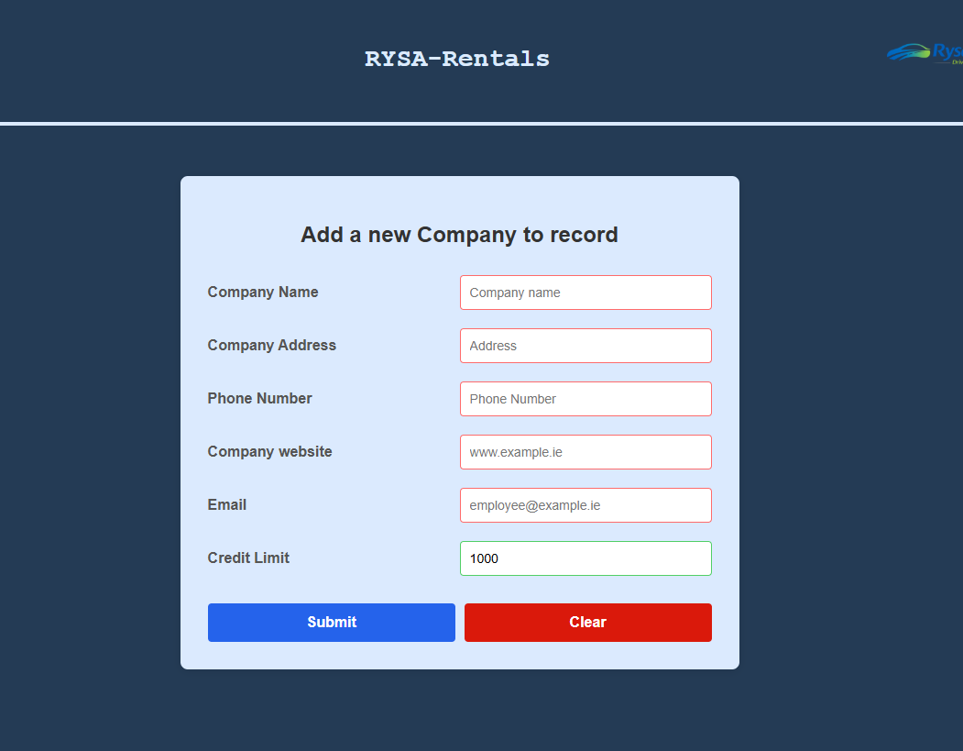

Code for this page
<!--
Screen - Add new company
This screen is a form to input data on a new company that is to be added to
the database, table Company
Jessica Power
C00312811
coding started - Feb 2026
-->

<!DOCTYPE html>
<html lang="en">
<head>
<meta charset="UTF-8">
<title>Company Management</title>

<!-- Link to external CSS file -->
<link rel="stylesheet" type="text/css" href="../../GroupWork/global.css">

</head>
<body>

<?php include('../../GroupWork/header.php') ?>

<div class="main">
<div class="nav">
<?php include('../../GroupWork/nav.php') ?>
</div>

<form
id="newCompany"
action="CompanyAdd.php"
onsubmit="return confirmCheck()"
method="POST">

<h2>Add a new Company to record</h2>

<div class="form-group">
<label for="name"> Company Name </label>
<input type="text"
name="name"
id="name"
placeholder="Company name"
autocomplete="off"
pattern="[A-Za-z .]+"
title="Letters, spaces and dots only"
required>
</div>

<div class="form-group">
<label for="address"> Company Address </label>
<input type="text"
name="address"
id="address"
placeholder="Address"
pattern="[a-zA-Z0-9 ]+"
title="No commas"
autocomplete="off"
required>
</div>

<div class="form-group">
<label for="phoneNo"> Phone Number </label>
<input type="text"
name="phoneNo"
id="phoneNo"
placeholder="Phone Number"
title="Digits only"
pattern="[0-9 ]+"
autocomplete="off"
required>
</div>

<div class="form-group">
<label for="web"> Company website </label>
<input type="text"
name="web"
id="web"
placeholder="www.example.ie"
pattern="(w{3}\.)?[\w\d]*\.([a-zA-Z]*\.)?([a-zA-Z]*)?$"
title="Please enter a valid URL"
autocomplete="off"
required>
</div>

<div class="form-group">
<label for="email" > Email </label>
<input type="text"
name="email"
id="email"
placeholder="employee@example.ie"
title="Enter a valid email address"
autocomplete="off"
pattern="[a-z0-9._%+\-]+@[a-z0-9.\-]+\.[a-z]{2,}$"
required>
</div>

<div class="form-group">
<label for="credit"> Credit Limit </label>
<input type="text"
name="credit"
id="credit"
placeholder="Credit Limit"
title="Authorized credit limit (MAX €9999)"
maxlength="4"
pattern="[0-9]+"
autocomplete="off"
value="1000"
required>
</div>

<div ></div>

<!-- Submit & Clear buttons -->
<div class="button-group">
<button type="submit">Submit</button>
<button type="reset">Clear</button>
</div>
</form>

<script src="../Company.js"></script>
</div>
</body>
</html>

Jessica/AddCompany/CompanyAdd.php
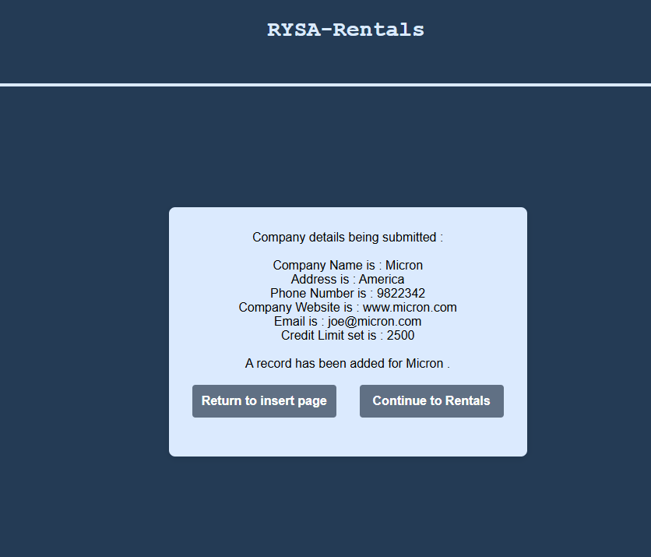

Code for the php
<!--
Screen - Add new company php side
This screen is to input data on a new company to
the database, table Company with mysql insert
Jessica Power
C00312811
coding started - Feb 2026
-->
<?php session_start(); ?>
<!DOCTYPE html>
<html>
<head>
<meta charset="UTF-8">
<title>Company Management</title>

<!-- Link to external CSS file -->
<link rel="stylesheet" href="../../GroupWork/global.css">
</head>
<body>

<?php include('../../GroupWork/header.php') ?>

<div class="main">
<div class="nav">
<?php include('../../GroupWork/nav.php') ?>
</div>
<?php

include '../../GroupWork/db.inc.php'; // Connect to database
date_default_timezone_set("UTC"); // Ensure consistent timezone

// Display submitted details for confirmation
echo "<form class='php-form'>Company details being submitted : <br>" . "<br>" .
"Company Name is : " . htmlspecialchars($_POST['name']) . "<br>" .
"<form class='php-form'>Address is : " . htmlspecialchars($_POST['address']) . "<br>" .
"Phone Number is : " . htmlspecialchars($_POST['phoneNo']) . "<br>" .
"Company Website is : " . htmlspecialchars($_POST['web']) . "<br>" .
"Email is : " . htmlspecialchars($_POST['email']) . "<br>" .
"Credit Limit set is : " . htmlspecialchars($_POST['credit']) . "<br>" ;

// Insert the new company record into the database
$sql = "Insert into Company (Name, Address, PhoneNo, WebAddress, Email, CreditLimit)
VALUES ('$_POST[name]','$_POST[address]','$_POST[phoneNo]'
,'$_POST[web]','$_POST[email]','$_POST[credit]')";

// Run the query and stop if there is an error
if (!mysqli_query($con, $sql)) {
die ("An Error in the SQL Query: " . mysqli_error($con));
}

// Confirm successful insert
echo "<br>A record has been added for " . htmlspecialchars($_POST['name']) . " " .
"." . "<br>" . "<br>";

// Close database connection
mysqli_close($con);
?>
<div class="form-group">
<input type="button" class="return" value="Return to insert page"
onclick="window.location.href='CompanyAdd.html.php'">
<input type="button" class="return" value="Continue to Rentals"
onclick="window.location.href='../RentalScreen/RentalSelCompany.html.php'">
</div>
</div>
</body>
</html>

Project AI Disclosure Document
Student Name: Jessica Power
Student ID: C00312811
Course Name IT Management
Project Title Car Rental 1
Code Unit For Add Screen section
Date Submitted: 24/03/2026

AI Assistance Disclosure
AI Technologies Used
Indicate whether you used AI technologies in completing this task:
X No, I did not use any AI tools.
☐ Yes, I used AI tools. (List all AI technologies used, e.g., ChatGPT, GitHub Copilot, Codeium, Google Bard, etc.)

Prompts Used
If AI was used, describe the prompts or queries you provided to the AI tools:

Nature of Assistance

Amend/View Screen
This screen allows the user to view details of a company and make changes. It is a blank form with a dropdown used to select the company, that company’s details then get populated into the form for viewing. The amend button unlocks the details allowing changes to be made.

Jessica/AmendCompany/CompanyAmend.html.php
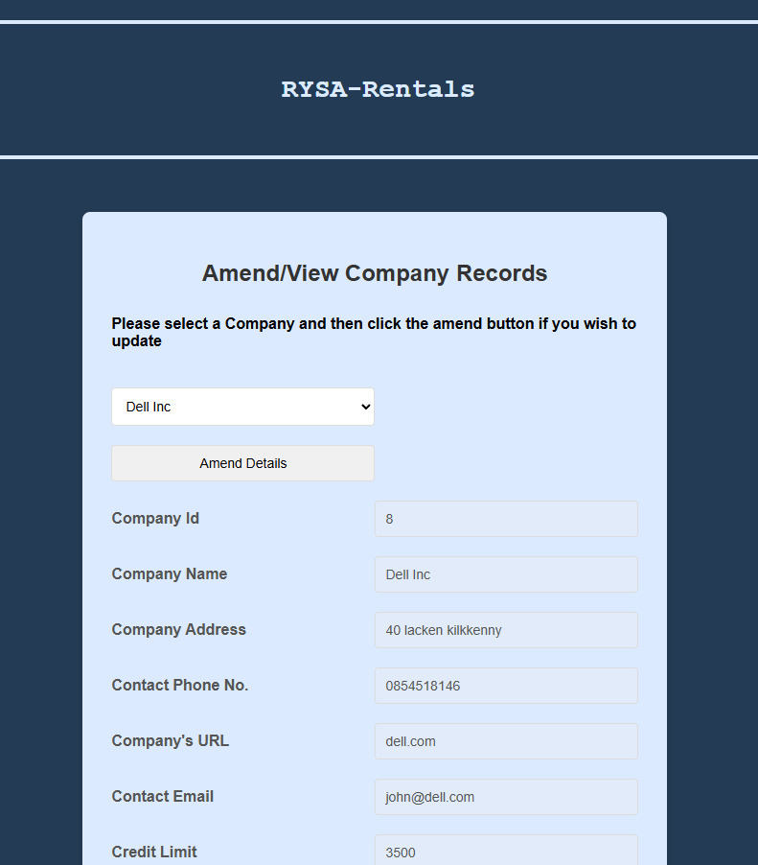
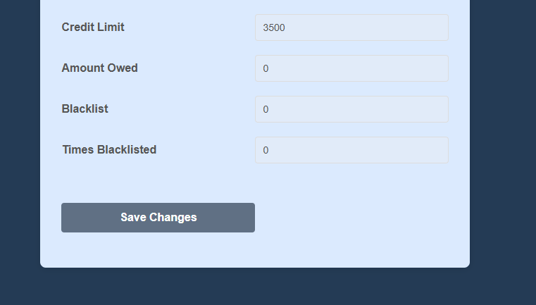

Code for this page
<!--
Write the code, html, CSS, Javascript and php to do the following:
• Using a list box show the names of all the students on the table.
• Allow the user to select a student then display all of the student details in labelled text boxes for viewing only (disabled).
• When the user clicks a button to amend the details, enable the text boxes (except the primary key field), and allow the user to change the details.
• Include some validation before the details can be saved.
• When the user clicks “Save”, present him/her with the option to confirm or cancel the changes.
• If the changes are confirmed, update the database, otherwise, no changes should be made.

This is for viewing and amending details HTML, Javascript side
Jessica Power
C00312811
Feb - 2026
-->
<!DOCTYPE html>
<html>
<head>
<meta charset="UTF-8">
<title>Company Management</title>
<!-- Link to external CSS file for page layout and styling -->
<link rel="stylesheet" type="text/css" href="../../GroupWork/global.css">
</head>
<body>

<?php include('../../GroupWork/header.php') ?>

<div class="main">
<div class="nav">
<?php include('../../GroupWork/nav.php') ?>
</div>

<form
name="myForm"
action="CompanyAmend.php"
onsubmit="return confirmCheck2()"
method="post"
>
<!-- Page heading -->
<h2>Amend/View Company Records</h2>

<!-- Instructional text for the user -->
<h4>Please select a Company and then click the amend button if you wish to update</h4>

<!-- Include the PHP file that outputs the <select> list (listbox) of companys -->
<?php include 'CompanyList.php'; ?>

<!-- Button to unlock the form fields for editing -->
<div class="form-group">
<input
type="button"
value="Amend Details"
id="amendViewbutton"
onclick="toggleLock()"
>
</div>
<!-- Form that submits amended details -->
<!-- onsubmit calls confirmCheck2() to confirm before saving -->

<div class="form-group">
<!-- Student ID field (read-only until unlocked) -->
<label for="amendid">Company Id</label>
<input
type="text"
name="amendid"
id="amendid"
disabled
value="amend"
>
</div>

<div class="form-group">
<!-- Name field -->
<label for="amendName">Company Name</label>
<input
type="text"
name="amendName"
id="amendName"
placeholder="Company name"
autocomplete="off"
pattern="[A-Za-z .]+"
title="Letters, spaces and dots only"
disabled
>
</div>

<div class="form-group">
<!-- Address field -->
<label for="amendAddress">Company Address</label>
<input
type="text"
name="amendAddress"
id="amendAddress"
placeholder="Address"
pattern="[a-zA-Z0-9 ]+"
title="No commas"
autocomplete="off"
disabled
>
</div>

<div class="form-group">
<!-- Phone number field -->
<label for="amendPhone">Contact Phone No.</label>
<input
type="text"
name="amendPhone"
id="amendPhone"
placeholder="Phone Number"
title="Digits only"
pattern="[0-9 ]+"
autocomplete="off"
disabled
>
</div>

<div class="form-group">
<!-- Web Address -->
<label for="amendWeb">Company's URL</label>
<input
type="text"
name="amendWeb"
id="amendWeb"
placeholder="www.example.ie"
pattern="(w{3}\.)?[\w\d]*\.([a-zA-Z]*\.)?([a-zA-Z]*)?$"
title="Please enter a valid URL"
autocomplete="off"
disabled
>
</div>

<div class="form-group">
<!-- Email field -->
<label for="amendEmail">Contact Email</label>
<input
type="text"
name="amendEmail"
id="amendEmail"
placeholder="employee@example.ie"
title="Enter a valid email address"
autocomplete="off"
pattern="[a-z0-9._%+\-]+@[a-z0-9.\-]+\.[a-z]{2,}$"
disabled
>
</div>

<div class="form-group">
<!-- credit limit field -->
<label for="credit"> Credit Limit </label>
<input
type="text"
name="credit"
id="credit"
placeholder="Credit Limit"
title="Authorized credit limit (MAX €9999)"
maxlength="4"
pattern="[0-9]+"
autocomplete="off"
disabled
>
</div>

<div class="form-group">
<!-- credit limit field -->
<label for="owed"> Amount Owed </label>
<input
type="text"
name="owed"
id="owed"
placeholder="Amount Owed"
disabled
>
</div>

<div class="form-group">
<!-- credit limit field -->
<label for="blacklist"> Blacklist </label>
<input
type="text"
name="blacklist"
id="blacklist"
placeholder="Blacklist"
disabled
>
</div>

<div class="form-group">
<!-- credit limit field -->
<label for="tBlacklist"> Times Blacklisted </label>
<input
type="text"
name="tBlacklist"
id="tBlacklist"
placeholder="Times Blacklisted"
disabled>
</div>

<div id="text" class="notSubmitted" ></div>

<br><br>
<div class="form-group">
<!-- Submit button to save changes -->
<input
type="submit"
value="Save Changes"
class = "return">
</div>
</form>
<script src="../Company.js"></script>
</div>
</body>
</html>
Jessica/AmendCompany/CompanyAmend.php
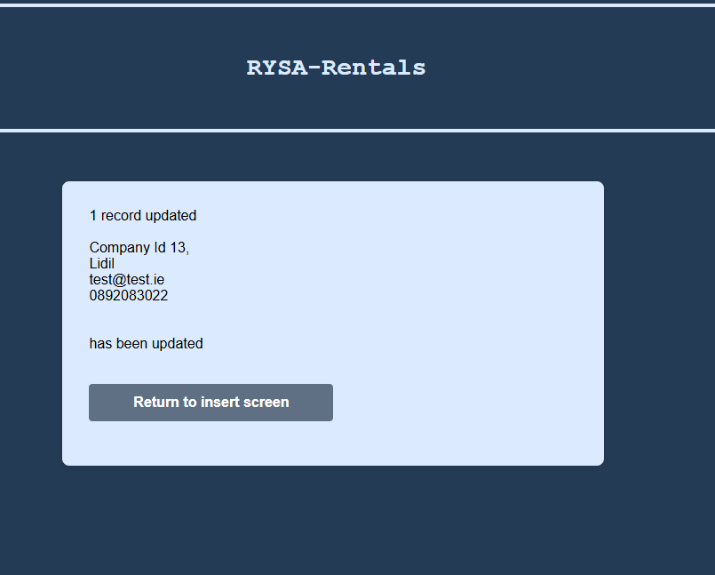
Code for the php
<!--
• Using a list box show the names of all the company on the table.
• Allow the user to select a company then display all of the details in labelled text boxes for viewing only (disabled).
• When the user clicks a button to amend the details, enable the text boxes (except the primary key field), and allow the user to change the details.
• Include some validation before the details can be saved.
• When the user clicks “Save”, present him/her with the option to confirm or cancel the changes.
• If the changes are confirmed, update the database, otherwise, no changes should be made.

This is for viewing and amending details php for updating the table with amended details
Jessica Power
C00312811
Feb - 2026
-->

<meta charset="UTF-8">
<title>Company Management</title>
<link rel="stylesheet" type="text/css" href="../../GroupWork/global.css">
<?php include('../../GroupWork/header.php') ?>

<div class="main">
<div class="nav">
<?php include('../../GroupWork/nav.php') ?>
</div>
<form action="CompanyAmend.html.php" method="post">
<?php

// Include database connection file
include '../../GroupWork/db.inc.php';

// Set the default timezone to UTC
date_default_timezone_set('UTC');

$date = date("Y-m-d H:i:s");

// Build the SQL UPDATE query to amend company details
$sql = "
UPDATE Company
SET
Name = '{$_POST['amendName']}',
Address = '{$_POST['amendAddress']}',
PhoneNo = '{$_POST['amendPhone']}',
WebAddress = '{$_POST['amendWeb']}',
Email = '{$_POST['amendEmail']}',
CreditLimit = '{$_POST['credit']}',
DateAmended = '{$date}'

WHERE
CompanyID = '{$_POST['amendid']}'";

// Execute the query and check for errors
if (!mysqli_query($con, $sql)) {

// Output MySQL error if query fails
echo "Error: " . mysqli_error($con);

} else {

// Check if any rows were actually updated
if (mysqli_affected_rows($con) != 0) {

// Display success message with record count
echo mysqli_affected_rows($con) . " record updated <br><br>";

// Display confirmation of updated company details
echo "Company Id " . $_POST['amendid'] . ", <br>" .
$_POST['amendName'] . " " . "<br>".
$_POST['amendEmail'] ." " . "<br>" .
$_POST['amendPhone'] .
"<br><br><br> has been updated<br><br><br>";

} else {

// No rows changed (e.g. same data submitted)
echo "No records were changed<br><br><br>";
}
}

// Close the database connection
mysqli_close($con);

?>

<div class="form-group">
<input type = "submit" class="return" value = "Return to insert screen"
onclick="window.location.href='CompanyAmend.html.php'">
</div>

</form>

Jessica/AmendCompany/CompanyList.php
This is the code that gets all of the company’s from the database that are not currently deleted. It stores them all in variables read to populate the form.
Code for CompanyList.php
<!--
• Using a list box show the names of all the companys on the table.
• Allow the user to select a company then display all of the details in labelled text boxes for viewing only (disabled).
• When the user clicks a button to amend the details, enable the text boxes (except the primary key field), and allow the user to change the details.
• Include some validation before the details can be saved.
• When the user clicks “Save”, present him/her with the option to confirm or cancel the changes.
• If the changes are confirmed, update the database, otherwise, no changes should be made.

This is for selecting a comapany from the db table
Jessica Power
C00312811
Feb - 2026
-->

<?php
// Include database connection settings and open a mysqli connection in $con
include "../../GroupWork/db.inc.php";

// Set default timezone so date/time functions behave consistently
date_default_timezone_set('UTC');

// Build SQL query to get active companys
$sql = "SELECT CompanyID, Name, Address, PhoneNo, WebAddress, Email, CreditLimit, isBlacklisted, AmountOwed ,timesBlacklisted
FROM Company
WHERE deleteFlag = 0
";

// Run the query and handle any errors
if (!$result = mysqli_query($con, $sql)) {
die('Error in querying the database: ' . mysqli_error($con));
}

// Start the HTML select list; when an option is clicked, call JavaScript function populate()
echo "<div class='listboxJ'><br><select name='listbox' id='listbox' onclick='populate()'><option >Select Company</option>";

// Loop through each row returned from the query
while ($row = mysqli_fetch_array($result)) {

// Extract fields from the current database row
$id = $row['CompanyID'];
$name = $row['Name'];
$address = $row['Address'];
$phoneNo = $row['PhoneNo'];
$web = $row['WebAddress'];
$email = $row['Email'];
$credit = $row['CreditLimit'];
$owed = $row['AmountOwed'];
$blacklist = $row['isBlacklisted'];
$times = $row['timesBlacklisted'];

// Build a combined string to store as the option value
// (id, company name, address, contact number, email, etc)
$allText = "$id,$name,$address,$phoneNo,$web,$email,$credit,$owed,$blacklist,$times";
// Output an option element showing company name to the user
echo "<option value='$allText'>$name</option>";
}
// Close the select tag
echo "</select></div>";
// Close the database connection
mysqli_close($con);
?>

Project AI Disclosure Document
Student Name: Jessica Power
Student ID: C00312811
Course Name IT Management
Project Title Car Rental 1
Code Unit For amend/view screen
Date Submitted: 24/03/2026
AI Assistance Disclosure
AI Technologies Used
Indicate whether you used AI technologies in completing this task:
X No, I did not use any AI tools.
☐ Yes, I used AI tools. (List all AI technologies used, e.g., ChatGPT, GitHub Copilot, Codeium, Google Bard, etc.)

Prompts Used
If AI was used, describe the prompts or queries you provided to the AI tools:

Nature of Assistance

Delete Screen
This screen allows you to select a company from a dropdown menu which then populates the form on the page displaying all the details of the selected company. The user can then delete the records but only if the company does not have any outstanding charges and is not currently blacklisted.
Jessica/DeleteCompany/CompanyDelete.html.php
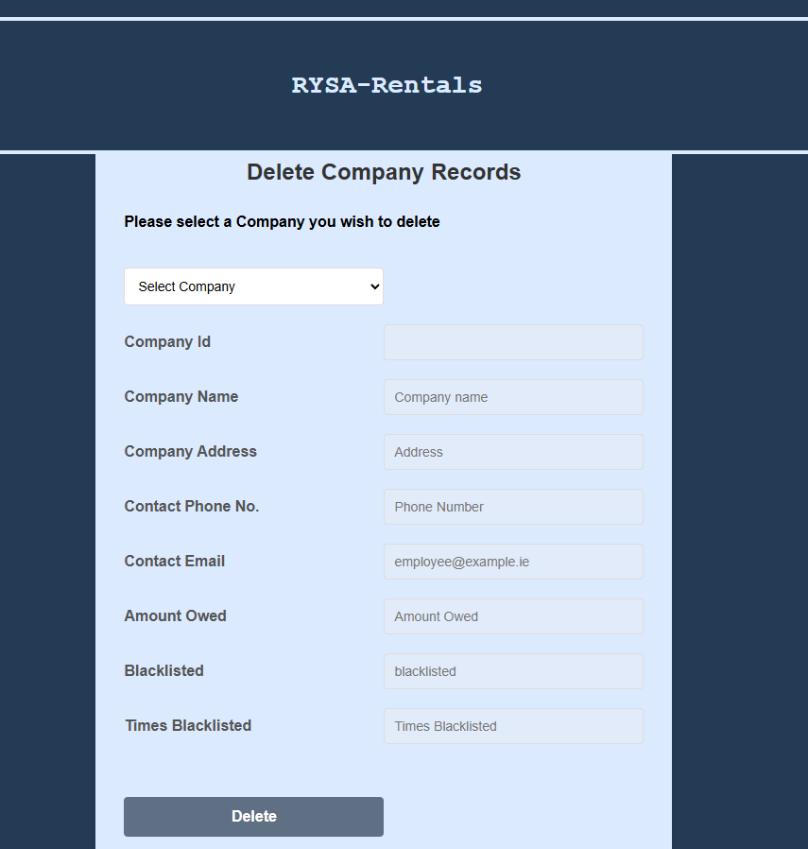

Code for this page
<!--
This is the Company delete screen for selecting a company displaying some of their info
such as money owed by them and if they are blacklisted or not as these values must be 0
to be able to delete them

This is for deleting details HTML, Javascript side
Jessica Power
C00312811
march - 2026
-->
<!DOCTYPE html>
<html>
<head>
<meta charset="UTF-8">
<title>Company Management</title>
<!-- Link to external CSS file for page layout and styling -->
<link rel="stylesheet" type="text/css" href="../../GroupWork/global.css">
</head>
<body>

<?php include('../../GroupWork/header.php') ?>

<div class="main">
<div class="nav">
<?php include('../../GroupWork/nav.php') ?>
</div>

<form
name="myForm"
action="CompanyDelete.php"
onsubmit="return confirmDelete()"
method="post"
>
<!-- Page heading -->
<h2>Delete Company Records</h2>

<!-- Instructional text for the user -->
<h4>Please select a Company you wish to delete</h4>

<!-- Include the PHP file that outputs the <select> list (listbox) of companys -->
<?php include 'CompanyListDel.php'; ?>
<!-- onsubmit calls confirmDelete() to confirm before saving -->

<div class="form-group">
<!-- Company ID field -->
<label for="delid">Company Id</label>
<input
type="text"
name="delid"
id="delid"
disabled
>
</div>

<div class="form-group">
<!-- Name field -->
<label for="delName">Company Name</label>
<input
type="text"
name="delName"
id="delName"
placeholder="Company name"
disabled
>
</div>

<div class="form-group">
<!-- Address field -->
<label for="delAddress">Company Address</label>
<input
type="text"
name="delAddress"
id="delAddress"
placeholder="Address"
disabled
>
</div>

<div class="form-group">
<!-- Phone number field -->
<label for="delPhone">Contact Phone No.</label>
<input
type="text"
name="delPhone"
id="delPhone"
placeholder="Phone Number"
disabled
>
</div>

<div class="form-group">
<!-- Email field -->
<label for="delEmail">Contact Email</label>
<input
type="text"
name="delEmail"
id="delEmail"
placeholder="employee@example.ie"
disabled
>
</div>

<div class="form-group">
<!-- amount owed field -->
<label for="owed"> Amount Owed </label>
<input
type="text"
name="owed"
id="owed"
placeholder="Amount Owed"
disabled
>
</div>

<div class="form-group">
<!-- blacklisted field -->
<label for="blacklisted"> Blacklisted </label>
<input
type="text"
name="blacklisted"
id="blacklisted"
placeholder="blacklisted"
disabled
>
</div>

<div class="form-group">
<!-- Times blacklisted field -->
<label for="tBlacklisted"> Times Blacklisted </label>
<input
type="text"
name="tBlacklisted"
id="tBlacklisted"
placeholder="Times Blacklisted"
disabled
>
</div>

<div id="text" class="notSubmitted" ></div>

<br><br>
<div class="form-group">
<!-- Submit button to save changes -->
<input
type="submit"
value="Delete"
class = "return">
</div>
</form>
<script src="../Company.js"></script>
</div>
</body>
</html>

Jessica/DeleteCompany/CompanyDelete.php

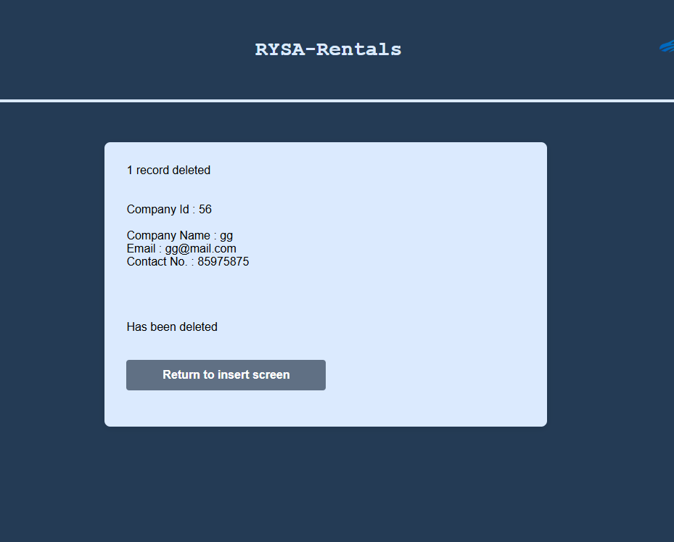
Code for this page
<!--
This is the php side of the delete screen setting the deleteFlag to 1/true and updating the
amended date stamp

Jessica Power
C00312811
March - 26
-->

<meta charset="UTF-8">
<title>Company Management</title>
<link rel="stylesheet" type="text/css" href="../../GroupWork/global.css">

<?php include('../../GroupWork/header.php') ?>

<div class="main">
<div class="nav">
<?php include('../../GroupWork/nav.php') ?>
</div>
<form name="myForm" action="CompanyDelete.html.php" method="post">

<?php
// Include database connection file (should create $con connection variable)
include '../../GroupWork/db.inc.php';

// Set the default timezone to UTC
date_default_timezone_set('UTC');

$date = date("Y-m-d H:i:s");

// SQL query to "soft delete" a record by setting deletedflag = true
// It uses the CompanyID sent via POST (from form)
$sql = "UPDATE Company
SET
deleteFlag = true,
DateAmended = '{$date}'

WHERE
CompanyID = '{$_POST['delid']}'
AND isBlacklisted = '0'
AND AmountOwed = '0'";

// Execute the SQL query
if (!$result = mysqli_query($con, $sql))
{
// If query fails, display the error message
echo "Error " . mysqli_error($con);
}

// Check if any rows were actually updated
if (mysqli_affected_rows($con) != 0 ) {

// Display success message with record count
echo mysqli_affected_rows($con) . " record deleted <br><br><br>";

// Display confirmation of updated company details
echo "Company Id : " . $_POST['delid'] . " <br><br>" .
"Company Name : " .$_POST['delName'] . " " . "<br>".
"Email : " .$_POST['delEmail'] ." " . "<br>" .
"Contact No. : " .$_POST['delPhone'] . " " . "<br><br>" .

"<br><br><br> Has been deleted<br><br><br>";

} else{
// Display confirmation of updated company details
echo "Company Id : " . $_POST['delid'] . " <br><br>" .
"Company Name : " .$_POST['delName'] . " " . "<br>".
"Email : " .$_POST['delEmail'] ." " . "<br>" .
"Contact No. : " .$_POST['delPhone'] . " " . "<br><br>" .
"Amount Owed : " .$_POST['owed'] ." " . "<br>" .
"BlackListed : " .$_POST['blacklisted'] ." " . "<br>" .

"<br><br><br> Has not been deleted<br><br><br>";
}

// Close the database connection
mysqli_close($con);
?>

<div class="form-group">
<input type = "submit" class="return" value = "Return to insert screen"
onclick="window.location.href='CompanyDelete.html.php'">
</div>
</form>

Jessica/DeleteCompany/CompanyListDel.php
Code for the selection list
<!--
• Using a list box show the names of all the companys on the table.
• Allow the user to select a company then display all of the details in labelled text boxes for viewing only (disabled).
• Include some validation before the details can be saved.
• When the user clicks “Delete”, present him/her with the option to confirm or cancel the changes.
• If the changes are confirmed, update the database, otherwise, no changes should be made.

This is for selecting a comaony from the db table
Jessica Power
C00312811
MARCH - 2026
-->

<?php
// Include database connection settings and open a mysqli connection in $con
include "../../GroupWork/db.inc.php";

// Set default timezone so date/time functions behave consistently
date_default_timezone_set('UTC');

// Build SQL query to get active companys
$sql = "SELECT CompanyID, Name, Address, PhoneNo, Email, isBlacklisted, AmountOwed, timesBlacklisted
FROM Company
WHERE deleteFlag = 0
";

// Run the query and handle any errors
if (!$result = mysqli_query($con, $sql)) {
die('Error in querying the database: ' . mysqli_error($con));
}

// Start the HTML select list; when an option is clicked, call JavaScript function popDelete()
echo "<div class='listboxJ'><br><select name='listbox' id='listbox' onclick='popDelete()'><option >Select Company</option>";

// Loop through each row returned from the query
while ($row = mysqli_fetch_array($result)) {

// Extract fields from the current database row
$id = $row['CompanyID'];
$name = $row['Name'];
$address = $row['Address'];
$phoneNo = $row['PhoneNo'];
$email = $row['Email'];
$blacklist = $row['isBlacklisted'];
$owed = $row['AmountOwed'];
$times = $row['timesBlacklisted'];

// Build a combined string to store as the option value
// (id, company name, address, contact number, email, etc)
$allText = "$id,$name,$address,$phoneNo,$email,$blacklist,$owed,$times ";

// Output an option element showing name to the user
echo "<option value='$allText'>$name</option>";
}

// Close the select tag
echo "</select></div>";

// Close the database connection
mysqli_close($con);
?>

Project
AI Disclosure Document
Student Name: Jessica Power
Student ID: C00312811
Course Name IT Management
Project Title Car Rental 1
Code Unit For delete screen
Date Submitted: 24/03/2026
AI Assistance Disclosure
AI Technologies Used
Indicate whether you used AI technologies in completing this task:
X No, I did not use any AI tools.
☐ Yes, I used AI tools. (List all AI technologies used, e.g., ChatGPT, GitHub Copilot, Codeium, Google Bard, etc.)

Prompts Used
If AI was used, describe the prompts or queries you provided to the AI tools:

Nature of Assistance
Indicate how AI technologies contributed to your work by selecting and elaborating on the relevant categories below:

Rental Screen
This screen brings the user through the process of a company renting a car. Starting with company selection, this page has a dropdown list of all the company’s in the database and to the right there is a button to add a company for if it is a new company looking to rent a vehicle. After selection a company the form will fill in the details about this company and importantly their credit limit and amount owed as this will be important later.
Once details are confirmed it brings the user to the available cars for rental displaying their details in a table, then selecting the car by the id is a dropdown list before continuing to the next page.
On this screen the user is displays all current selected details for the company, vehicle and the rental costs associated with the vehicle. They are then asked for a return date and the cost to rent that vehicle for the number of days is calculated. If the cost to rent goes over the credit limit they will not be permitted to proceed with the rental. However if it is with in their limit, the user is finally displayed all details regarding this rental and the details are pushed to update the database for the respective tables.
Jessica/RentalScreen/RentalSelCompany.html.php
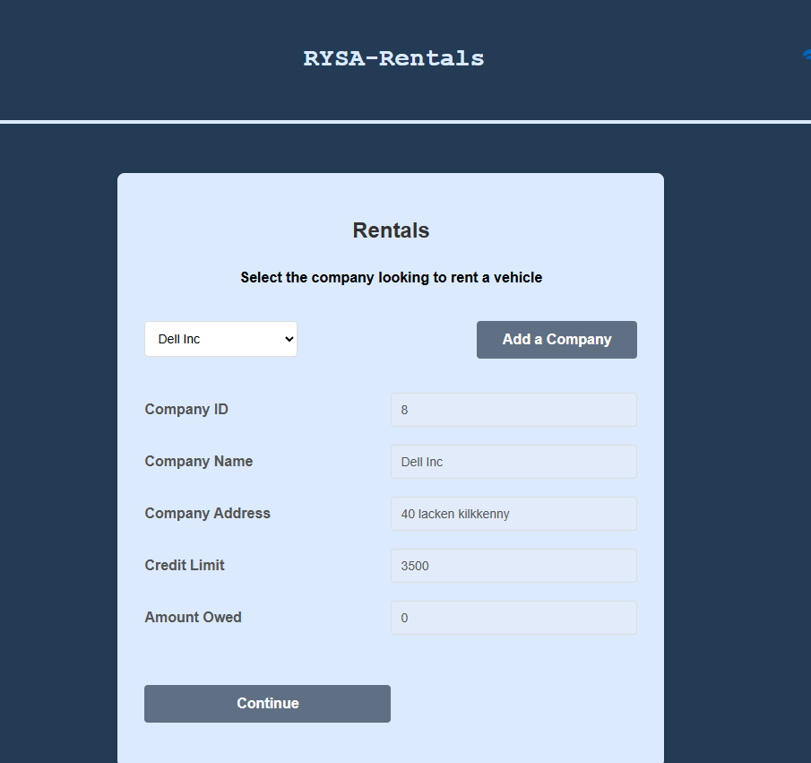
Code for this page
<!--
Screen - Add new company
This screen is a form to input data on a new company that is to be added to
the database, table Company
Jessica Power
C00312811
coding started - Feb 2026
-->
<?php session_start(); ?>
<!DOCTYPE html>
<html lang="en">
<head>
<meta charset="UTF-8">
<title>Rentals</title>

<!-- Link to external CSS file -->
<link rel="stylesheet" type="text/css" href="../../GroupWork/global.css">

</head>
<body>

<?php include('../../GroupWork/header.php') ?>

<div class="main">
<div class="nav">
<?php include('../../GroupWork/nav.php') ?>
</div>

<form
name="myForm"
action="Rent.html.php"
onsubmit="return confirmSel() && validateSel('listbox');"
method="post">

<h2>Rentals</h2>

<h4 style="text-align:center;">Select the company looking to rent a vehicle</h4>

<div class="form-group">

<!-- Include the PHP file that outputs the <select> list (listbox) of companys -->

<?php include 'CompanySel.php'; ?>
<input type="button" class="return" value="Add a Company"
onclick="window.location.href='../AddCompany/CompanyAdd.html.php'">
</div>

<div class="form-group">
<!-- Name field -->
<label for="comID">Company ID</label>
<input
type="text"
name="comID"
id="comID"
placeholder="Company ID"
value=""
required
disabled
>
</div>

<div class="form-group">
<!-- Name field -->
<label for="comName">Company Name</label>
<input
type="text"
name="comName"
id="comName"
placeholder="Company name"
required
disabled
>
</div>

<div class="form-group">
<!-- Address field -->
<label for="comAddress">Company Address</label>
<input
type="text"
name="comAddress"
id="comAddress"
placeholder="Address"
disabled
>
</div>

<div class="form-group">
<!-- credit limit field -->
<label for="credit"> Credit Limit </label>
<input
type="text"
name="credit"
id="credit"
placeholder="Credit Limit"
disabled
>
</div>

<div class="form-group">
<!-- credit limit field -->
<label for="owed"> Amount Owed </label>
<input
type="text"
name="owed"
id="owed"
placeholder="Amount Owed"
disabled
>
</div>

<br><br>
<div class="form-group">
<!-- Submit button to save changes -->
<input
type="submit"
value="Continue"
class = "return">
</div>
</form>

<script type="text/javascript">// this function validates that a company has been selected from the drop down before proceeding
function validateSel() {
var com = document.getElementById('listbox');
if(com.selectedIndex == 0 || com.options[com.selectedIndex].value == -1) {
alert('select a Company from option!');
return false;
}
return true;
}
</script>
<script src="../Company.js"></script>
</div>
</body>
</html>

Jessica/RentalScreen/CompanySel.php
Code for this php
<!--
• Using a list box show the names of all the companys on the table.
• Allow the user to select a company then display all of the details in labelled text boxes for viewing only (disabled).
• Include some validation before the details can be saved.
• When the user clicks “Delete”, present him/her with the option to confirm or cancel the changes.
• If the changes are confirmed, update the database, otherwise, no changes should be made.

This is for selecting a comaony from the db table
Jessica Power
C00312811
MARCH - 2026
-->

<?php
session_start();
// Include database connection settings and open a mysqli connection in $con
include "../../GroupWork/db.inc.php";

// Set default timezone so date/time functions behave consistently
date_default_timezone_set('UTC');

// Build SQL query to get active companys
$sql = "SELECT Name, Address, CreditLimit, AmountOwed, CompanyID
FROM Company
WHERE deleteFlag = 0 AND isBlacklisted = 0
";

// Run the query and handle any errors
if (!$result = mysqli_query($con, $sql)) {
die('Error in querying the database: ' . mysqli_error($con));
}

// Start the HTML select list, when an option is clicked, call JavaScript function popDelete()
echo "<div class='listboxJ'><br><select name='listbox' id='listbox' onclick='popSel()' required><option >Select Company</option>";

// Loop through each row returned from the query
while ($row = mysqli_fetch_array($result)) {

// Extract fields from the current database row
$name = $row['Name'];
$address = $row['Address'];
$credit = $row['CreditLimit'];
$owed = $row['AmountOwed'];
$id =$row['CompanyID'];
$allText = "$name,$address,$credit,$owed,$id";

$_SESSION['company']=$row['CompanyID'];

// Output an option element showing name to the user
echo "<option value='$allText'>$name</option>";
}

// Close the select tag
echo "</select></div>";

// Close the database connection
mysqli_close($con);
?>

Jessica/RentalScreen/Rent.html.php
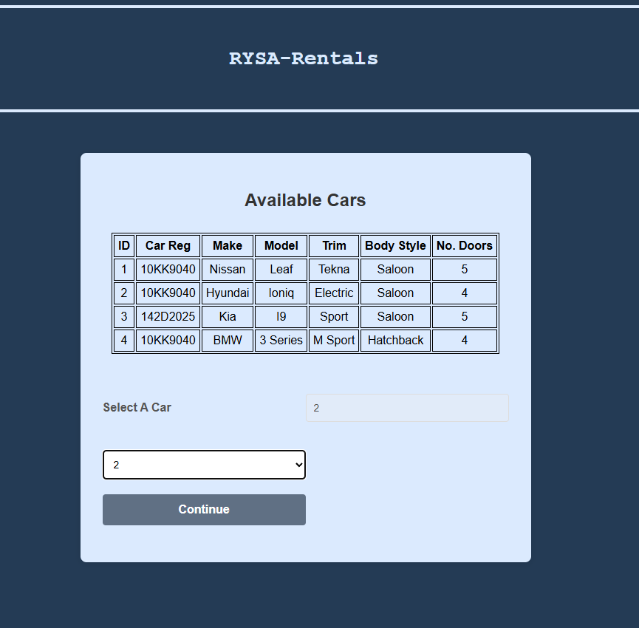
Code for this page
<!--
Screen - rental screen
This screen is a form to input data on a new company that is to be added to
the database, table Company
Jessica Power
C00312811
coding started - Mar 2026
-->

<?php
// Include database connection settings and open a mysqli connection in $con
include "../../GroupWork/db.inc.php";
session_start();
$_SESSION['company']=$_POST['comID'];

$sql = "SELECT
Car.carID, Car.carReg, CarType.Manufacturer,
CarType.Model, CarType.Version, Car.bodyStyle, Car.noOfDoors
FROM
Car
INNER JOIN CarType
ON Car.CarType=CarType.CarTypeID
WHERE
Car.DeletedFlag = 0 AND Car.currentStatus = 'Available' ";

// Run the query and handle any errors
if (!$result = mysqli_query($con, $sql)) {
die('Error in querying the database: ' . mysqli_error($con));
}

?>

<!DOCTYPE html>
<html lang="en">
<head>
<meta charset="UTF-8">
<title>Rental</title>

<!-- Link to external CSS file -->
<link rel="stylesheet" type="text/css" href="../../GroupWork/global.css">

</head>

<body>

<?php include('../../GroupWork/header.php') ?>

<div class="main">
<div class="nav">
<?php include('../../GroupWork/nav.php') ?>
</div>

<form action = "rentConfirm.php" method = "post" name = "rental" onsubmit="return confirmCheck() && carsend()">
<h2>Available Cars</h2>

<?php

echo "<table>
<tr><th>ID </th><th>Car Reg</th><th>Make</th><th>Model</th><th>Trim</th><th>Body Style</th><th>No. Doors</th></tr>";

// Loop through each row returned from the query
while ($row = mysqli_fetch_array($result)) {

//Display data of availible cars from the database
echo
"<td>". $row['carID']." </td>
<td>".$row['carReg']."</td>
<td>".$row['Manufacturer']."</td>
<td>".$row['Model']."</td>
<td>".$row['Version']."</td>
<td>". $row['bodyStyle']."</td>
<td>". $row['noOfDoors']."</td>

</tr>";
}

echo "</table>";

mysqli_close($con);
?>
<br><br><br>
<div class="form-group">
<!-- Selection -->
<label for="rental">Select A Car </label><br>
<input
type="text"
name="selected"
id="selected"
placeholder="Selected ID"
required
disabled
>

</div>
<?php include 'CarSel.php'; ?>
<div class="form-group">
<!-- Submit button to save changes -->
<input
type="submit"
value="Continue"
class = "return"
>

</div>
</form>
<script src="../Company.js"></script>
</div>
</body>
</html>

Jessica/RentalScreen/CarSel.php
Code for this php
<!--
• Using a list box show the names of all the companys on the table.
• Allow the user to select a company then display all of the details in labelled text boxes for viewing only (disabled).
• Include some validation before the details can be saved.
• When the user clicks “Delete”, present him/her with the option to confirm or cancel the changes.
• If the changes are confirmed, update the database, otherwise, no changes should be made.

This is for selecting a comaony from the db table
Jessica Power
C00312811
MARCH - 2026
-->

<?php
session_start();
// Include database connection settings and open a mysqli connection in $con
include "../../GroupWork/db.inc.php";

// Set default timezone so date/time functions behave consistently
date_default_timezone_set('UTC');

// Build SQL query to get active companys
$sql = "SELECT carID
FROM Car
WHERE DeletedFlag = 0 AND currentStatus = 'Available'
";

// Run the query and handle any errors
if (!$result = mysqli_query($con, $sql)) {
die('Error in querying the database: ' . mysqli_error($con));
}

// Start the HTML select list; when an option is clicked, call JavaScript function popDelete()
echo "<div class='listboxJ'><br><select name='listbox' id='listbox' onClick='carpop()'><option >Select Car</option>";

// Loop through each row returned from the query
while ($row = mysqli_fetch_array($result)) {

// Extract fields from the current database row
$id = $row['carID'];

$_SESSION['RAC']=$row['carID'];

// Output an option element showing name to the user
echo "<option value='$id' id='selected' >$id</option>";
}

// Close the select tag
echo "</select></div>";

// Close the database connection
mysqli_close($con);
?>

Jessica/RentalScreen/rentConfirm.php
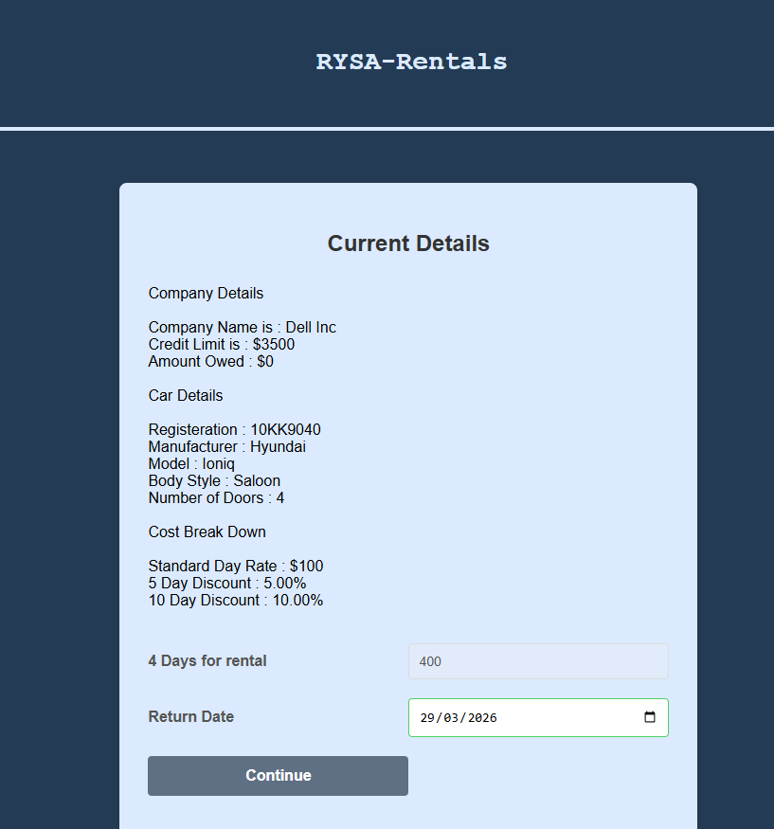
Code for this page
<!--
Screen - Rental
This screen is to select the company looking to rent a vehicle, select availible vehicles, calculate the cost based on
the return date and discounts that vehicle has applied and book out said vehicle
Jessica Power
C00312811
coding started - Mar 2026
-->
<?php session_start();
//session varaibles from selected company to selected car
$_SESSION['RAC']=$_POST['selected'];

$selRAC = $_SESSION['RAC'];
$selCID = $_SESSION['company'];
;?>
<!DOCTYPE html>
<html lang="en">
<head>
<meta charset="UTF-8">
<title>Rental</title>

<!-- Link to external CSS file -->
<link rel="stylesheet" type="text/css" href="../../GroupWork/global.css">
</head>
<body>

<?php include('../../GroupWork/header.php') ?>

<div class="main">
<div class="nav">
<?php include('../../GroupWork/nav.php') ?>
</div>

<form
action = "confirm.php"
method = "post"
name = "final"
onsubmit="return submitCheck()">
<h2>Current Details</h2>

<?php
// Include database connection settings and open a mysqli connection in $con
include "../../GroupWork/db.inc.php";

$comSQL= "SELECT
Name, CreditLimit, AmountOwed
FROM
Company
WHERE
CompanyID = '$selCID'";

$carSQL= "SELECT
Car.carReg, CarType.Manufacturer, CarType.Model, Car.carType, Car.bodyStyle,
Car.noOfDoors
FROM
Car
INNER JOIN CarType
ON Car.CarType=CarType.CarTypeID
WHERE
carID = '$selRAC' ";

// Run the query and handle any errors
if (!$result = mysqli_query($con, $comSQL)) {
die('Error in querying the database: ' . mysqli_error($con));
}

// Loop through each row returned from the query
while ($row = mysqli_fetch_array($result)) {

// Display submitted details for confirmation
echo "Company Details <br>" . "<br>" .
"Company Name is : " . $row['Name'] . "<br>" .
"Credit Limit is : $" . $row['CreditLimit'] . "<br>" .
"Amount Owed : $" . $row['AmountOwed'] . "<br>" ;

$credit = $row['CreditLimit'];
$owed = $row['AmountOwed'];
}

echo "<br>";

// Run the query and handle any errors
if (!$resultcar = mysqli_query($con, $carSQL)) {
die('Error in querying the database: ' . mysqli_error($con));
}

// Loop through each row returned from the query
while ($row = mysqli_fetch_array($resultcar)) {

// Display submitted details for confirmation
echo "Car Details <br>" . "<br>" .
"Registeration : " . $row['carReg'] . "<br>" .
"Manufacturer : " . $row['Manufacturer'] . "<br>" .
"Model : " . $row['Model'] . "<br>" .
"Body Style : " . $row['bodyStyle'] . "<br>" .
"Number of Doors : " . $row['noOfDoors'] . "<br><br>";

$carType = $row['carType'];
}

$catSQL = "SELECT
RentalCategory
FROM
CarType
WHERE
CarTypeID = '$carType'";

// Run the query and handle any errors
if (!$resultcat = mysqli_query($con, $catSQL)) {
die('Error in querying the database: ' . mysqli_error($con));
}

// Loop through each row returned from the query
while ($row = mysqli_fetch_array($resultcat)) {
$rentalCat = $row['RentalCategory'];

}

$costSQL = "SELECT
StndDayCost, FiveDayDiscount, TenDayDiscount
FROM
RentalCat
WHERE
RentalCategory = '$rentalCat'";

// Run the query and handle any errors
if (!$resultcost = mysqli_query($con, $costSQL)) {
die('Error in querying the database: ' . mysqli_error($con));
}

// Loop through each row returned from the query
while ($row = mysqli_fetch_array($resultcost)) {
$StndDayCost = $row['StndDayCost'];
$FiveDayDiscount = $row['FiveDayDiscount'];
$TenDayDiscount = $row['TenDayDiscount'];

// Display submitted details for confirmation
echo "Cost Break Down <br>" . "<br>" .
"Standard Day Rate : " . "$" . $StndDayCost . "<br>" .
"5 Day Discount : " . $FiveDayDiscount . "%" . "<br>" .
"10 Day Discount : " . $TenDayDiscount ."%" . "<br>"
;

}

// Close the database connection
mysqli_close($con);
?>

<br><br>
<div class="form-group">

<label id="rentday" for="rentcost"></label>
<input
type="text"
name="rentcost"
id="rentcost"
value="Cost"
disabled>
</div>

<div class="form-group">
<label for="returnDate">Return Date</label>
<input
type="date"
name="returnDate"
id="returnDate"
onchange="costCAL()"
required>
</div>

<div class="form-group">
<input
type="submit"
id="next"
value="Continue"
class = "return"
disabled>
</div>
</form>
<script>
//Var for cost calculations
var credit = "<?php echo"$credit"?>";
var owed = "<?php echo"$owed"?>";

var standard = "<?php echo"$StndDayCost"?>";
var five = "<?php echo"$FiveDayDiscount"?>";
var ten = "<?php echo"$TenDayDiscount"?>";

var allowed = credit-owed;
var proceed = document.getElementById('rentday');

function costCAL(){ //function that takes return date gets total days renting to the calculate the cost with applied
//discounts based on the rental category of selected vihicle

var returnDate = document.getElementById('returnDate').value;
var rtnBACK = new Date(returnDate);
var today = new Date();
var millisecondsDiff = rtnBACK.getTime() - today.getTime()//converts both dates to millisecond values
var daysDiff = Math.round(
millisecondsDiff / (24 * 60 * 60 * 1000)+1) //the plus one is to offset hours differences

if(daysDiff<1){
proceed.textContent = "Must be future date "; //cannot select previous date must be renting in future
}
else{
proceed.textContent = daysDiff + " Days for rental";

if(allowed>0){
var stdcost=daysDiff*standard;

if(daysDiff<5){
if(allowed<stdcost){
document.getElementById('rentcost').value="Over Credit Limit"; //if cost to rent exceeds availible credit
//they cannot proceed
}else{
document.getElementById('rentcost').value=stdcost;
document.getElementById('next').disabled=false; //enables continue button
}
}
if(daysDiff>=5 && daysDiff<10){
var fivecost=stdcost-(stdcost*(five/100)); //if return date exceeds 5 days discount is calculated
if(allowed<fivecost){
document.getElementById('rentcost').value="Over Credit Limit";
}else{
document.getElementById('rentcost').value=fivecost;
document.getElementById('next').disabled=false;
}
}
if(daysDiff>=10){
var tencost=stdcost-(stdcost*(ten/100)); //if return date exceeds 10 days discount is calculated
if(allowed<tencost){
document.getElementById('rentcost').value="Over Credit Limit";
}else{
document.getElementById('rentcost').value=tencost;
document.getElementById('next').disabled=false;
}
}
}
else{
document.getElementById('rentcost').value="No Credit"; //if amount owed equall credit limit
}

}
}

function submitCheck(){
// Variable to store the user's response from the confirm dialog
var response;

// Show confirmation dialog asking the user to save changes
response = confirm('Are you sure you want to proceed?');

// If the user clicks "OK"
if (response) {

// Allow the action to proceed
document.getElementById("rentcost").disabled = false;
return true;
}
else {

// Prevent the action
return false;
}
}

</script>
<script src="../Company.js"></script>
</div>
</body>
</html>

Jessica/RentalScreen/confirm.php
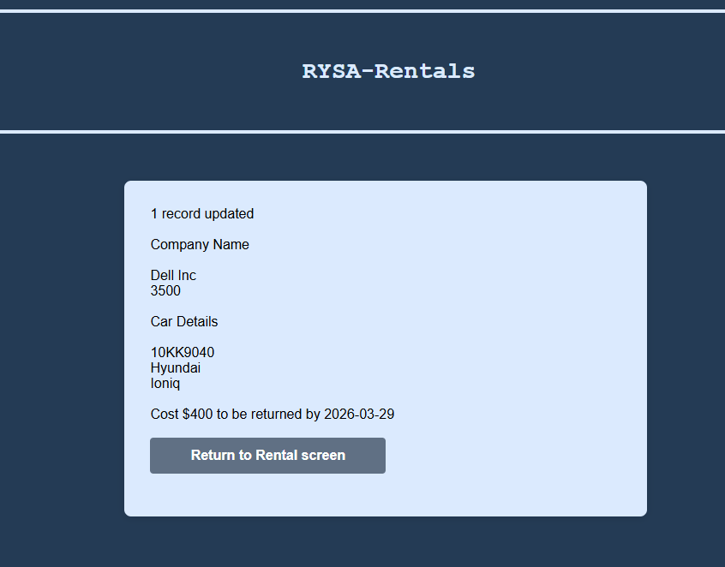
Code for this page
<!--
This screen simply displays all information from the process of renting a car to a company as well as
notifying that the records have been updated with displayed information

Jessica Power
C00312811
Feb - 2026
-->
<?php session_start();
//session varaibles from selected company to selected car
$_SESSION['cost']=$_POST['rentcost'];
$_SESSION['rtn']=$_POST['returnDate'];

$RAC = $_SESSION['RAC'];
$CID = $_SESSION['company'];
$MONEY = $_SESSION['cost'];
$return = $_SESSION['rtn'];
;?>

<meta charset="UTF-8">
<title>Rental</title>
<link rel="stylesheet" type="text/css" href="../../GroupWork/global.css">
<?php include('../../GroupWork/header.php') ?>

<div class="main">
<div class="nav">
<?php include('../../GroupWork/nav.php') ?>
</div>
<form action="rentConfirm.php" method="post">
<?php

// Include database connection file
include '../../GroupWork/db.inc.php';

// Set the default timezone to UTC
date_default_timezone_set('UTC');

$date = date("Y-m-d H:i:s");

// Build the SQL UPDATE query to for company table and car table
$updatesql = "

UPDATE Company, Car
SET Company.AmountOwed = Company.AmountOwed + '$MONEY',
Company.TotalRentals = Company.TotalRentals + 1,
Company.DateAmended = '{$date}',
Car.currentStatus = 'Rented',
Car.CumulativeRentals = Car.CumulativeRentals + 1
WHERE
Company.CompanyID = '$CID'
AND Car.CarID = '$RAC' ";
//SQL query gathered for display info from car, company and cartype tables
$carSQL= "SELECT
Car.carReg, Car.carType, Car.bodyStyle,
CarType.Manufacturer, CarType.Model,
Company.Name, Company.CreditLimit
FROM
Car, Company, CarType
WHERE
Car.carID = '$RAC'
and Company.CompanyID='$CID'
AND CarType.CarTypeID=Car.carType";

// Execute the query and check for errors
if (!mysqli_query($con, $updatesql)) {

// Output MySQL error if query fails
echo "Error: " . mysqli_error($con);

} else {

// Check if any rows were actually updated
if (mysqli_affected_rows($con) != 0) {

// Run the query and handle any errors
if (!$result = mysqli_query($con, $carSQL)) {
die('Error in querying the database: ' . mysqli_error($con));
}

// Loop through each row returned from the query
while ($row = mysqli_fetch_array($result)) {
// Display success message with record count
echo mysqli_affected_rows($con) . " record updated <br><br>";

// Display confirmation of updated details
echo "Company Name " . "<br><br>" .
$row['Name'] . " <br>" .
$row['CreditLimit'] . " " . "<br><br>".
"Car Details " . "<br><br>" .
$row['carReg'] . " <br>" .
$row['Manufacturer'] . " " . "<br>" .
$row['Model'] . " " . "<br><br>" .
"Cost $" . $MONEY . " to be returned by " . $return . "<br><br>"
;
}

} else {

// No rows changed (e.g. same data submitted)
echo "No records were changed<br><br><br>";
}
}

// Close the database connection
mysqli_close($con);

?>

<div class="form-group">
<input type = "button" class="return" value = "Return to Rental screen"
onclick="window.location.href='RentalSelCompany.html.php'">
</div>

</form>
Project
AI Disclosure Document
Student Name: Jessica Power
Student ID: C00312811
Course Name IT Management
Project Title Car Rental 1
Code Unit For rental screen
Date Submitted: 24/03/2026

AI Assistance Disclosure
AI Technologies Used
Indicate whether you used AI technologies in completing this task:
X No, I did not use any AI tools.
☐ Yes, I used AI tools. (List all AI technologies used, e.g., ChatGPT, GitHub Copilot, Codeium, Google Bard, etc.)

Prompts Used
If AI was used, describe the prompts or queries you provided to the AI tools:

Nature of Assistance

Sarah Crotty

ADD SCREEN
This screen gives the user the ability to add a new car type to the database. The user provides details such as theManufacturer, Model, Version, Engine size, Fuel Type and rental category. Rental Category is populated from the RentalCat table.
There is html validation for input field as well as a confirm details pop up when submitting also javascript code making the cars types follow strict rules such as, Electric cars can only have engine size 0, petrol/ diesel must be greater than 0 and the car type cannot already exist UNLESS the flag is set to deleted (Y) . You are then taken to a php page displaying the details that have been set to the database and given an option to return to the add screen.

/Sarah/AddCarType/addcarType.html.php
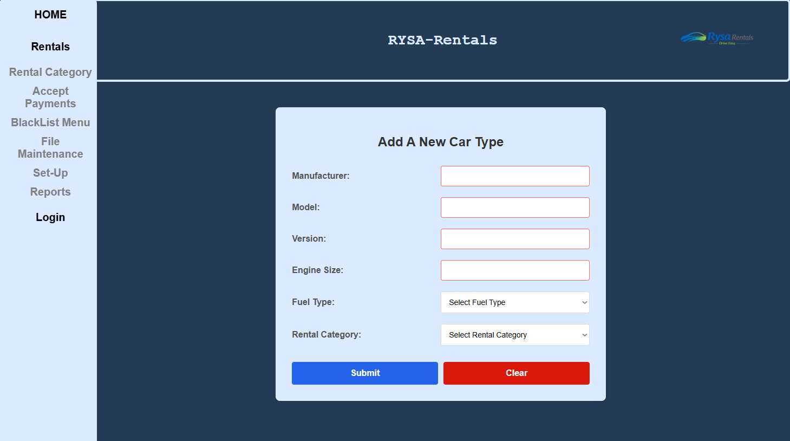
Add Screen Code
addcarType.html.php
<!-- Name: Sarah Crotty -->
<!-- Student Number: C00309469 -->
<!-- Purpose: add car type screen form html -->
<!--Project: Car rental -->
<HTML>
<head>
<link rel="stylesheet" type="text/css" href="../../GroupWork/global.css"> <!-- link css -->
</head>
<body>

<?php include('../../GroupWork/header.php') ?> <!-- include header -->

<div class="main">
<div class="nav"> <!-- nav bar link -->
<?php include('../../GroupWork/nav.php') ?> <!-- include navbar php -->
</div>

<!-- FORM -->
<form method="POST" action="addcarType.php" onsubmit="return validateForm();">
<h2> Add A New Car Type </h2>
<div class="form-group">
<label for="manufacturer"> Manufacturer:</label>
<input type=text id="manufacturer" name="manufacturer" required pattern="[A-Za-z\s]+" title="Letters only" maxlength="30">
</div>
<div class="form-group">
<label for="model"> Model:</label>
<input type=text id="model" name="model" required pattern="[A-Za-z0-9\s\-]+" title="Letters, numbers, spaces and hyphens only" >
</div>
<div class="form-group">
<label for="version"> Version:</label>
<input type=text id="version" name="version" required pattern="[A-Za-z\s]+" title="Letters only" maxlength="20">
</div>
<div class="form-group">
<label for="engine"> Engine Size:</label>
<input type=number id="engine" name="engine" min="0" max="3.0" step="0.1" required>
</div>
<div class="form-group">
<label for="fuel"> Fuel Type:</label>
<select name="fuel" id="fuel" required>
<option value="">Select Fuel Type</option>
<option value="hybrid">Hybrid</option>
<option value="electric">Electric</option>
<option value="petrol">Petrol</option>
<option value="diesel">Diesel</option>
</select>
</div>
<div class="form-group">
<label for="category">Rental Category:</label>
<select name="category" id="category" required>
<option value="">Select Rental Category</option>
<?php
include '../../GroupWork/db.inc.php';

$sql = "SELECT RentalCategory FROM RentalCat ORDER BY RentalCategory";
$result = mysqli_query($con, $sql);

if (!$result)
{
die("Query failed: " . mysqli_error($con));
}

while ($row = mysqli_fetch_array($result))
{
echo "<option value='" . $row['RentalCategory'] . "'>" . $row['RentalCategory'] . "</option>";
}
?>
</select>
</div>

<!-- BUTTONS -->
<div> </div>
<div class="button-group">
<button type="submit">Submit</button>
<button type="reset">Clear</button>
</div>
</form>
<script src="addcarType.js"></script> <!--linking external javascript file-->
</div>
</body>
</HTML>
Sarah/AddCarType/addcarType.php
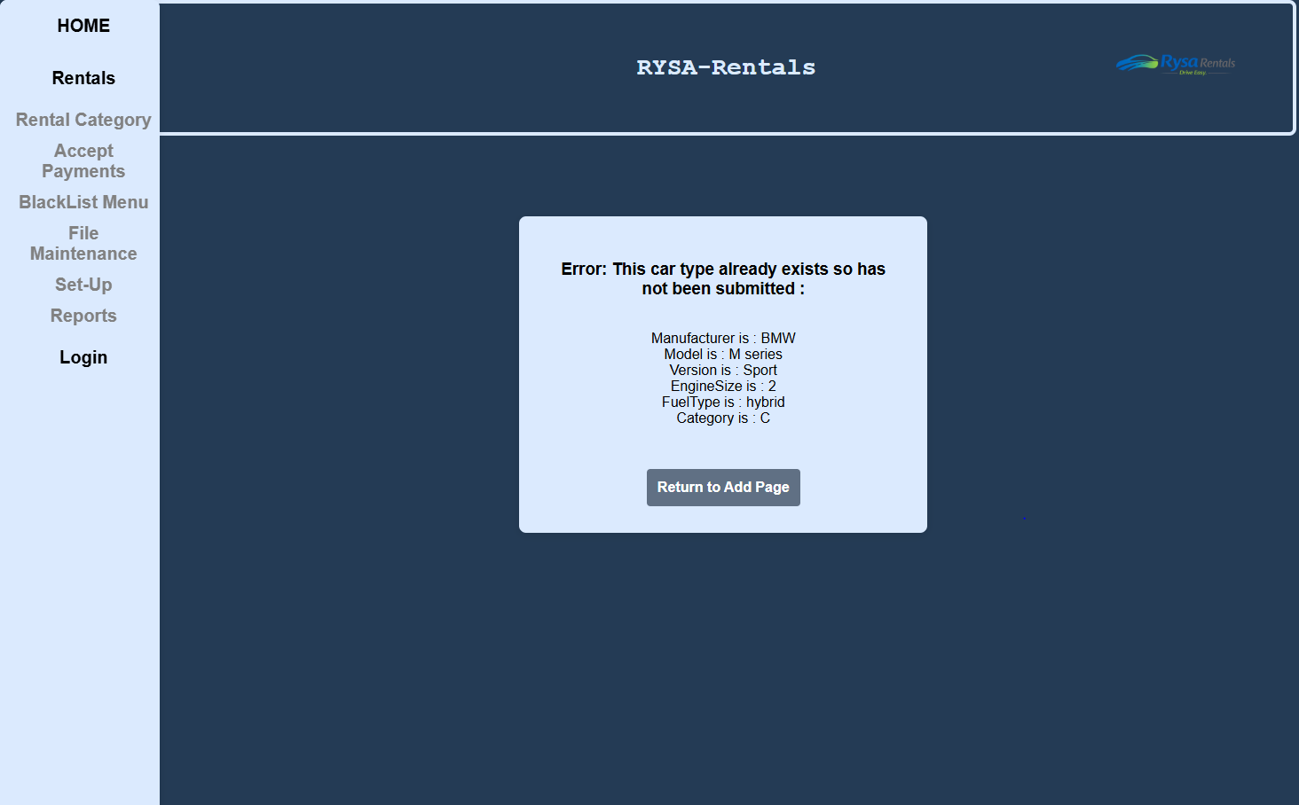
Php code.
<!-- Name: Sarah Crotty -->
<!-- ID: C00309469 -->
<!-- Purpose: php file for add screen with connection and insert commands -->
<!-- Project: Car Rental -->
<HTML>
<head>
<link rel="stylesheet" type="text/css" href="../../GroupWork/global.css">
</head>
<body>

<?php include('../../GroupWork/header.php') ?>

<div class="main">
<div class="nav">
<?php include('../../GroupWork/nav.php') ?>
</div>

<?php
include '../../GroupWork/db.inc.php';

$manufacturer = mysqli_real_escape_string($con, $_POST["manufacturer"]);
$model = mysqli_real_escape_string($con, $_POST["model"]);
$version = mysqli_real_escape_string($con, $_POST["version"]);
$engine = mysqli_real_escape_string($con, $_POST["engine"]);
$fuel = mysqli_real_escape_string($con, $_POST["fuel"]);
$category = mysqli_real_escape_string($con, $_POST["category"]);

// check for duplicate before inserting
$query = "SELECT * FROM CarType
WHERE Manufacturer = '$manufacturer'
AND Model = '$model'
AND Version = '$version'
AND EngineSize = '$engine'
AND FuelType = '$fuel'
AND DeletedFlag = 'N'";

$result = mysqli_query($con, $query);

if (!$result)
{
die("ERROR: " . mysqli_error($con));
}

// inserting if not duplicate
if (mysqli_num_rows($result) == 0)
{
$insert = "INSERT INTO CarType
(Manufacturer, Model, Version, EngineSize, FuelType, RentalCategory)
VALUES
('$manufacturer','$model','$version','$engine','$fuel','$category')";

if (!mysqli_query($con, $insert))
{
die("The insert has failed: " . mysqli_error($con));
}

$newID = mysqli_insert_id($con);

echo "<form class='php-form'><h3>Car type details being submitted : </h3><br>" .
"Auto Generated ID : " . $newID . "<br>" .
"Manufacturer is : " . $manufacturer . "<br>" .
"Model is : " . $model . "<br>" .
"Version is : " . $version . "<br>" .
"EngineSize is : " . $engine . "<br>" .
"FuelType is : " . $fuel . "<br>" .
"Category is : " . $category . "<br>" .
"<br><div class='button-group'><a href='addcarType.html.php' class='return'>Return to Add Page</a></div>" .
"</form>";
}
else
{
echo "<form class='php-form'><h3>Error: This car type already exists so has not been submitted : </h3><br>" .
"Manufacturer is : " . $manufacturer . "<br>" .
"Model is : " . $model . "<br>" .
"Version is : " . $version . "<br>" .
"EngineSize is : " . $engine . "<br>" .
"FuelType is : " . $fuel . "<br>" .
"Category is : " . $category . "<br>" .
"<br><div class='button-group'><a href='addcarType.html.php' class='return'>Return to Add Page</a></div>" .
"</form>";
}
mysqli_close($con);
?>
</div>
</body>
</HTML>
Java Script Code.
<!-- Name: Sarah Crotty -->
<!-- Student Number: C00309469 -->
<!-- Purpose: add car type screen javascript -->
<!--Project: Car rental -->
// function for validating the form //
function validateForm()
{
//variables//
let manufacturer = document.getElementById("manufacturer").value;
let model = document.getElementById("model").value;
let version = document.getElementById("version").value;
let engine = document.getElementById("engine").value;
let fuel = document.getElementById("fuel").value;
let category = document.getElementById("category").value;
let engineNum = parseFloat(engine);
// making sure all fields arent empty //
if (manufacturer === "" || model === "" || version === "" || engine === "" || fuel === "" || category === "")
{
alert("All fields must be filled.")
return false;
}
// making sure the engine size is valid //
if (isNaN(engineNum) || engineNum < 0)
{
alert("Engine size must be a valid number.")
return false;
}
//rule for engine size for the electric cars//
if (fuel === "electric" && engineNum !== 0)
{
alert("Electic cars can only have an engine size of 0.")
return false;
}
//rule for non electric cars, they must be greater than 0//
if (fuel !== "electric" && engineNum <= 0)
{
alert("Engine size must be greater than 0.")
return false;
}
//confirm before insert//
if (!confirm("Please confirm that the details supplied are correct"))
{
return false;
}
{
return true; }}
AI Disclosure Document
Student Name: Sarah Crotty
Student ID: C00309469
Course Name Software Development
Project Title RYSA Rentals
Code Unit Add Screen
Date Submitted: 25/03/2026
AI Assistance Disclosure
AI Technologies Used
Indicate whether you used AI technologies in completing this task:
X No, I did not use any AI tools.
☐ Yes, I used AI tools. (List all AI technologies used, e.g., ChatGPT, GitHub Copilot, Codeium, Google Bard, etc.)

Prompts Used
If AI was used, describe the prompts or queries you provided to the AI tools:

Nature of Assistance
Indicate how AI technologies contributed to your work by selecting and elaborating on the relevant categories below:
- Code Suggestions & Auto-Completion: (e.g., AI suggested code snippets, function implementations, syntax corrections, etc.)

DELETE SCREEN
This screen gives the user the ability to soft delete a car type from the database setting delete flag to Y. The user chooses a car type from a dropdown menu, this populates a form so details are visible but not changeable! Then you have the option to delete or clear the form. If delete is chosen it first checks if there is a car that has this Car type, If so the car type can not be deleted. Otherwise the car type is removed ofcourse with javascript asking/ confirming you truly want to delete the car type. You are then brought to the php screen which displays either the error or the details of the car that was deleted with a button giving the option to return to the delete screen.
/Sarah/DeleteCarType/deletecarType.html.php
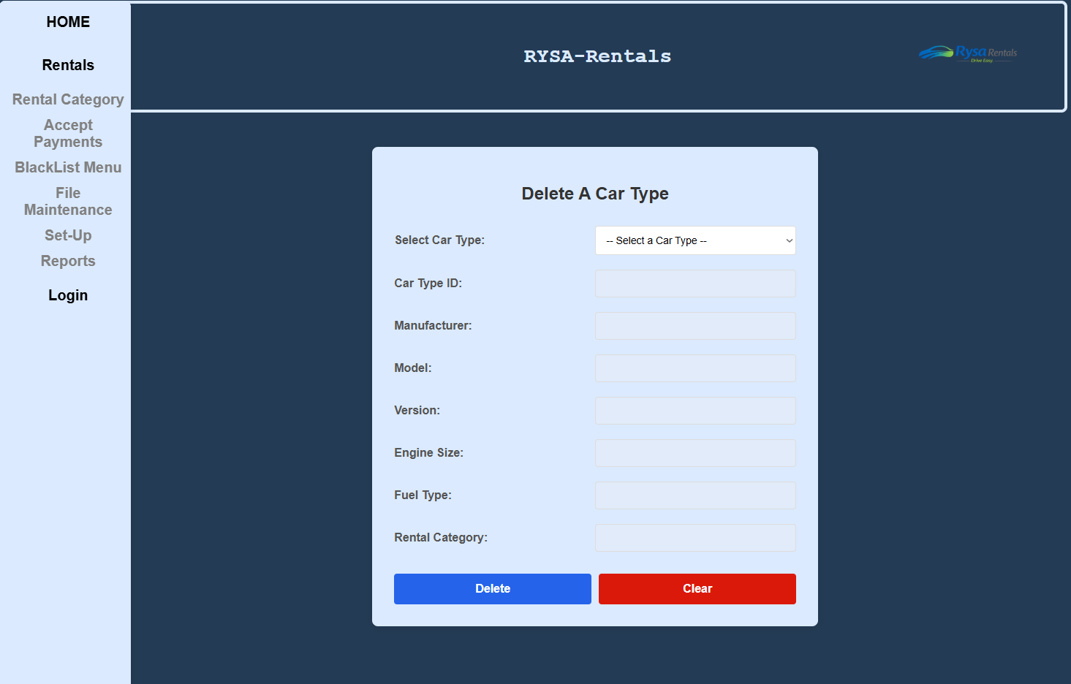
Delete Screen Code.
deleteCarType.html.php
<!-- Name: Sarah Crotty -->
<!-- Student Number: C00309469 -->
<!-- Purpose: delete car type screen form html -->
<!--Project: Car rental -->
<HTML>
<head>
<link rel="stylesheet" type="text/css" href="../../GroupWork/global.css"> <!-- link css -->
</head>
<body>

<?php include('../../GroupWork/header.php') ?> <!-- include header -->

<div class="main">
<div class="nav"> <!-- nav bar link -->
<?php include('../../GroupWork/nav.php') ?> <!-- include navbar php -->
</div>

<!-- FORM -->
<form method="POST" action="deletecarType.php" onsubmit="return confirmCheck();">
<h2>Delete A Car Type</h2>

<div class="form-group">
<label for="listbox">Select Car Type:</label>
<select id="listbox" name="listbox" onclick="populate()" required>
<option value="">-- Select a Car Type --</option>
<?php
include '../../GroupWork/db.inc.php';

// only show car types not already flagged for deletion
$sql = "SELECT CarTypeID, Manufacturer, Model, Version, EngineSize, FuelType, RentalCategory
FROM CarType
WHERE DeletedFlag = 'N'
ORDER BY Manufacturer, Model";

$result = mysqli_query($con, $sql);

if (!$result)
{
die("Query failed: " . mysqli_error($con));
}

while ($row = mysqli_fetch_array($result))
{
// store all details comma-separated in value so populate() can fill the fields
$allText = $row['CarTypeID'] . "," . $row['Manufacturer'] . "," . $row['Model'] . "," .
$row['Version'] . "," . $row['EngineSize'] . "," . $row['FuelType'] . "," .
$row['RentalCategory'];

echo "<option value='" . $allText . "'>" .
$row['Manufacturer'] . " " . $row['Model'] . " " . $row['Version'] .
"</option>";
}

mysqli_close($con);
?>
</select>
</div>

<!-- visible disabled fields - populate() fills these when user picks from listbox -->
<div class="form-group">
<label for="delID">Car Type ID:</label>
<input type="text" id="delID" name="delID" disabled/>
</div>
<div class="form-group">
<label for="delManufacturer">Manufacturer:</label>
<input type="text" id="delManufacturer" name="delManufacturer" disabled/>
</div>
<div class="form-group">
<label for="delModel">Model:</label>
<input type="text" id="delModel" name="delModel" disabled/>
</div>
<div class="form-group">
<label for="delVersion">Version:</label>
<input type="text" id="delVersion" name="delVersion" disabled/>
</div>
<div class="form-group">
<label for="delEngine">Engine Size:</label>
<input type="text" id="delEngine" name="delEngine" disabled/>
</div>
<div class="form-group">
<label for="delFuel">Fuel Type:</label>
<input type="text" id="delFuel" name="delFuel" disabled/>
</div>
<div class="form-group">
<label for="delCategory">Rental Category:</label>
<input type="text" id="delCategory" name="delCategory" disabled/>
</div>

<!-- BUTTONS -->
<div class="button-group">
<button type="submit">Delete</button>
<button type="reset">Clear</button>
</div>
</form>

<script src="deletecarType.js"></script> <!--linking external javascript file-->
</div>
</body>
</HTML>

Sarah/DeleteCarType/deletecarType.php
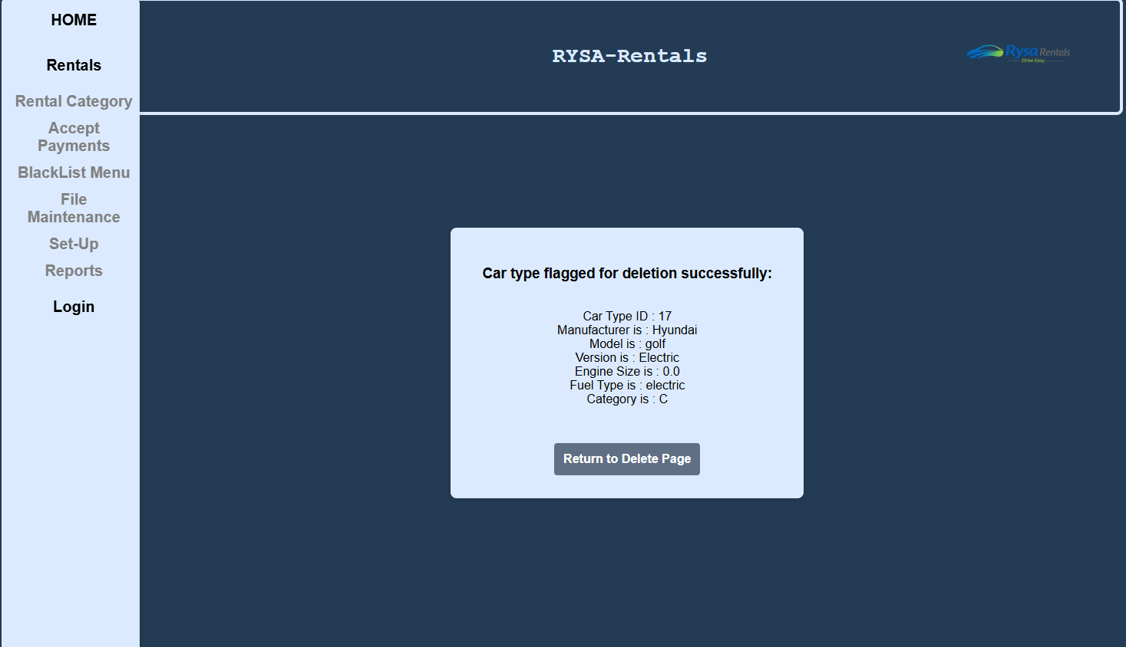
deletecarType.php code
<?php
/* Name: Sarah Crotty */
/* ID: C00309469 */
/* Purpose: php file for delete screen - sets DeletedFlag to 'Y' (soft delete) */
/* Project: Car Rental */
?>
<HTML>
<head>
<link rel="stylesheet" type="text/css" href="../../GroupWork/global.css"> <!-- link css -->
</head>
<body>

<?php include('../../GroupWork/header.php') ?> <!-- include header -->

<div class="main">
<div class="nav"> <!-- nav bar link -->
<?php include('../../GroupWork/nav.php') ?> <!-- include navbar php -->
</div>

<?php
include '../../GroupWork/db.inc.php';

// variables from hidden POST fields
$delID = mysqli_real_escape_string($con, $_POST["delID"]);
$delManufacturer = mysqli_real_escape_string($con, $_POST["delManufacturer"]);
$delModel = mysqli_real_escape_string($con, $_POST["delModel"]);
$delVersion = mysqli_real_escape_string($con, $_POST["delVersion"]);
$delEngine = mysqli_real_escape_string($con, $_POST["delEngine"]);
$delFuel = mysqli_real_escape_string($con, $_POST["delFuel"]);
$delCategory = mysqli_real_escape_string($con, $_POST["delCategory"]);

// check if any non-deleted cars of this type still exist in the fleet
$check = "SELECT * FROM Car WHERE carType = '$delID' AND DeletedFlag = 'N'";
$checkResult = mysqli_query($con, $check);

if (!$checkResult)
{
die("Check query failed: " . mysqli_error($con));
}

if (mysqli_num_rows($checkResult) > 0)
{
// cars still exist for this type - refuse the delete
echo "<form class='php-form'><h3>Error: Cannot delete this car type — there are still cars of this type in the fleet.</h3><br>" .
"Car Type ID : " . $delID . "<br>" .
"Manufacturer is : " . $delManufacturer . "<br>" .
"Model is : " . $delModel . "<br>" .
"Version is : " . $delVersion . "<br>" .
"<br><div class='button-group'><a href='deletecarType.html.php' class='return'>Return to Delete Page</a></div>" .
"</form>";
}
else
{
// no cars of this type exist - safe to soft delete
$sql = "UPDATE CarType SET DeletedFlag = 'Y' WHERE CarTypeID = '$delID'";

if (!mysqli_query($con, $sql))
{
die("The delete has failed: " . mysqli_error($con));
}

// check something was actually updated
if (mysqli_affected_rows($con) != 0)
{
// success output
echo "<form class='php-form'><h3>Car type flagged for deletion successfully:</h3><br>" .
"Car Type ID : " . $delID . "<br>" .
"Manufacturer is : " . $delManufacturer . "<br>" .
"Model is : " . $delModel . "<br>" .
"Version is : " . $delVersion . "<br>" .
"Engine Size is : " . $delEngine . "<br>" .
"Fuel Type is : " . $delFuel . "<br>" .
"Category is : " . $delCategory . "<br>" .
"<br><div class='button-group'><a href='deletecarType.html.php' class='return'>Return to Delete Page</a></div>" .
"</form>";
}
else
{
// nothing changed
echo "<form class='php-form'><h3>Error: No record was updated. Please try again.</h3><br>" .
"Car Type ID : " . $delID . "<br>" .
"<br><div class='button-group'><a href='deletecarType.html.php' class='return'>Return to Delete Page</a></div>" .
"</form>";
}
}

// closing database connection
mysqli_close($con);
?>

</div>
</body>
</HTML>

Java Script Code
<!-- Name: Sarah Crotty -->
<!-- Student Number: C00309469 -->
<!-- Purpose: delete car type screen javascript -->
<!--Project: Car rental -->

// populate() - fires when user clicks the listbox
// splits the comma-separated option value and fills the display fields
function populate()
{
let sel = document.getElementById("listbox");
let result = sel.options[sel.selectedIndex].value;

if (result === "") return; // nothing selected yet

let details = result.split(',');

// fill the visible disabled fields so user can see the details
document.getElementById("delID").value = details[0];
document.getElementById("delManufacturer").value = details[1];
document.getElementById("delModel").value = details[2];
document.getElementById("delVersion").value = details[3];
document.getElementById("delEngine").value = details[4];
document.getElementById("delFuel").value = details[5];
document.getElementById("delCategory").value = details[6];
}

// confirmCheck() - runs on form submit
// checks something is selected, asks for confirmation, then enables fields for POST
function confirmCheck()
{
let sel = document.getElementById("listbox");

// make sure user has actually selected something
/* if (sel.value === "")
{
alert("Please select a car type to delete.");
return false;
}
*/
// ask user to confirm before deleting
if (!confirm("Are you sure you want to delete this car type?"))
{
return false;
}

// enable all fields so they are included in the POST (disabled fields don't submit)
document.getElementById("delID").disabled = false;
document.getElementById("delManufacturer").disabled = false;
document.getElementById("delModel").disabled = false;
document.getElementById("delVersion").disabled = false;
document.getElementById("delEngine").disabled = false;
document.getElementById("delFuel").disabled = false;
document.getElementById("delCategory").disabled = false;

return true;
}

AI Disclosure Document
Student Name: Sarah Crotty
Student ID: C00309469
Course Name Software Development
Project Title RYSA Rentals
Code Unit Delete Screen
Date Submitted: 25/03/2026
AI Assistance Disclosure
AI Technologies Used
Indicate whether you used AI technologies in completing this task:
X No, I did not use any AI tools.
☐ Yes, I used AI tools. (List all AI technologies used, e.g., ChatGPT, GitHub Copilot, Codeium, Google Bard, etc.)

Prompts Used
If AI was used, describe the prompts or queries you provided to the AI tools:

Nature of Assistance
Indicate how AI technologies contributed to your work by selecting and elaborating on the relevant categories below:
- Code Suggestions & Auto-Completion: (e.g., AI suggested code snippets, function implementations, syntax corrections, etc.)

- Debugging & Error Fixing: (e.g., AI identified and corrected syntax/logical errors, suggested refactoring, etc.)

AMEND SCREEN
This screen gives the user the ability to amend a car type in the database. The user selects a Car type from a dropdown menu, once chosen the form is filled disabled at first showing details, then if you click amend details button the fields are editable. I made sure that all validation in add screen applies to the amend screen also meaning an electric car cant be more than 0 engine size, petrol/diesel has to be more than 0, etc. You can clear the form to remove details or save changes which asks for confirmation then brings you to the php screen. The php screen shows car details changed and has a button to return to the amend screen.
Sarah/AmmendCarType/amendcarType.html.php
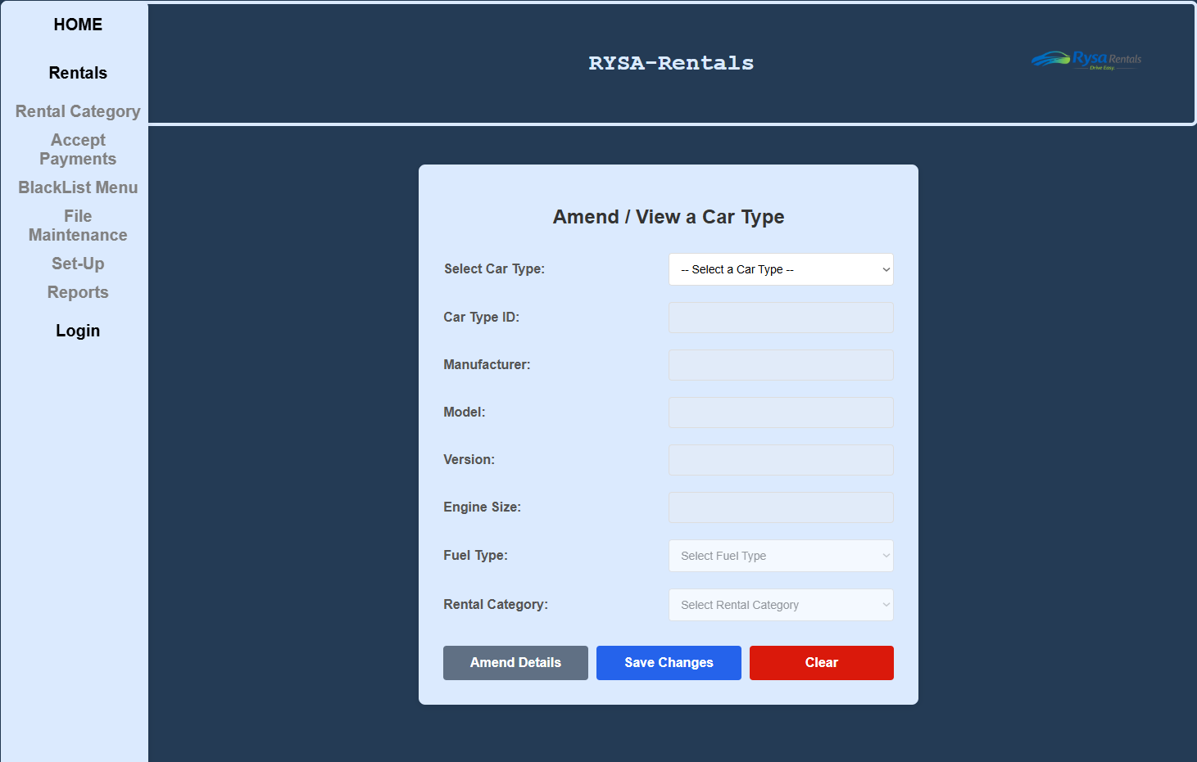
Amend Screen Code
amendcarType.html.php
<!-- Name: Sarah Crotty -->
<!-- Student Number: C00309469 -->
<!-- Purpose: amend/view car type screen form html -->
<!--Project: Car rental -->
<HTML>
<head>
<link rel="stylesheet" type="text/css" href="../../GroupWork/global.css"> <!-- link css -->
</head>
<body>

<?php include('../../GroupWork/header.php') ?> <!-- include header -->

<div class="main">
<div class="nav"> <!-- nav bar link -->
<?php include('../../GroupWork/nav.php') ?> <!-- include navbar php -->
</div>

<!-- FORM -->
<form method="POST" action="amendcarType.php" onsubmit="return confirmCheck();" name="amendForm">
<h2>Amend / View a Car Type</h2>

<!-- LISTBOX -->
<div class="form-group">
<label for="listbox">Select Car Type:</label>
<select id="listbox" name="listbox" onclick="populate()">
<option value="" selected disabled>-- Select a Car Type --</option>
<?php
include '../../GroupWork/db.inc.php';

// only show car types not flagged for deletion
$sql = "SELECT CarTypeID, Manufacturer, Model, Version, EngineSize, FuelType, RentalCategory
FROM CarType
WHERE DeletedFlag = 'N'
ORDER BY Manufacturer, Model";

$result = mysqli_query($con, $sql);

if (!$result)
{
die("Query failed: " . mysqli_error($con));
}

while ($row = mysqli_fetch_array($result))
{
// comma-separated value so populate() can split and fill the fields
$allText = $row['CarTypeID'] . "," . $row['Manufacturer'] . "," . $row['Model'] . "," .
$row['Version'] . "," . $row['EngineSize'] . "," . $row['FuelType'] . "," .
$row['RentalCategory'];

echo "<option value='" . $allText . "'>" .
$row['Manufacturer'] . " " . $row['Model'] . " " . $row['Version'] .
"</option>";
}

mysqli_close($con);
?>
</select>
</div>

<!-- car type is disabled so cant be edited-->
<div class="form-group">
<label for="amendID">Car Type ID:</label>
<input type="text" id="amendID" name="amendID" disabled/>
</div>

<div class="form-group">
<label for="amendManufacturer">Manufacturer:</label>
<input type="text" id="amendManufacturer" name="amendManufacturer" pattern="[A-Za-z\s]+" title="Letters only" maxlength="30" disabled/>
</div>

<div class="form-group">
<label for="amendModel">Model:</label>
<input type="text" id="amendModel" name="amendModel" pattern="[A-Za-z0-9\s\-]+" title="Letters, numbers, spaces and hyphens only" disabled/>
</div>

<div class="form-group">
<label for="amendVersion">Version:</label>
<input type="text" id="amendVersion" name="amendVersion" pattern="[A-Za-z\s]+" title="Letters only" maxlength="20" disabled/>
</div>

<div class="form-group">
<label for="amendEngine">Engine Size:</label>
<input type="number" id="amendEngine" name="amendEngine" min="0" max="3.0" step="0.1" disabled/>
</div>

<div class="form-group">
<label for="amendFuel">Fuel Type:</label>
<select id="amendFuel" name="amendFuel" disabled>
<option value="">Select Fuel Type</option>
<option value="hybrid">Hybrid</option>
<option value="electric">Electric</option>
<option value="petrol">Petrol</option>
<option value="diesel">Diesel</option>
</select>
</div>

<div class="form-group">
<label for="amendCategory">Rental Category:</label>
<select id="amendCategory" name="amendCategory" disabled>
<option value="">Select Rental Category</option>
<?php
include '../../GroupWork/db.inc.php';

$sql = "SELECT RentalCategory FROM RentalCat ORDER BY RentalCategory";
$result = mysqli_query($con, $sql);

if (!$result)
{
die("Query failed: " . mysqli_error($con));
}

while ($row = mysqli_fetch_array($result))
{
echo "<option value='" . $row['RentalCategory'] . "'>" . $row['RentalCategory'] . "</option>";
}

mysqli_close($con);
?>
</select>
</div>

<!-- BUTTONS -->
<div class="button-group">
<button type="button" class="amendbutton" id="amendBtn" onclick="toggleLock()">Amend Details</button>
<button type="submit">Save Changes</button>
<button type="reset" onclick="resetForm()">Clear</button>
</div>

</form>

<script src="amendcarType.js"></script> <!--linking external javascript file-->
</div>
</body>
</HTML>

Sarah/DeleteCarType/deletecarType.php
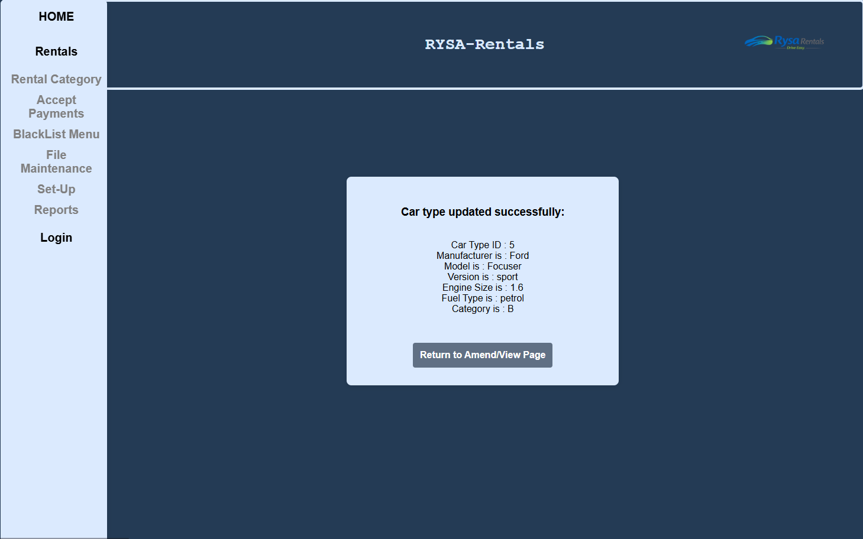
amendcarType.php code
<?php
/* Name: Sarah Crotty */
/* ID: C00309469 */
/* Purpose: php file for amend/view car type screen - runs UPDATE query */
/* Project: Car Rental */
?>
<HTML>
<head>
<link rel="stylesheet" type="text/css" href="../../GroupWork/global.css"> <!-- link css -->
</head>
<body>

<?php include('../../GroupWork/header.php') ?> <!-- include header -->

<div class="main">
<div class="nav"> <!-- nav bar link -->
<?php include('../../GroupWork/nav.php') ?> <!-- include navbar php -->
</div>

<?php
include '../../GroupWork/db.inc.php';

// variables from POST - CarTypeID tells the WHERE clause which record to update
$amendID = mysqli_real_escape_string($con, $_POST["amendID"]);
$amendManufacturer = mysqli_real_escape_string($con, $_POST["amendManufacturer"]);
$amendModel = mysqli_real_escape_string($con, $_POST["amendModel"]);
$amendVersion = mysqli_real_escape_string($con, $_POST["amendVersion"]);
$amendEngine = mysqli_real_escape_string($con, $_POST["amendEngine"]);
$amendFuel = mysqli_real_escape_string($con, $_POST["amendFuel"]);
$amendCategory = mysqli_real_escape_string($con, $_POST["amendCategory"]);
// check for a duplicate - same details already exist on an active (not deleted) record
// exclude the current record itself using CarTypeID != '$amendID'
$dupCheck = "SELECT * FROM CarType
WHERE Manufacturer = '$amendManufacturer'
AND Model = '$amendModel'
AND Version = '$amendVersion'
AND EngineSize = '$amendEngine'
AND FuelType = '$amendFuel'
AND DeletedFlag = 'N'
AND CarTypeID != '$amendID'";
$dupResult = mysqli_query($con, $dupCheck);

if (!$dupResult)
{
die("Duplicate check failed: " . mysqli_error($con));
}

if (mysqli_num_rows($dupResult) > 0)
{
// a matching active record already exists - refuse the update
echo "<form class='php-form'><h3>Error: A car type with these details already exists and has not been deleted.</h3><br>" .
"Manufacturer is : " . $amendManufacturer . "<br>" .
"Model is : " . $amendModel . "<br>" .
"Version is : " . $amendVersion . "<br>" .
"Engine Size is : " . $amendEngine . "<br>" .
"Fuel Type is : " . $amendFuel . "<br>" .
"<br><div class='button-group'><a href='amendcarType.html.php' class='return'>Return to Amend/View Page</a></div>" .
"</form>";
mysqli_close($con);
exit();
}
// no duplicate found - safe to run the UPDATE
// CarTypeID is never changed, only used in WHERE
$sql = "UPDATE CarType SET
Manufacturer = '$amendManufacturer',
Model = '$amendModel',
Version = '$amendVersion',
EngineSize = '$amendEngine',
FuelType = '$amendFuel',
RentalCategory = '$amendCategory'
WHERE CarTypeID = '$amendID'";
if (!mysqli_query($con, $sql))
{
die("The update has failed: " . mysqli_error($con));
}

// check rows were actually affected
if (mysqli_affected_rows($con) != 0)
{
// success output
echo "<form class='php-form'><h3>Car type updated successfully:</h3><br>" .
"Car Type ID : " . $amendID . "<br>" .
"Manufacturer is : " . $amendManufacturer . "<br>" .
"Model is : " . $amendModel . "<br>" .
"Version is : " . $amendVersion . "<br>" .
"Engine Size is : " . $amendEngine . "<br>" .
"Fuel Type is : " . $amendFuel . "<br>" .
"Category is : " . $amendCategory . "<br>" .
"<br><div class='button-group'><a href='amendcarType.html.php' class='return'>Return to Amend/View Page</a></div>" .
"</form>";
}
else
{
// no changes were made (user saved without editing anything)
echo "<form class='php-form'><h3>No changes were made.</h3><br>" .
"Car Type ID : " . $amendID . "<br>" .
"<br><div class='button-group'><a href='amendcarType.html.php' class='return'>Return to Amend/View Page</a></div>" .
"</form>";
}
// close database connection
mysqli_close($con);
?>

</div>
</body>
</HTML>
Java Script Code
amendcarType.js code
<!-- Name: Sarah Crotty -->
<!-- Student Number: C00309469 -->
<!-- Purpose: amend/view car type screen javascript -->
<!--Project: Car rental -->

// populate() - fires when user clicks the listbox
// splits the comma-separated option value and fills all the form fields
function populate()
{
let sel = document.getElementById("listbox");
let result = sel.options[sel.selectedIndex].value;

if (result === "") return; // nothing selected yet

let details = result.split(',');

// fill all fields with selected car type details
document.getElementById("amendID").value = details[0];
document.getElementById("amendManufacturer").value = details[1];
document.getElementById("amendModel").value = details[2];
document.getElementById("amendVersion").value = details[3];
document.getElementById("amendEngine").value = details[4];

// fuel type dropdown - loop options to find and select the match
let fuelSel = document.getElementById("amendFuel");
for (let i = 0; i < fuelSel.options.length; i++)
{
if (fuelSel.options[i].value === details[5])
{
fuelSel.selectedIndex = i;
break;
}
}

// rental category dropdown - same approach
let catSel = document.getElementById("amendCategory");
for (let i = 0; i < catSel.options.length; i++)
{
if (catSel.options[i].value === details[6])
{
catSel.selectedIndex = i;
break;
}
}

// reset to view mode (locked) whenever a new selection is made
lockFields();
document.getElementById("amendBtn").textContent = "Amend Details";
}

// lockFields() - disables all editable fields (view mode)
// Car Type ID stays disabled always - never editable per spec
function lockFields()
{
document.getElementById("amendManufacturer").disabled = true;
document.getElementById("amendModel").disabled = true;
document.getElementById("amendVersion").disabled = true;
document.getElementById("amendEngine").disabled = true;
document.getElementById("amendFuel").disabled = true;
document.getElementById("amendCategory").disabled = true;
}

// toggleLock() - called by Amend Details button
// switches between view mode (locked) and amend mode (unlocked)
function toggleLock()
{
let btn = document.getElementById("amendBtn");

if (btn.textContent === "Amend Details")
{
// switch to amend mode - enable editable fields
document.getElementById("amendManufacturer").disabled = false;
document.getElementById("amendModel").disabled = false;
document.getElementById("amendVersion").disabled = false;
document.getElementById("amendEngine").disabled = false;
document.getElementById("amendFuel").disabled = false;
document.getElementById("amendCategory").disabled = false;
btn.textContent = "View Details";
}
else
{
// switch back to view mode
lockFields();
btn.textContent = "Amend Details";
}
}

// confirmCheck() - runs on form submit
// validates engine/fuel rules, asks for confirmation, then enables all fields for POST
function confirmCheck()
{
// make sure a car type has been selected
if (document.getElementById("amendID").value === "")
{
alert("Please select a car type first.");
return false;
}

// engine/fuel validation - same rules as add screen
let engineNum = parseFloat(document.getElementById("amendEngine").value);
let fuel = document.getElementById("amendFuel").value;

// electric cars must have engine size of 0
if (fuel === "electric" && engineNum !== 0)
{
alert("Electric cars can only have an engine size of 0.");
return false;
}

// non-electric cars must have engine size greater than 0
if (fuel !== "electric" && engineNum <= 0)
{
alert("Engine size must be greater than 0.");
return false;
}

// ask user to confirm the changes
if (!confirm("Please confirm that the details supplied are correct."))
{
return false;
}

// enable ALL fields so they are included in POST (disabled fields don't submit)
// Car Type ID must be enabled too so PHP knows which record to UPDATE
document.getElementById("amendID").disabled = false;
document.getElementById("amendManufacturer").disabled = false;
document.getElementById("amendModel").disabled = false;
document.getElementById("amendVersion").disabled = false;
document.getElementById("amendEngine").disabled = false;
document.getElementById("amendFuel").disabled = false;
document.getElementById("amendCategory").disabled = false;

return true;
}

// resetForm() - clears all fields back to empty when Clear is clicked
function resetForm()
{
document.getElementById("amendID").value = "";
document.getElementById("amendManufacturer").value = "";
document.getElementById("amendModel").value = "";
document.getElementById("amendVersion").value = "";
document.getElementById("amendEngine").value = "";
document.getElementById("amendFuel").selectedIndex = 0;
document.getElementById("amendCategory").selectedIndex = 0;
document.getElementById("listbox").selectedIndex = 0;
lockFields();
document.getElementById("amendBtn").textContent = "Amend Details";
}

AI Disclosure Document
Student Name: Sarah Crotty
Student ID: C00309469
Course Name Software Development
Project Title RYSA Rentals
Code Unit Amend Screen
Date Submitted: 25/03/2026
AI Assistance Disclosure
AI Technologies Used
Indicate whether you used AI technologies in completing this task:
X No, I did not use any AI tools.
☐ Yes, I used AI tools. (List all AI technologies used, e.g., ChatGPT, GitHub Copilot, Codeium, Google Bard, etc.)

Prompts Used
If AI was used, describe the prompts or queries you provided to the AI tools:

Nature of Assistance
Indicate how AI technologies contributed to your work by selecting and elaborating on the relevant categories below:
- Code Suggestions & Auto-Completion: (e.g., AI suggested code snippets, function implementations, syntax corrections, etc.)

- Debugging & Error Fixing: (e.g., AI identified and corrected syntax/logical errors, suggested refactoring, etc.)

COMPANY REPORT SCREEN
This screen gives shows a report of all the company’s in the system, it only shows company’s that flag is not deleted. It shows company name, address, total rentals, if blacklisted, credit limit and amount owed. User can order by company name, best customer and amount owed. I have it set so if blacklisted the Y is bolded in red. This report uses its own css to show capabilities and how our personal style is different. The rest of the website is uniform and the same. We made our reports different to show personality. My css has features such as odd rows being a darker grey which is a common practice and heading is in blue along with other features that can be seen in image below.
Sarah/CompanyReport/companyReport.php
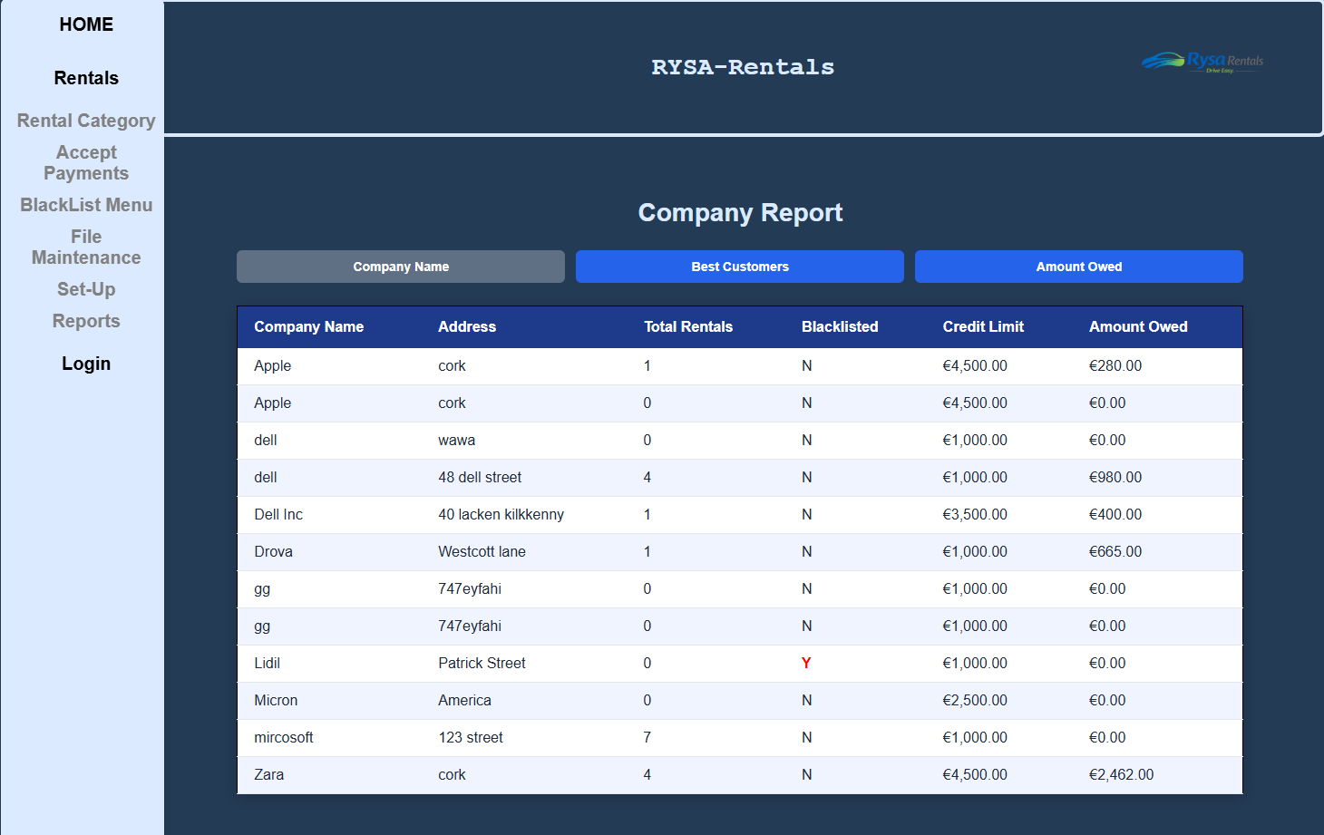
Company Report Screen Code
companyReport.php
<!-- Name: Sarah Crotty -->
<!-- Student Number: C00309469 -->
<!-- Purpose: Company report - sortable by name, best customers, amount owed -->
<!-- Project: Car Rental -->
<!DOCTYPE html>
<html>
<head>
<link rel="stylesheet" type="text/css" href="companyReport.css"> <!-- report specific css -->
</head>
<body>

<?php include('../../GroupWork/header.php'); ?> <!-- includes global.css + header bar -->

<div class="main">

<div class="nav">
<?php include('../../GroupWork/nav.php'); ?> <!-- includes nav.css + sidebar -->
</div>

<div class="report-container">

<h2 class="report-title">Company Report</h2> <!-- page heading -->

<?php
include '../../GroupWork/db.inc.php'; // include database connection
date_default_timezone_set('UTC'); // sets timezone
?>

<!-- hidden form used by javascript to store and submit the selected sort choice -->
<form action="companyReport.php" method="post" name="reportForm" class="report-form">
<input type="hidden" name="choice"> <!-- hidden field stores which report button was chosen -->
</form>

<!-- report sort buttons -->
<!-- clicking a button calls javascript which puts a value into hidden field and submits form -->
<div class="report-buttons">
<input type="button" id="companyButton" value="Company Name" onclick="companyOrder()"
title="Alphabetical order of company name">
<input type="button" id="customerButton" value="Best Customers" onclick="customerOrder()"
title="Descending order of total rentals">
<input type="button" id="owedButton" value="Amount Owed" onclick="owedOrder()"
title="Descending order of amount owed">
</div>

<script>
// sets hidden choice to Company and submits form
function companyOrder() { document.reportForm.choice.value = "Company"; document.reportForm.submit(); }

// sets hidden choice to Customer and submits form
function customerOrder() { document.reportForm.choice.value = "Customer"; document.reportForm.submit(); }

// sets hidden choice to Owed and submits form
function owedOrder() { document.reportForm.choice.value = "Owed"; document.reportForm.submit(); }
</script>

<?php
// default sort choice on first load before any button is pressed
$choice = "Company";

// if form has been submitted and choice is not empty, use the posted value
if (ISSET($_POST['choice']) && $_POST['choice'] != "") { $choice = $_POST['choice']; }

// if Company button chosen, disable Company button and sort report alphabetically by company name
if ($choice == "Company")
{
?>
<script>
document.getElementById("companyButton").disabled = true;
document.getElementById("customerButton").disabled = false;
document.getElementById("owedButton").disabled = false;
</script>
<?php
$sql = "SELECT Name, Address, TotalRentals, isBlacklisted, CreditLimit, AmountOwed
FROM Company
WHERE deleteFlag = 0
ORDER BY Name";
produceReport($con, $sql); // send query to function that builds and displays report table
}

// if Customer button chosen, disable Best Customers button and sort by TotalRentals descending
if ($choice == "Customer")
{
?>
<script>
document.getElementById("companyButton").disabled = false;
document.getElementById("customerButton").disabled = true;
document.getElementById("owedButton").disabled = false;
</script>
<?php
$sql = "SELECT Name, Address, TotalRentals, isBlacklisted, CreditLimit, AmountOwed
FROM Company
WHERE deleteFlag = 0
ORDER BY TotalRentals DESC";
produceReport($con, $sql); // send query to function that builds and displays report table
}

// if Amount Owed button chosen, disable Amount Owed button and sort by AmountOwed descending
if ($choice == "Owed")
{
?>
<script>
document.getElementById("companyButton").disabled = false;
document.getElementById("customerButton").disabled = false;
document.getElementById("owedButton").disabled = true;
</script>
<?php
$sql = "SELECT Name, Address, TotalRentals, isBlacklisted, CreditLimit, AmountOwed
FROM Company
WHERE deleteFlag = 0
ORDER BY AmountOwed DESC";
produceReport($con, $sql); // send query to function that builds and displays report table
}

// function to run query and display the report in table format
function produceReport($con, $sql)
{
$result = mysqli_query($con, $sql); // runs SQL query

// if query fails, stop page and show mysql error
if (!$result)
{
die("Query failed: " . mysqli_error($con));
}

// starts report table and prints headings
echo "<table class='report-table'>
<thead>
<tr>
<th>Company Name</th>
<th>Address</th>
<th>Total Rentals</th>
<th>Blacklisted</th>
<th>Credit Limit</th>
<th>Amount Owed</th>
</tr>
</thead>
<tbody>";

// loops through each company record returned by query
while ($row = mysqli_fetch_array($result))
{
// if company is blacklisted display Y in red, otherwise display N
if ($row['isBlacklisted'] == 1)
{
$blacklisted = "<span class='blacklisted-y'>Y</span>";
}
else
{
$blacklisted = "N";
}

// prints one table row for each company
echo "<tr>
<td>" . $row['Name'] . "</td>
<td>" . $row['Address'] . "</td>
<td>" . $row['TotalRentals'] . "</td>
<td>" . $blacklisted . "</td>
<td class='amount'>€" . number_format($row['CreditLimit'], 2) . "</td>
<td class='amount'>€" . number_format($row['AmountOwed'], 2) . "</td>
</tr>";
}

// closes table body and table
echo " </tbody>
</table>";
}

mysqli_close($con); // close database connection
?>

</div><!-- end report-container -->
</div><!-- end main -->

</body>
</html>
companyReport.css
/* Name: Sarah Crotty */
/* Student Number: C00309469 */
/* Purpose: CSS for company report page */
/* Project: Car Rental */

/* removes default form styling from our global css cause a box was appearing */
.report-form {
background: none;
box-shadow: none;
padding: 0;
margin: 0;
border-radius: 0;
}

/* company report container */
.report-container {
width: 100%;
margin-top: 180px; /* pushes report below fixed header */
padding: 30px;
}

/* button area for the sorting buttons */
.report-buttons {
display: flex;
gap: 12px;
justify-content: center;
margin: 25px 0;
}

/* styling for report buttons */
.report-buttons input[type=button] {
padding: 10px 24px;
background-color: #2563eb;
color: white;
border: none;
border-radius: 6px;
font-weight: bold;
cursor: pointer;
}

/* hover effect for report buttons */
.report-buttons input[type=button]:hover {
background-color: #1e3a8a;
}

/* disabled button styling */
.report-buttons input[type=button]:disabled {
background-color: #607084;
cursor: not-allowed;
}

/* company report table styling */
.report-table {
border-collapse: collapse;
width: 100%;
background-color: #ffffff;
box-shadow: 0 4px 16px rgba(0,0,0,0.2);
}

/* table heading row */
.report-table thead tr {
background-color: #1e3a8a;
}

/* table heading cells */
.report-table th {
color: #ffffff;
padding: 14px 18px;
text-align: left;
font-weight: bold;
border: none;
}

/* table data cells */
.report-table td {
padding: 11px 18px;
border: none;
border-bottom: 1px solid #e5e7eb;
color: #1f2937;
text-align: left;
}

/* alternating row colour for readability */
.report-table tbody tr:nth-child(even) {
background-color: #f0f4ff;
}

/* row hover effect */
.report-table tbody tr:hover td {
background-color: #dbeafe;
}

/* styling for blacklisted Y value */
.blacklisted-y {
color: red;
font-weight: bold;
}

/* report page heading */
.report-title {
text-align: center;
color: #dbeafe;
margin-bottom: 15px;
font-size: 28px;
font-weight: bold;
}

AI Disclosure Document
Student Name: Sarah Crotty
Student ID: C00309469
Course Name Software Development
Project Title RYSA Rentals
Code Unit Company Report Screen
Date Submitted: 25/03/2026
AI Assistance Disclosure
AI Technologies Used
Indicate whether you used AI technologies in completing this task:
X No, I did not use any AI tools.
☐ Yes, I used AI tools. (List all AI technologies used, e.g., ChatGPT, GitHub Copilot, Codeium, Google Bard, etc.)

Prompts Used
If AI was used, describe the prompts or queries you provided to the AI tools:

Nature of Assistance
Indicate how AI technologies contributed to your work by selecting and elaborating on the relevant categories below:
- Code Suggestions & Auto-Completion: (e.g., AI suggested code snippets, function implementations, syntax corrections, etc.)

- Debugging & Error Fixing: (e.g., AI identified and corrected syntax/logical errors, suggested refactoring, etc.)

